Producer price indices in the third quarter of 2010

In the third quarter of 2010, agricultural producer prices increased compared to previous quarter by 6.2%. Prices of crop products increased by 10.0%, prices of animal products by 2.3%. Prices of potatoes were higher by 23.6%, cereals by 15.0% and fruits by 5.3%. Prices of vegetables increased by 24.7% (-14.5% in the second quarter). Among animal products price increase was recorded in pigs for slaughter (+7.7%) and milk (+2.6%). Prices of eggs decreased by 15.5%.

Prices of agricultural producers were higher by 7.9% in the third quarter of 2010 year-on-year (-2.9% in the second quarter of 2010). The growth came mainly from crop products, in which prices grew by 9.8%. Prices of animal products were higher by 6.0%. Price growth in crop products (+11.9) was due to higher prices of potatoes (+13.1%), fruit (+21.3%) and vegetables (+54.8%). As for animal products, lower were prices of eggs (-12.4%), pigs for slaughter (-8.4%) and poultry (-1.6%). Prices of milk increased by 24.9%.

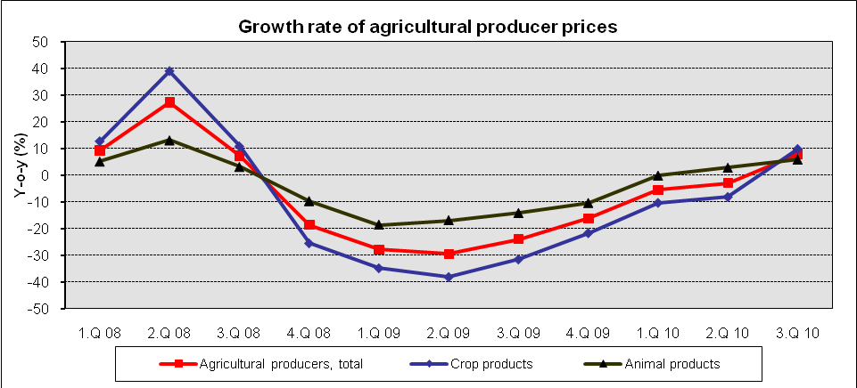

In the third quarter of 2010, industrial producer prices increased compared to previous quarter by 0.4%. Prices increased primarily in ‘basic metals, fabricated metal products’ (+5.0%). Prices went up in ‘food products, beverages and tobacco’ (+1.0%). Prices decreased primarily in ‘chemicals and chemical products’ (-4.4%) and ‘coke, refined petroleum products’ (-2.0%).

Prices of industrial producer increased by 2.2% in the third quarter of 2010 (-1.3% in the second quarter of 2010) year-on-year. Prices increased the most in ‘coke, refined petroleum products’ by 26.8% (+37.0% in the second quarter), ‘basic metals, fabricated metal products’ by 9.5% (no change in the second quarter), ‘mining and quarrying’ by 8.3% (+8.6% in the second quarter) and ‘chemicals and chemical products by 6.5% (+17.9% in the second quarter). Prices decreased primarily in ‘basic pharmaceutical products’ (-3.9%), ‘transport equipments’ (-3.5%) and ‘food products, beverages and tobacco’ (-1.8%).

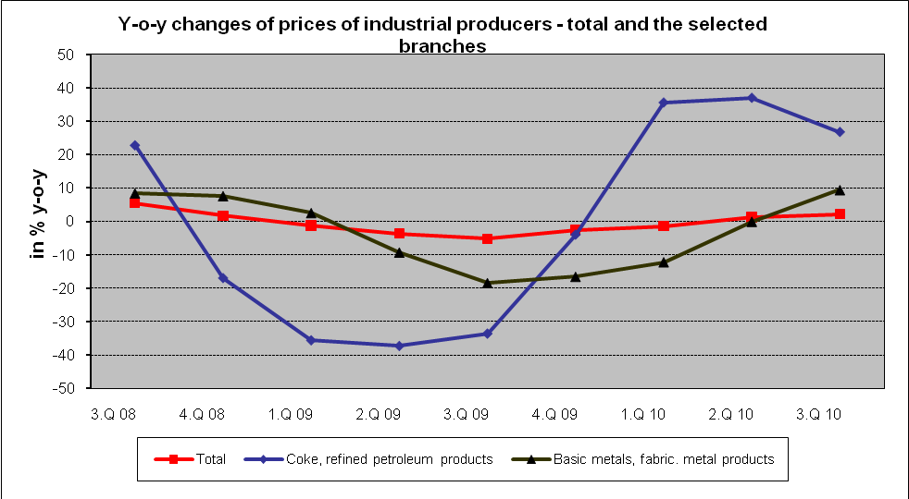

According to an estimate, in the third quarter of 2010, construction work prices decreased compared to previous quarter by 0.1%, prices of construction material input increased by 1.1%.
According to an estimate, construction work prices in the third quarter of 2010 compared to the corresponding period of 2009 were lower by 0.2% year-on-year, prices of construction material input increased by 2.3%.

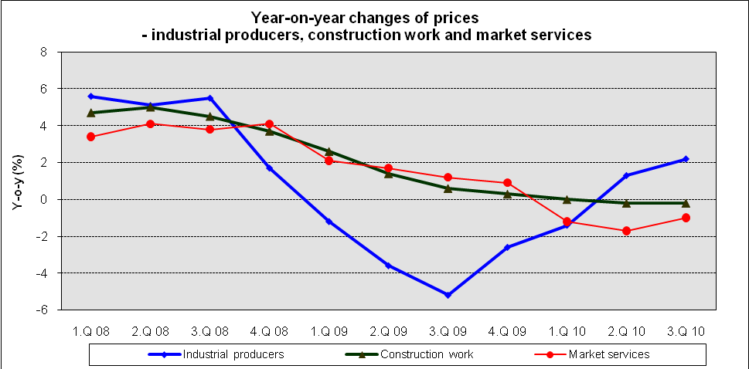

In the third quarter of 2010, market services prices decreased compared to previous quarter by 0.7%. Lower were mainly prices of advertising and market research by 6.9%, telecommunications services by 0.8% and financial intermediation by 0.4%. On the contrary, prices in real estate services, freight transport and postal and courier services increased by 0.3%, 0.9% and 1.1%, respectively. Market services prices in total excluding advertising services increased by 0.1%.
In the third quarter of 2010, prices of market services were lower compared to the corresponding period of 2009 by 1.0% in total. The development of total price level was affected mainly by prices in advertising and market research, which were lower by 4.6%. On the increase were prices in employment activities by 9.2%. Market services prices in total excluding advertising services decreased by 0.5%.

