17 May 2024

Number of working females was increasing

Employment and unemployment in the Czech Republic as measured by the Labour Force Sample Survey – 1st quarter of 2024
A refined estimate, after having included new demographic data, shows a year-on-year (y-o-y) increase of the employment by 188.9 thousand persons. The number of the unemployed, according to the methodology of the International Labour Organization (ILO), increased by 14.4 thousand persons. The number of the economically inactive aged 15+ years decreased by 90.9 thousand. The development is considerably influenced by aging of the domestic population and also by integration of foreigners on the Czech labour market.

Employment

In the Q1 2024, the seasonally adjusted average number of employed persons increased by 155.0 thousand persons, compared to the Q4 2023. This piece of data reflects a considerable population increase, coming of mainly females – war refugees from Ukraine, as well as their inclusion in the Czech economy.

The number of working persons aged 15+ years increased by 188.9 thousand, y-o-y, i.e. by 3.8% to 5 201.0 thousand. The increase is mainly owing to an increment in the number of working females. Their number was by 145.8 thousand higher, y-o-y. The number of working persons aged 45–59 years considerably increased, by 118.2 thousand; what was also inconsiderable was an increase of working persons aged 60+ years, whose number grew by 65.0 thousand, year-on-year. Conversely, in the age categories of 15–24 years and 25–29 years, a slight year-on-year decrease in the number of working persons was recorded.

Chart 1: The number of working persons in the national economy and their structure by age group (thousand)
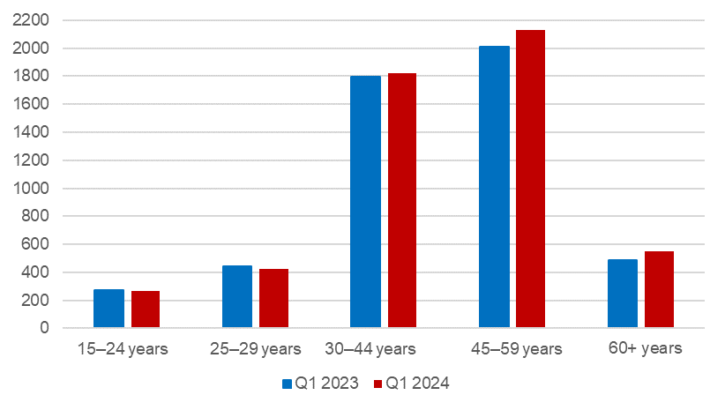 Source: CZSO, LFSS

The number of employees increased by 149.1 thousand persons. The number of the self-employed (without unpaid contributing family workers) increased by 39.9 thousand persons. This overall increase is owing to an increase in the number of the self-employed without employees (own-account workers), namely by 44.2 thousand. The number of the self-employed with employees (employers) slightly decreased (a decrease by 4.2 thousand).

According to data for the Q1 2024, the development of employment in individual economic activities (CZ-NACE sections) in the Czech Republic was different⁾. In the primary sector of agriculture, forestry and fishing, the number of working persons increased, year-on-year, by 11.4 thousand to 148.0 thousand. In the secondary sector of industry and construction, a slight increase in the number of working persons was recorded; their number increased by 17.6 thousand to 1 832.5 thousand. In the tertiary sector of services, the total employment increased, y-o-y, by 162.7 thousand to 3 220.5 thousand. In this sector, the number of working persons especially increased in the section of ‘education’ by 43.4 thousand persons and also in the section of ‘wholesale and retail trade; repair of motor vehicles and motorcycles’ by 28.1 thousand persons, and in the section of ‘public administration and defence; compulsory social security,’ in which the number of working persons increased by 21.9 thousand persons. A slight decrease in the number of working persons was only recorded in the section of ‘water supply; sewerage, waste management and remediation activities,’ in which the number of working persons decreased by 6.4 thousand persons.

Chart 2: The number of working persons in the national economy by economic activity (thousand)

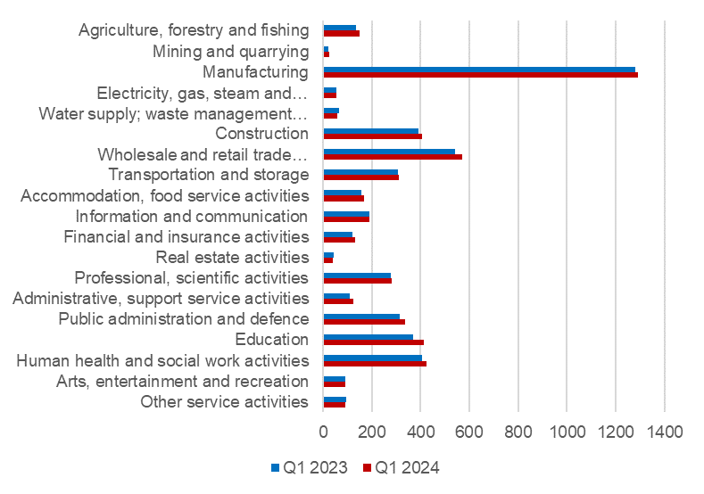

Source: CZSO, LFSS

Along with changes in the structure by economic activity (CZ-NACE section), changes in the structure of working persons by occupation also occurred. According to the Classification of Occupations (CZ-ISCO), the number of working persons increased the most in the major group of professionals (by 100.2 thousand) and in the group of service and sales workers (by 49.8 thousand). On the other hand, the biggest decrease occurred in the major group of clerical support workers (by 58.4 thousand).

Chart 3: The number of working persons in the national economy by Classification of Occupations (thousand)
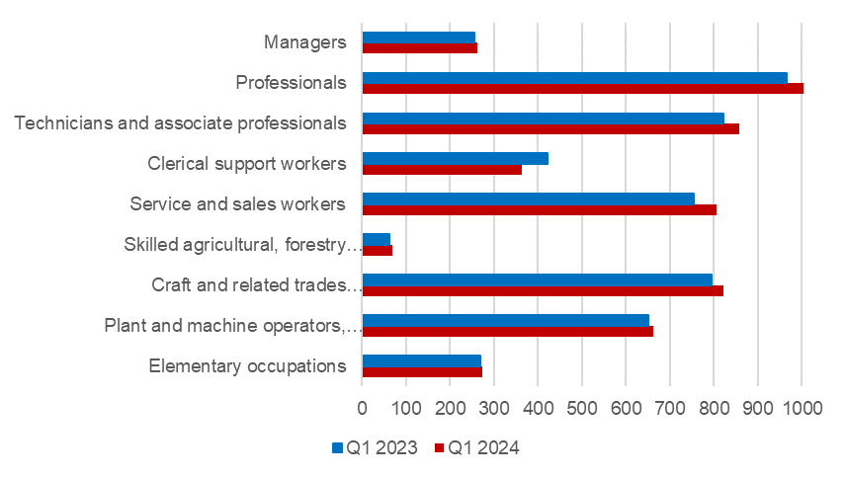

Source: CZSO, LFSS

The development trend in the number of working persons according to the educational attainment is also related to those changes in the employment structure. The number of working persons with primary education increased by 13.6 thousand to 237.7 thousand. The number of working persons with secondary education without A-level examination increased by 45.8 thousand to 1 644.4 thousand persons. The number of employed persons with secondary education with A-level examination increased the most, by 78.6 thousand, to 1 892.7 thousand working persons. The number of employed persons with tertiary education increased by 50.4 thousand to 1 424.8 thousand persons.

The employment rate (the percentage of working persons in the age group of 15–64 years old) increased in the Q1 2024 compared to the corresponding period of the previous year by 0.4 percentage point (p. p.) to 74.9%. The male employment rate decreased by 0.3 p. p. to 80.9%, the female one increased by 1.3 p. p. to 68.8%.

Unemployment

The seasonally adjusted average number of unemployed persons according to the ILO methodology⁾ increased in the Q1 2024 by 2.9 thousand persons, compared to that in the Q4 2023.

Chart 4: The number of the unemployed in Regions of the Czech Republic (thousand)
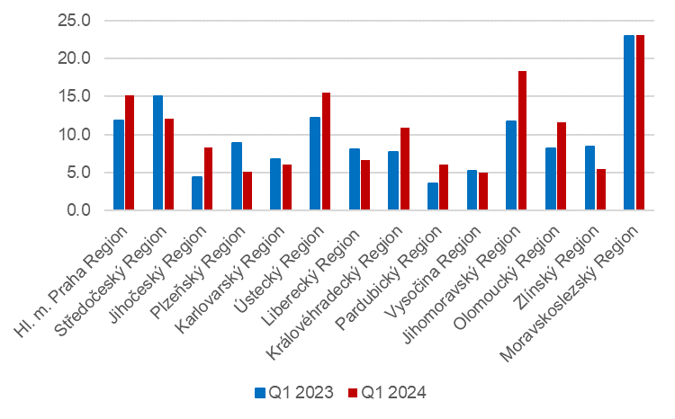
Source: CZSO, LFSS

The total number of the unemployed aged 15+ years increased, year-on-year. The number of the unemployed increased by 14.4 thousand to 149.1 thousand persons. Specifically, it was mainly an increase in the number of the unemployed females by 11.9 thousand to 80.6 thousand. The number of the unemployed males increased by 2.5 thousand to 68.5 thousand.

The number of the unemployed increased the most in the Jihomoravský Region (by 6.6 thousand) and in the Jihočeský Region (by 3.9 thousand).

The number of persons unemployed for one year and longer also increased; their number increased in total by 10.0 thousand persons, y-o-y, and reached 47.2 thousand persons. The number of the long-term unemployed males increased by 6.4 thousand, y-o-y, the number of the long-term unemployed females in the Q1 2024 increased by 3.6 thousand compared to the corresponding period of 2023.

Chart 5: The number of the long-term unemployed (for 1 year and longer) and their age structure (thousand)

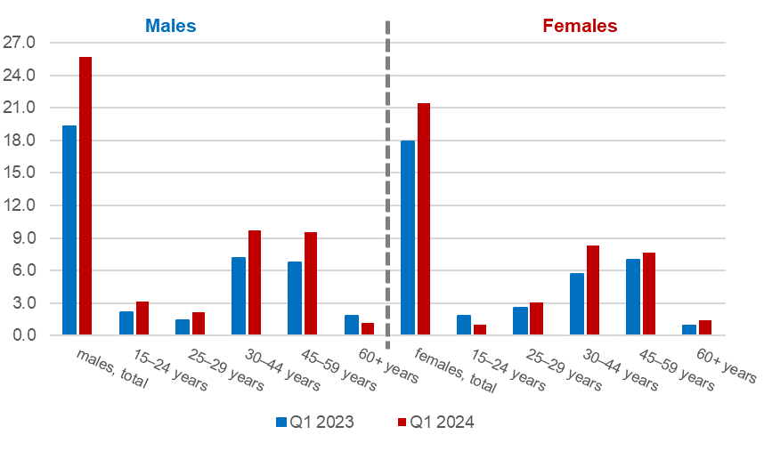
Source: CZSO, LFSS

The general unemployment rate according to the ILO definition in the age group of
15–64 years old (the percentage of the unemployed in the labour force, i.e. in the sum of the employed and the unemployed) increased by 0.2 p. p., year-on-year. The unemployment rate was 2.8%^{*)} in the Q1 2024 and in the corresponding period of the previous year it was 2.7%^{*)}.

^{*)} rounded
Chart 6: Unemployment rate of the 15–64 years old in Regions of the Czech Republic (%)
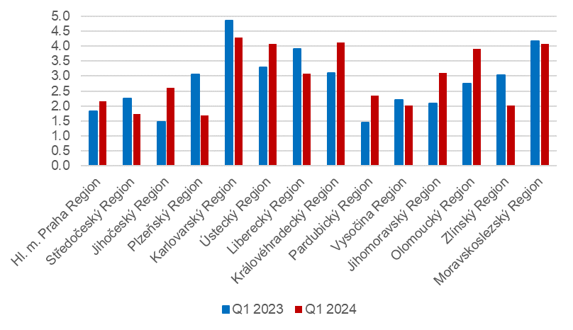
Source: CZSO, LFSS

In terms of a regional comparison, the general unemployment rate of the 15–64 years old was the highest in the Karlovarský Region (4.3%) and in the Královéhradecký Region, in the Moravskoslezský Region, and in the Ústecký Region (4.1% in each of the Regions). The biggest decrease in the unemployment rate was in the Plzeňský Region (by 1.4 p. p. to 1.7%); the Region also had the lowest unemployment rate in Czechia.

Economic inactivity

The number of economically inactive persons aged 15+ years was by 90.9 thousand lower, year-on-year, and amounted to 3 429.1 thousand. The number of economically inactive females decreased by 76.0 thousand; the number of economically inactive males was by 14.9 thousand lower than a year ago.

In the sample survey, data are also collected on persons who do not work and do not seek a job in an active manner and therefore do not comply with the ILO conditions for the unemployed, yet they state that they would like to work. In the Q1 2024, the number of such persons was 78.4 thousand persons, i.e. by 4.8 thousand persons more than in the corresponding period of 2023. The number of persons who are willing to work, however, they are not able to start in a potential job immediately, is relatively high. Only 17.8 thousand of the persons are able to start in a job within a fortnight, at the latest.

Methodological change in the LFSS

As of the 2nd quarter of 2023, as announced in advance, the methodology of the weighting scheme and grossing up changed (details in Czech only).
Note:
Recalculation to the same population structure
The Labour Force Sample Survey (LFSS) is carried out in selected dwelling households. Collective accommodation establishments are not included in the survey. The data found were weighted to the population of the Czech Republic based on the results of the demographic statistics as at the end of the given year; estimates of the number of persons living outside private households were subtracted from the population totals of the demographic statistics.

Authors:
Marta Petráňová, phone number: (+420) 274 054 357, e-mail: marta.petranova@czso.cz
Gabriela Strašilová, phone number: (+420) 567 109 071, e-mail: gabriela.strasilova@czso.cz
Unit for Labour Forces, Migration, and Equal Opportunities

⁾ Data for economic activities (CZ-NACE sections) may be influenced by the employed methodology of the Labour Force Sample Survey (LFSS). The survey only covers persons living in dwellings (flats), i.e. private households. Data on persons living in collective accommodation establishments are not measured; these establishments often give accommodation to foreign nationals.
⁾ The ILO methodology defines the unemployed as persons who during the reference period were without a job, did not work an hour for pay or remuneration, and were in an active manner seeking a job they would be able to join within fortnight at the latest. This methodology is uniform for all EU Member States and provides internationally comparable data. It has to be taken into consideration that the definition of “the unemployed” by the ILO differs from the definition of “job applicants kept in the register of the labour offices” of the Ministry of Labour and Social Affairs.

