COLLECTION OF INFORMATION
_________________________________________________________________________________
Year 2013

Analyses Prague, September 27, 2013
Publication Code: 1111-12

Tendencies and Factors of Macroeconomic Development of the Czech Republic in 2011

Prepared by: Ing. Drahomíra Dubská, CSc., Ing. Jan Ferenc
Contact: Ing. Drahomíra Dubská, CSc., Tel. 274054041, E-mail: drahomira.dubska@czso.cz

_________________________________________________________________________________

Czech Statistical Office
2013

© Czech Statistical Office, Prague 2013

C O N T E N T S Page

Introduction 1
Summary 2

1. Global economy development 1.1. GDP and debt crisis 4
1.2. Quantitative easing as an instrument for economic recovery 4
1.3. New developing countries 6
1.4. Commodity markets 7
1.5. Financial markets 8

2. Macroeconomic development in the Czech Republic in the European context
with regard to 2011 11
2.1. Development of economy by GDP development 11

3. Imbalances 15
3.1. Internal imbalance 15
3.1.1. Government sector deficit 15
3.1.2. Gross consolidated debt of government sector 17
3.1.3. Private debt, public tenders, state aid, guarantees 20
and social benefits
3.1.3.1. Private sector debt 20
3.1.3.2. Public tenders 23
3.1.3.3. State aid 23
3.1.3.4. Guarantees 24
3.1.3.5. Social benefits 24
3.1.4. Imbalances in institutional sectors 25
3.2. External imbalance 27
3.2.1. Deficit of current account of balance of payments 27

4. Convergence of the Czech Republic to the EU average 30
4.1. Real convergence 30
4.2. Nominal convergence 33

5. Competitiveness of the Czech economy 35
5.1. Change of the exports share from the Czech Republic in global export 35
5.2. Costs competitiveness by labour costs 36
5.3. Non-price factors of competitiveness 37
5.3.1. Employment in knowledge-intensive activities 37
5.3.2. Support of sophisticated activities 38
5.3.3. Tertiary education 40

Team of authors:
Ing. Drahomíra Dubská, CSc. (Introduction, Summary, Chapters 2, 3, 4 and 5)
Ing. Jan Ferenc (Chapter 1)

Introduction

The Czech Statistical Office has re-established the publication of a regular annual extensive analysis entitled “Tendencies and Factors of Macroeconomic Development in the Czech Republic”. As opposed to previous years, this time its concept has been modified.

A significant change over previous years is the strong emphasis placed on international comparison, which is omnipresent across all the topics discussed. The emphasis placed on this comparison makes sense because of the Czech Republic’s special position in the economic sphere, a position granted by its high degree of openness towards both Europe and the rest of the world but also simply by where it is situated territorially, which can be relevant for demographic changes influenced by migration and has an effect on the social-economic sphere. On the contrary, a method is maintained when the development in a given year – or year, for which the data are available – is put into the mid-term to long-term perspective. This provided very interesting results as of 2011, the time of transition: from the strong boom in the Czech economy, through the crisis year 2009, to a subsequent ascent out of this crisis. The year 2011 showed that maintaining a growth trajectory is not an easy task.

As far as analysis of factual issues is concerned, a predominant focus on detailed analysis of gross domestic product and related indicators of national account systems (NAS) was not a preferred approach this time. The focus instead was on the monitoring of tendencies at times when the economy is potentially driven out of balance. This includes a view of balanced economic activities of institutional sectors of the Czech economy and changes in its ability to compete on a European and global scale, the intensity with which the Czech Republic is attempting to converge towards the economic advancement of Europe and the results of this effort.

Given the significance of the 2011 European sovereign debt crisis for the Eurozone and the real European economy, the first part of this analysis is dedicated to the development of the global and European economy, particularly from the perspective of the debt crisis and subsequent actions that were intended to reduce its impact. The development in commodity and financial markets was added to the analysis. The chapter concerning the internal imbalance of the Czech Republic measured by fiscal parameters, also a big macroeconomic issue of 2011, is the most elaborated part in the present publication. The reduction of internal debt became a fundamental paradigm of the economic policy of the government, to which all other objectives were subordinated. Therefore, this chapter pays attention to the level and particularly the structure of the government sector deficit, including an analysis of the public tenders, state aid, guarantees, social benefits and positions of the Czech Republic in these spheres in comparison with other EU countries. At the same time, the gross consolidated debt of the government sector of the Czech Republic was also discussed. And for the first time, the private debt was analysed, and an indicator was formulated of the so-called complex debt and the position of the Czech Republic in the context of the EU-27 countries.

The real convergence of the Czech Republic to the EU-27 average is also studied according to the success of the individual regions of the country in the analysis, including the evaluation of nominal convergence based on how the Maastricht criteria have been fulfilled in the last five years. The last chapter is dedicated to selected price and non-price related parameters of the competitiveness of the Czech economy.

Summary

      - As in previous years, large developing economies contributed to the growth of the global economy in 2011. The so-called BRIC group (Brazil, Russia, India and China) were joined by South Africa, Indonesia and Malaysia. While the European economy suffered from the sovereign debt crisis, the US economy, following support in the form of quantitative easing, grew faster than the EU-27 or Japan. The economic slump of the latter was also influenced by a natural disaster. Following the growth of prices in the first half of 2011, commodity stock markets continued to suffer losses, and some correction could be seen on stock markets after the end of each round of quantitative easing. Financial investors preferred bonds of countries with relatively healthy public finances (Germany). Gold and the Swiss franc have become popular “safe havens” for investments. As opposed to the stimulating impulses of economic policies in the USA, Eurozone, UK or China, the Czech economy operated in an increasingly restrictive environment in 2011.
- 2011 confirmed that real convergence of the Czech Republic towards the average level of economic and monetary union in Europe by GDP per capita based on purchasing power parity (PPS) was discontinued. According to Czech Statistical Office (CZSO) data from national accounts, the Czech economy continued to converge to the average level of EU-27 – following the visible increase of relative share since 2011 – even in the crisis year of 2009 when this indicator reached 82.2% of the EU-27 average. In 2010, the position of the Czech Republic with regard to GDP per capita in PPP dropped to 79.6% of EU-27 average – the position of Prague dropped from 175.5% to 172.3%, while other regions, Prague excluded, in aggregate dropped from 69.7% to 67.1%. Their real convergence for such a long period was almost unnoticeable, as the above-mentioned indicator of EU-27 average was 66.6% in 1995.
- While with regard to GDP growth rate the Czech Republic was positioned in the first third of EU-27 countries in the period 2004–2010, it stood in the middle of the ranking in 2011.
- In the decade 2000–2010, the majority of expenditure components of GDP had grown three times faster than the average of the most developed countries of the Union (EU-15). The exception was government final consumption expenditures, the growth of which was higher in the old EU countries (+23.2%) than in the case of the Czech Republic (+20.2%), the reason being much stricter cuts in the government sector of the Czech Republic in 2005–2011 when the expenditures rose only by 4%, while in the EU-15 they rose by 9% in aggregate.
- The growth of the Czech economy in the last two decades – with the exception of the currency crisis in 1990s – has been relatively stable without significant fluctuations of external or internal imbalance.
- Concerning the internal balance by government sector deficit to nominal GDP, the position of the Czech Republic has showed long-term improvement – from the 22nd place among EU-27 countries in 2000 to 9th place in 2011. Ironically, the position of the Czech Republic in the European context steadily declined in the years of the strongest economic boom. In 2011, the deficit of the Czech government sector was 3.1% of nominal GDP, and the value only slightly exceeded the convergence criteria limit determined by the Maastricht Treaty.
- The position of the Czech Republic with regard to gross debt of the government sector in the ranking of the EU-27 dropped from the 4th place in 2000 (17.8% of nominal GDP) to 7th place in 2011 (41.2%). However, in the European context the position is still positive – in the EU-27 the gross consolidated government sector debt to GDP ratio was twice the value of the Czech Republic’s in 2011 (82.5%), and even higher in the Eurozone (87.2%).
- Apart from a good position in terms of government sector debt, the private debt, i.e. debt of households and businesses, is also favourable in the Czech Republic – in relation to nominal GDP the debt was the third lowest in the EU-27 in 2010 (71.6% of GDP) while in 2003 it was 49.2% of the nominal GDP.
- A “complex” debt (both public and private) of 109.7% of GDP in 2010 meant that the Czech Republic held the position of the second least indebted country of the EU-27 (following Romania with 107.2% of GDP, while Slovakia with 110.1% of GDP was third). For instance, the total debt of Ireland stood at 385% of its GDP, while it was 351% for Cyprus, 318% for Portugal and 287% for Denmark. Greece with 269% of GDP was the seventh most indebted EU country with the highest government sector debt ratio (145%).
- Regarding the fulfilment of Maastricht criteria, i.e. the so-called nominal convergence towards the European level, the Czech Republic was successful in all criteria, with the exception of the 3% limit for government deficits in relation to GDP – however even in spite of this, these relative deficits were more positive than the EU-27 average; the criterion of the exchange rate stability is not fulfilled by the Czech Republic due to the fact that it does not participate in ERM II system.
- Concerning selected parameters of competitiveness, the Czech Republic continues to lose ground mostly because the labour is becoming more and more expensive – in 1995–2010 the most significant increase of real unit labour costs among the EU 27 countries was recorded. Also the increase of the Czech Republic’s share in world exports has been on continual decline following the peaks in 2004 and 2005.
- With regard to selected non-price factors of competitiveness, the Czech Republic maintains a position in the bottom half of the European ranking. In the so-called “knowledge-intensive activities“ there are 33.4% of the totally employed persons in the Czech Republic as opposed to 60% in Luxembourg and 51% in Norway or Switzerland. Regarding the support of sophisticated activities, in the form of the share of expenditures on research and development, in 2005 and 2006 the Czech Republic was making a significant progress towards convergence to the EU-27 average, but later an opposite trend occurred. In 2010, the share was 1.56% in the Czech Republic against 2% of the EU average, in Finland it was 3.9% and in Sweden 3.4%, but only 0.6% in Slovakia. Education as per share of persons with tertiary education is not growing in the Czech Republic when compared to the European average. Since 2006, the share of young women with this level of education in relation to the total number of women in the age group of 25–34 has been on a steady increase against less growth of the share of young men. This poses a risk for demographic development, as social research shows that women with such a level of education often tend to postpone motherhood or do not have children at all.

1. Development of the global economy

1. 1. GDP and sovereign debt crisis

- Only fragile  growth in 2010 and 2011 | 2011 was not the first post-crisis year, as economic experts still hoped back in 2009. The sovereign debt crisis that struck Europe, the USA and Japan as well brought a necessity to cut expenditures from public budgets – and the need to pay for state liabilities (but also liabilities of NGO’s and private entities) made both the public and private sectors seek ways to cut expenditures. Therefore, state budgets sought and continue to seek new sources of income. The strategies developed to create savings differed across countries, resulting in a slowdown of economic growth that will probably last into the coming years as well. This was reflected in the slowdown of growth in the developed countries in 2011 and was followed by gradual slide back into recession. No sooner than at turn of 2011 and 2012, the EU started to find measures against this development.
- By putting  more emphasis on growth support, the USA saw more growth-positive development than Europe | Even in crisis, the economic policy of the USA put rather more emphasis on the support of economic growth than savings. This strategy was partially successful. The US GDP grew at 1.7% in 2011, which represents a significant slowdown from 3% growth in 2010, but it still means a rate that exceeds GDP in the EU as a whole and in the Eurozone too (both are at 1.5%). However, this growth was not accompanied by improvement of other indicators that are necessary for economic balance, employment in particular – in 2011 the unemployment rate was 8.5%, a year before 9.1%, and 7.2% in December 2008. However, even monetary strategies to support growth keep failing.
- The largest  developing economies with no significant problems, “new EU countries” struck by the crisis relatively less seriously | The economies of countries in Southeast Asia and Latin America and to some extent Russia managed to avoid the crisis. Asia and Latin America, specifically Brazil, Argentina and Chile, have gone through many financial crisis in the 1990s that they managed to solve autonomously. In economic terms these solutions included various reforms, nationalization, devaluation of national currencies and declarations of bankruptcies, i.e. in general by writing off one half of state debt. However, such tools are not available to the European Monetary Union.  Due to extensive fiscal and economic reforms that have been adopted to meet the so-called Maastricht criteria, the “new” countries were caught unaware by the debt crisis relatively less seriously than the EU-15 countries, some of which had not been fulfilling the Maastricht criteria prior to the outbreak of the crisis
- Growth  rates in the EU, Eurozone and in the USA | The year on year GDP growth rate in 27 of the EU countries rose from 1.3% per year in 2002 to 3.3% in the peak year of prosperity (2006). In the pre-crisis year of 2007, the EU economy grew by 3.2%. Eurozone countries recorded a year on year growth of 0.9% in 2002 and 3% in 2007 – in the same period, the German economy had grown from stagnation in 2002 to 3.3% in 2007. Estonia, which had to dig deep to cope with the financial crisis, posted an average annual GDP growth of 7.9% in this period. In 2007, Slovakia recorded a year on year growth of 10.5%, while in 2002 it was 4.6%. The economy of the Czech Republic had steadily sped up from 2.1% in 2002 to 7% in 2006. Even a year later, its GDP grew by 5.7%.  The USA found itself in a rather shifted rhythm. It experienced economic growth exceeding 4% from 1997 to 2000, but at the turn of the century the GDP rate in the USA slowed down to 1–2%. The American economy saw its best years already in 2004 and 2005 with GDP growth at 3.5%, or at 3.1% respectively.

1.2. Quantitative easing as an instrument for economic recovery
- Printing money as a tool for the growth of the US economy until 2011, lowering interest rates in Europe |  | The Fed, the American central bank, confronted the recession by employing a strategy of so-called quantitative easing when traditional monetary instruments, in particular the drastic lowering of basic interest rates, did not yield the desired outcomes – lending transactions did not recover, the economy (both enterprises and consumers) did not draw down the cheap money and no growth occurred. Essentially, this was a bad debt redemption by the central bank for cash. In some cases, the government took part in the program by acquiring ownership interests for redemption of bad debts in some financial institutions. Following the restructuring of loans and financial stabilization, such ownership interest was resold to the original owners for a market price. (According to US government calculations, most of these investments have been paid up.) The second round of quantitative easing ended in 2011 with purchased state bonds of USD 600 billion (totalling USD 1200 billion from December 2008 to March 2010).  The European Central Bank (ECB) hesitated with the lowering of interest rates and did not act to make use of quantitative easing during this phase of the crisis. Aid for the banks at risk was left to the decision of the individual governments of the EMU member states.
- Fast debt generation of problematic European countries… | Efforts of problematic European countries to prop up their own banks and to stabilize the economy to avoid recession resulted in fast debt generation by these countries. In spite of this, the plan was almost successful: the banking sector released loan flows and in 2010 there was an economic growth recovery (EU-27 +2% in 2010, Eurozone +1.9%, Germany +3.7%, Czech Republic +2.7%). However, this recovery was not strong enough to put an end to chronically increasing debt of public budgets. Unemployment did not improve and there was growth of inflation. at the same time, basic interest rates stood, from a long-term perspective, at historical minimums. The reason might be that the new money was for the most part used to prop up banks and public budgets. Much of this money did not enter the real economy as it may have seemed. Moreover, there is a probability that should this newly issued money enter the real economy, it would have been used to cover the current debt of business (from loans and insolvency) and households rather than for new investments, creation of job opportunities or growth of salaries.
- … despite actions taken with no positive result… | Incomes of state budgets were not sufficient to cover social expenditures. The unfavourable socio-demographic development in European countries continued to create deficits on retirement accounts. Weak economic growth did not create job opportunities, which again encumbered the social expenditures of the state and in turn limited the sources of budget income. Therefore, in 2011 a significant downturn of economic growth occurred, falling to 1.5% in both the EU and Eurozone, to 1.7% in the Czech Republic and less seriously in Germany to 3%. The downturn of economic growth in 2011 had been proceeding gradually since the beginning of the year.  The first problems were reported by Ireland and soon after by Greece. Spain, Portugal and Italy followed. The interest from bonds and/or revenues, that were asked by investors with the securities of these countries, reached an amount that would not, given their economic performance, allow these countries to pay for their liabilities. This resulted in a lack of liquidity and an inability of the governments to fulfil their obligations even towards their own citizens. These countries lost credit at financial markets which refused to lend money to cover increasing state debts with no prospects that the general functioning of these economies would improve.
- A new fall into recession… | In this environment, both business and households started having problems with their liabilities, and subsequently risk assets of the banks started to grow. Instead of the anticipated stabilization of the economy and a slow transition to moderate but stable economic growth, as early as the second half of the year it was apparent that a second fall into economic recession was much more likely. The governments of European countries did not have financial reserves, while global financial markets refused to provide loans for affordable interest. This was also the reason why the second fall into recession threatened to have much more serious consequences than in 2008 (including concerns that the Eurozone would disintegrate).
- … despite the approach of quantitative easing also taken by the ECB | The European countries launched extensive programs of public expenditure cuts and growth of state income (particularly from taxes). However, this did not lead to the reduction of state budget deficits or at least to such an extent as planned by the governments. In addition, these cuts have significantly contributed to the reduction of GDP dynamics.  The ECB reacted to the closing of loan transactions with problematic states on financial markets at the end of 2011 when the first round of quantitative easing was launched. Limited by its mandate that did not allow the banks to provide direct loans to governments, it provided 523 institutions, mostly commercial banks, with cheap loans in the form of 3-year bonds at a total amount of EUR 489 billion in 2011. (The second round of the program was announced at the end of February with the amount of cheap loans up to EUR 530 billion and 800 institutions asked for the newly emitted funds.) The volume of funds disbursed as part of the program was not large enough to solve the debt crisis of the peripheral states. However, it averted the acute threat of a closing of the loan market, as well as a collapse of financial institutions in the most affected countries and the most laden banks.
- Formation of the so-called European bailout funds | By forming special institutions, namely the European bailout funds, the political representation of the Eurozone decided to bypass the fact that the ECB cannot provide loans directly to governments, as well as the fact that, according to the rules for the functioning of the Eurozone, each member state is responsible for its budget deficits. In May 2010, the EU-27 decided to form the Financial Stability Fund to help the states struck by debt crisis. Its lending capacity is EUR 440 billion and it shall cease to exist when the bonds issued are paid up (probably in 2013). In order to ensure that the Eurozone would have a permanent ability to prop up problematic economies, it was decided that a permanent European Financial Stabilization Mechanism be formed to obtain relatively cheap funds on financial markets (up to EUR 60 billion combined with the lending capacity of the above-mentioned Financial Stability Fund). Lending instruments of the International Monetary Fund (IMF) form the third part of the European bailout funds in the amount of EUR 250 billion. In order to save the peripheral member states of the Eurozone, loans in the amount of EUR 750 billion should thus be available. Upon their request, the total guarantees were increased to EUR 780 billion in October 2011.
- USA, an exception in GDP rates | Economic recovery in the USA and the EU’s 2011 political measures significantly reduced a probability of a deep and steep slump that would have an impact on the growth of the global economy. It appears however that the measures agreed upon were taken too late. The trust of businesses in the future economic development and doubts of financial markets drove the yields from bonds of Eurozone states high again, the debt crisis grew more serious and in the last quarter of 2011 the moderate economic growth changed into a year on year fall of 1.3%. GDP fell also in Japan as a result of natural disasters and the drop in foreign demand for Japanese production. On the other hand, economic activity kept growing in the USA, final consumption investments recorded an increase and a recovery in the loan and labour market could be seen.

1. 3. New developing countries

- Latin America and Asia lost dynamic, but growth of these countries persisted | The fast-growing economies of Southeast Asia and Latin America responded to the crisis in Europe and to the threat of Eurozone disintegration relatively sensitively. Firstly, they were jeopardized by a drop of export potential, and secondly, the influx of foreign investments in these countries declined. The overheating of the economies of China and India in previous years is responsible for the slowdown of their economic growth rate. As opposed to the developed countries or the countries of Central and Eastern Europe, the unemployment rate of the large and developing economies of Asia and Latin America remains relatively low as a result of their previous dynamic growth.
Table 1: Year on year GDP growth (in %)
 | 2010 | 2011 | 4.Q2011
World | 5.3 | 3.9 | 3.2
EU | 2.0 | 1.6 | 0.9
Eurozone | 1.9 | 1.4, | 0.7
Central and Eastern Europe | 4.5 | 5.3 | 3.8
USA | 3.0 | 1.7 | 1.6
Japan | 4.4 | -0.7 | -0.6
New fast-growing Asian economies in total | 8.5 | 4.0 | 3.1
China | 10.4 | 9.2 | 8.9
India | 10.6 | 7.2 | 6.1
Latin America and Caribbean countries | 6.2 | 4.5 | 3.6
Source: MMF
1. 4. Commodity markets
- Prices of commodities were the only inflation impulse, but their increase is only temporary as a result of the weakening pace of the global economy |  |  | On a global scale, the inflation rate was relatively low due to the fact that basic interest rates in the strongest economies were close to zero and large new liquidity sums were issued by central banks. The only inflation pressure was recorded in the prices of commodities. In the half year of 2008, oil prices posted a historical high. In the beginning of 2011, following the information concerning the quantitative easing of central banks, the prices were around USD 115. They dropped later towards USD 100 and after the next growth wave rose to USD 115 per barrel.  Similarly, other industrial commodities are on the decline. This development reflects the downturn of economic activities, including the expectations concerning a further slowdown in the growth rate of the global economy in the coming period. Based on these arguments, i.e. by correlation of the prices of commodities and anticipated economic growth (i.e. by consumption), sharp stock market movements during the oil and food crisis in 2007 and 2008 could be explained. (Increasing demand in China and India was responsible for the increase of rice prices and so on.) However, commodity stock markets respond with growth also to an increased uncertainty on financial markets. Merchants who do not purchase commodities for consumption or physical business with commodities use commodity contracts to increase risk margins and to cover higher costs incurred to secure their speculations. However, in the absence of demand signals, this led to the opposite effect – as movements on both stock and commodity markets become more and more synchronized. Therefore, the year 2011 showed that investors started to pull away even from commodity markets.
 | Chart No. 1 | Price of Brent oil (in USD per barrel) |  | Chart No. 2 | Price of copper (in USD/100 per pound)
 | 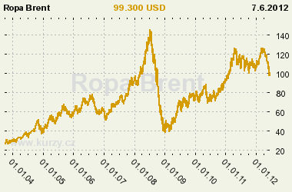 |  |  | 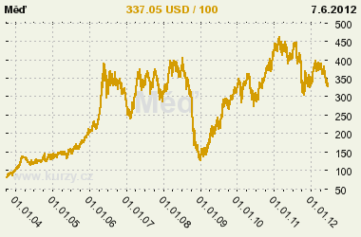

Source: kurzy.cz

1. 5. Financial markets

- Shares stagnated over the large spectrum |  | Since 2000, global stock markets have been very volatile and have more or less stagnated over the large spectrum of values. Price fluctuations had a global character, with markets oscillating irrespective of the region, and with partial variances with regard to their dynamics. In 2011, the American market was the most effective, mostly thanks to the stimulus policy of the Fed. Concerning the performance of stock markets, Europe, as a whole, lagged behind, with German and British stock markets the strongest. Poor performance was also shown by the Japanese stock market which did not perform much differently than Southern Europe. The growth from 2009 to 2011 was a combination of steps taken by central banks, particularly by the American Fed with an aim to pump new liquidity into the market and stimulate economic growth. In this regard, 2011 was no exception. Following the end of each of the American programs of quantitative easing, QE1 and QE2 stock markets corrected downwards. The mere announcement of the intention to proceed with the next round in August 2010 and September 2011 became a signal for growth. Thus, the weakening or strengthening of the American dollar was a dominant determinant for price movements.
Chart No. 5 | DAX stock index (spread 2–9 thousand points b.) |  | Chart No. 6 | Nikkei 225 stock index (spread 5–20 thousand points)
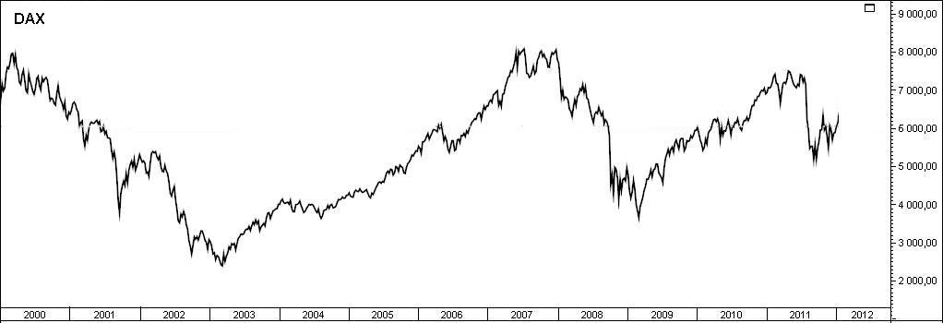 |  |  | 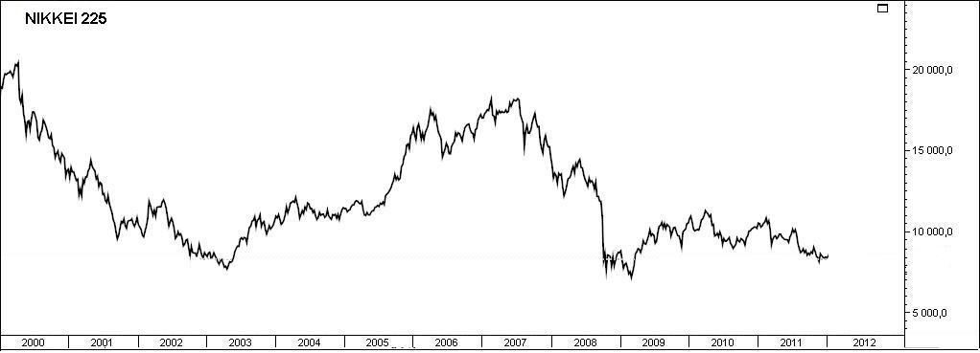
Source: www.thinkorswimm.com and www.saxobank.com

Chart No. 7: S&P 500 stock index since 2000 (Development in each of the phases of quantitative easing shown)

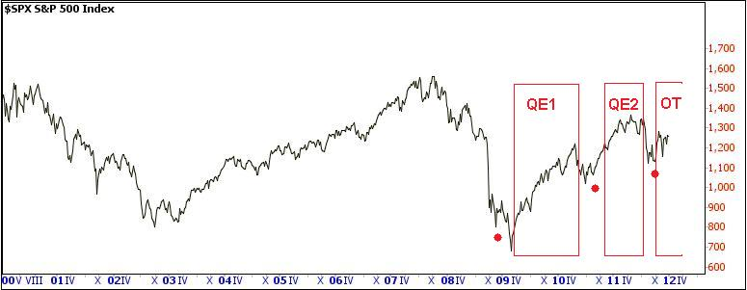
Source: www.thinkorswimm.com and www.saxobank.com

- Globalization: markets move together in trend terms |  | Stock indexes of the markets of USA (S&P 500), Germany (DAX-30) and Japan (NIKKEI-225) move together in trend terms. From the long-term perspective, the Japanese index is the weakest. American S&P 500 recorded a historical maximum in October 2007 and in the end of 2011 was by one fifth lower, with the German DAX down by almost 30% and the British FTSE-100 by almost 20%. The yields of American government bonds with ten year maturity have been falling for a long time (since 1982). As a result of the interventions by the Bank of Japan, the yields of bonds of the Japanese government saw the same trend. The yields of government bonds of Germany (Chart 8) have also been falling since 1990s. No sooner than in 2012, the bonds of Spain (Chart 9) reacted to fading demand of investors connected with difficulties of the country.
Chart No. 8 | Yields of German government bonds |  | Chart No. 9 | Yields of Spanish government bonds
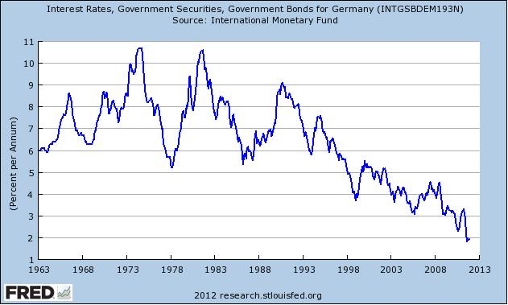 |  |  | 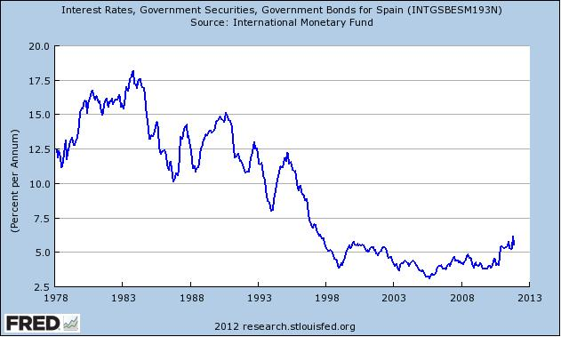  Source: http://research.stlouisfed.org

 | - Fed took over the initiative on capital markets with new initiative called Operation Twist; with one of the results being the weakening of American dollar |  | Since 2008, American Fed, mostly due to its stimulation programs of QE1 and QE2 quantitative easing, or their modification with extended maturity of bonds called Operation Twist in 2011, is the key factor determining to a great extent the behaviour of capital markets in the aftermath of American subprime mortgage and bank crisis. Even the mere announcement of intentions (November 2008 for QE1, August 2010 for QE2 and September 2011 for Operation Twist) to support economic growth through stimulation packages led in both QE cases to weakening of the dollar connected with the rise of prices of other investment assets – in particular, stock markets and yields from government bonds. In both cases, such stimulation of growth was limited in time by pumping of artificially supported liquidity into the markets and soon after its end it was followed by steep corrections.
 | - Investors sought “safe havens” in the overall uncertainty on financial markets |  | In the end of 2011, the trust according to global index of purchasing managers reached its peak in the past 9 months, which indicated potential positive development for the beginning of 2012. However, the problem was that this index maintained positive values only due to positive forward-looking expectations in India, Canada, the United States, Turkey and Russia. Also hard data from real economy in the last quarter of 2011 later showed that in many countries important for the development of global economy this quarter recorded the poorest performance since the crisis year of 2009.  In 2011, financial investors concerned with small progress regarding the solution of the crisis in the Eurozone, and uncertain whether or not there is a permanent strong growth of the Chinese economy and due to overall imbalance of the global economy, sought safe placements for their assets. This was not very succesful, so cash was piling up. Nevertheless, the so-called “safe havens", in particular investments into precious metals, and specifically gold, worked again. In the half of 2011, the price of gold surged to around USD 1800 per troy ounce, which was approximately twice as much as in the crisis year of 2009. At the same time, it must be said that the price of gold on commodity markets did not exceed USD 500 per troy ounce in the entire first half of the past decade. Swiss franc was similarly attractive as gold. Strong demand for this currency made the Swiss central bank to intervene fearing that strong currency might inhibit the competitiveness of the country. The intervention was successful and the Swiss franc weakened in the half of the year.
Chart No. 10 |  | Price of gold (in USD per troy ounce) |  | Chart No. 11 | Exchange rate dollar to Swiss franc
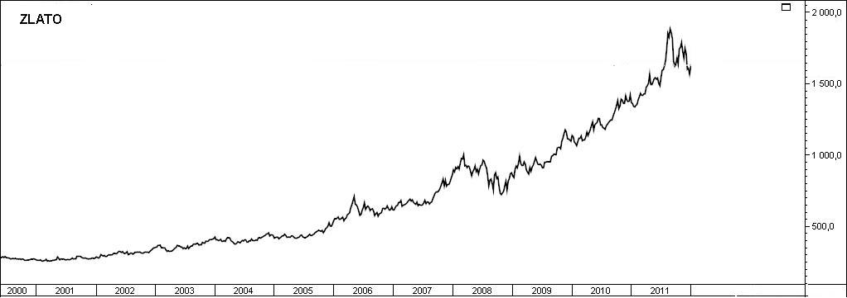 |  |  |  | 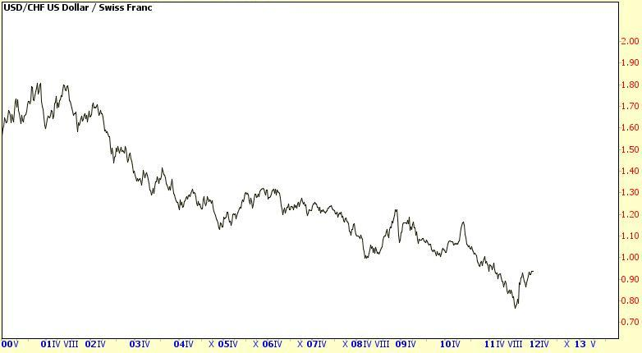
Source: www.saxobank.com

- Macroeconomic development of the Czech Republic in the European context with regard to 2011

The Czech Republic economy became more dynamic following its entry into the European Union. A similar effect occurred in most of the countries that joined the project of a common European space with free movement of goods, services and capital and labour. Even though their economic cycles are not yet synchronized with the EU-27 cycle, some countries with a higher share of international exports in their economic performance draw benefits from that. The Czech Republic, predominantly with good growth in the European context in 2001–2011 and particularly in 2006–2011, saw declining performance in 2011, and in the ranking of the 27 countries of the EU it was positioned in the middle, which represented its second worst position after 2002.

  - Performance of the economy by the development of gross domestic product

- In 2011, the position of a fast growing economy in the European context was lost |  | While the Czech economy has featured predominantly in the first third of the ranking of the EU-27 since 2004, it was positioned in its bottom half in 2011 with the reason being that the post-crisis performance-related development was on the par with the EU average and the slump of the Czech economy in 2009 as such was slightly deeper than the decline of the EU-27. At the same time, the growth structure in 2011 was different from the growth structure of EU-27. While household and government final consumption expenditure participated substantially in the increase of GDP of the EU, the same role was played by foreign trade in the Czech Republic.
- GDP growth of the CR in 2011 was slightly higher than growth of the EU-27 and Eurozone |  | The gross domestic product (GDP) of the Czech Republic in real terms grew by 1.7% in 2011 against 2010, representing a slightly faster pace than the growth of the economy of the European Union (+1.5%). The so-called “old” EU countries that were members of the Union before 1 May 2004 when ten new countries joined the EU, recorded even slower growth (+1.4%). The growth rate of the group of countries using the euro was the same as the year on year dynamics of the EU-27 (+1.5%) in 2011.
- Strong Germany in 2011 |  | At the same time Germany, being the largest European economy, saw very strong growth (+3%), therefore the dynamics of the “rest” of the three large economies of the old member states (EU-15) were logically mostly lower. The economic growth of Italy (+0.4%) and the UK (+0.7%) was below the average of the EU-15, while the economy of France (+1.7%) stood above the average.
- Three countries with year on year falls |  | A year on year fall was recorded by some “peripheral” economies of the European Union (Slovenia -0.2%, Portugal -1.6% and Greece -6.9%). After the double-digit slumps in the crisis year of 2009, the Baltic states posted the fastest growth (Estonia +7.6%, Lithuania +5.9%, Latvia +5.5%) along with Poland (+4.3%) and also Sweden (+3.9%). In real terms, the GDP of the troubled Ireland that had been on a steady decline in the previous three years, recorded a moderate growth in 2011 (+0.7%).
- Regarding the growth rate, the Czech economy had been positioned in the first third of the ranking of the EU-27 since 2004, in 2011 it was in the middle of the ranking |  | The post-crisis surge of the Czech economy – in real terms GDP fell by 4.7% in 2009 – was demonstrated by GDP growth of the Czech Republic in 2010 (+2.7%) which was only slightly higher than the growth in the EU-27 (+2%). This was sufficient for a place among the top five fastest growing economies in 2010. However, it only remotely recalled the massive year on year surge in performance from 2005–2007 when the Czech economy in real terms converged strongly towards the EU level, in terms of increases – +6.8% (2005), +7% (2006) and +5.7% (2007).  However, these massive spurts of growth were sufficient for the position in the first third of the ranking of countries with greatest GDP dynamics only in 2005 and 2006 – in 2005 the Czech Republic took the fourth place behind the Baltic states, and in 2006 it was also surpassed by Romania and Slovakia. In the past ten years, the Czech Republic featured in the first third of the fastest EU countries also in 2004, 2008 and 2010. In 2011, the position in the middle of the ranking (14th place) is the second worst after 2002 (16th place).
Chart No. 12 | Real GDP (y/y in %, comparison of countries and groupings) |  | Chart No. 13 | Real GDP of CR in quarter on quarter (seasonally adjusted) and year on year comparison (in %)
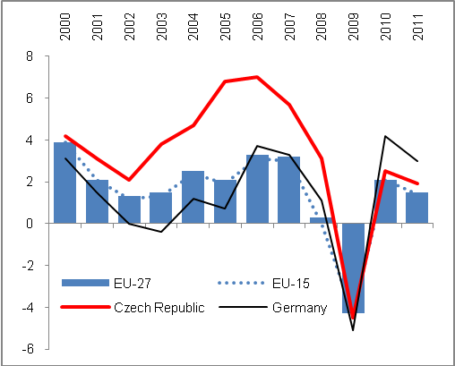 |  |  | 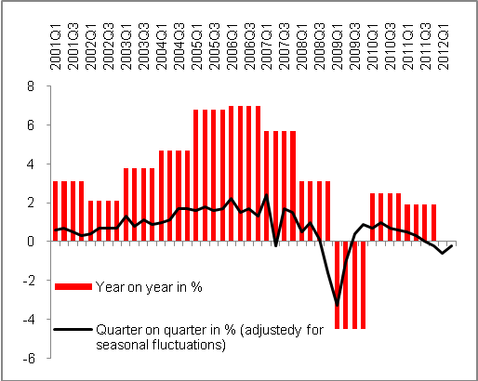
Source: CZSO, Eurostat

- From the long-term perspective, the economic performance of the CR has grown three times faster than that of the EU-27… |  | From the long-term perspective and in the European context, the Czech Republic is among states whose GDP volumes have significantly increased – in 2011 GDP was two fifths higher (+41.9%) than in 2000. It was the eighth greatest increase in economic performance among the EU-27 countries. Although the figure for the EU average is not yet available, it can be concluded based on the data for 2010 (+13.9%) that the GDP increase in the Czech Republic was three times higher than that of the EU-27 in 2011 as compared to 2000.
- … but it was far from achieving the dynamics of Slovakia as the fastest growing EU economy |  | Only economies of the Baltic states recorded more significant growth in 2011 against 2000 with DGP growth by more than half – Lithuania (+62.1%), Estonia (+52%) and Latvia (+51.3%) and also countries that were the last to join the EU, namely Romania (+53%) and Bulgaria (+51.9%). Stronger growth than the Czech Republic for this period has also been recorded by Poland (+52.9%). However, the greatest GDP increase in real terms in the context of the entire EU-27 was achieved by the Slovak economy, the performance of which rose by almost two thirds (+64.7%),  The economic performance of the group of the most developed European countries (EU-15) grew less (+12.3%) than that of the EU-27 as a result of the stronger growth of those countries that became EU member states later (the higher dynamics are logical when we consider the lower costs). However, not all “new” countries managed to post similar results. For example, in 2011 the GDP of Hungary has grown by less than one quarter since 2000 (+23.5%), which was less than the increase of such an advanced economy as Sweden (+28.1%). The weakest growth was recorded by Italy and Portugal where GDP has grown against the base from 2010 by not even 5% (+4.2% and +4.8% respectively) in 2011.
- GDP increase for 2006–2011, the fourth greatest among EU-27 |  | The comparison against the base in 2005, the period in which the Czech Republic had gone through the strongest and longest economic phase of prosperity, but also the crisis year 2009, shows an even more positive picture of the performance of the Czech economy. The GDP increase of the Czech Republic for 2005–2011 (+16.1%) was the fourth highest in the EU-27 and surpassed the dynamics of the EU (+6.1%) for this period by 2.6 times. It was mainly caused by the fact that the crisis slump of the Czech economy in 2009 (-4.7%) was slightly deeper than the EU-27 average (-4.3%). However, the average annual growth in 2004–2007 standing at +6.1% was significantly higher than in the EU (+2.8%).
- Most of the countries from the enlargement wave of 2004 are successful |  | Of the 12 countries that joined the EU in the last two waves of enlargement, seven converged by increases of their economies for 2006–2011 to the average level of the European Economic and Monetary Union – their growth rates were higher than the average growth of EU-27 for this period.
Chart No. 14 | Real GDP (y/y in %, CR and selected states, 2012 and 2013 estimate by Eurostat) |  | Chart No. 15 | Real GDP ( y/y in %, regression analysis, 2012 and 2013 estimate by Eurostat)
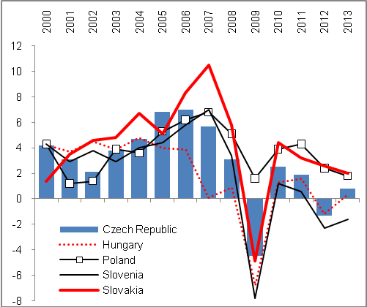 |  |  | 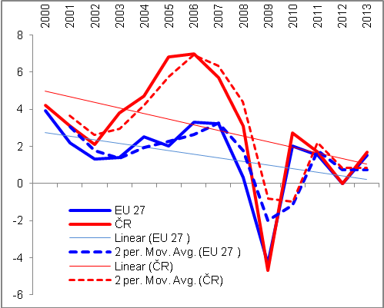Source: CZSO, Eurostat, own calculations

- The increase in volume of most expenditure components of GDP in 2000–2010 in the Czech Republic was approx. three times higher than EU dynamics with the exception of final government consumption expenditure | It is clear from the long-term development of individual components on the expenditure side of GDP, that is, for 2000–2010, that their volume has risen three times against the dynamics of these components of the old EU countries (EU-15) combined than in the Czech Republic. The domestic demand in the Czech Republic has grown in real terms in the given period by 29%, while it grew by 11.8% in the EU-15. Household final consumption expenditure has increased in real terms by almost two fifths (+39.6%), while in the EU-15 it grew only by 12.3%, with the export of goods and services in the Czech Republic by 115%, against +34% in the EU-15. The difference in the dynamics of investments is significant when the formation of gross fixed capital exceeded the base from 2010 by 31.7% in the Czech Republic, while only by 2.9% in the EU-15 (see Table 2).  On the contrary, costs for final consumption of the government sector rose in the decade of 2000–2010 in the most developed EU countries (EU-15) almost by one quarter (+23.2%), while only by one fifth in the Czech Republic (+20.5%). This was predominantly influenced by the development since 2005 when the increase of government final consumption expenditure in 2005–2011 was more than two times higher (+9%) as compared to the small increase in the Czech Republic. In particular, the more restrictive fiscal policy of EU-15 countries was responsible for this, as expenditures of these countries were mostly influenced by the condition of budgets of the problematic countries of the “South” and countries providing aid from their budgets towards the end of the above-mentioned period.
- A comparison for 2005–2011 showed a drop in investments in the EU-15 against their growth in CR; dynamics of household consumption influenced by the economic level reached | The period of 2005–2011 was characterized by approximately three times higher dynamics of export and import of goods and services in real terms apparent in the Czech Republic as opposed to the dynamics of the EU-15 (Chart 2). Domestic demand grew by 8.7% against +3.5% for the EU-15. Regarding household final consumption expenditure, the data concerning the increase of the EU-15 for 2011 was not available when this report was being compiled, but it can be seen for individual countries that the growth of consumption of households by 11.5% in the Czech Republic for 2005–2011 was significantly higher than e.g. that of Germany (+3.3%) or the drop in the UK (-0.5%), but much lower when compared to Poland (+26.5%). This comparison is strongly affected by the higher economic level of households of the old EU countries modifying the dynamics by the comparison base used.  In the crisis period, the formation of gross fixed capital fell in the EU-15 group much more significantly than in the Czech Republic, where growth of 9.2% was reported in 2005–2011 while investment dropped in the EU-15.
- The increase of gross added value in CR against the EU-15 more was significant in the period of crisis | The increase of gross added value in the Czech Republic for 2000–2011 was also three times higher than that of the EU-15 (+44.1% against +15.4%). For 2005–2011 the mutual dynamic ratio was even more profound (+17.6% against +5.7% in the EU-15).  This can be explained by the structure of economies, because the crisis occurring in the given period struck the service sector dominating in the developed countries more severely. On the other hand, the relatively strong share of the secondary sector in the Czech economy was responsible for the fact that, given relatively fast elimination of losses in production and export caused by weakened foreign demand, particularly the manufacturing industry and the added value created by this industry recorded an overall positive development for the entire period 2005–2011.

Table 2: Increase of GDP major components in medium and long-term perspective (in real terms, in %)

 | 2000–2010 |  | 2005–2011
 | CR | EU-15 | CR | EU-15
Household final consumption expenditure | 39.6 | 12.3 | 11.2 | -*
Government final consumption expenditure | 20.5 | 23.2 | 4.0 | 9.0
Gross fixed capital formation | 31.7 | 2.9 | 9.2 | -2.7
Export of goods and services | 115.0 | 34.0 | 53.0 | 19.5
Import of goods and services | 93.9 | 33.2 | 14.4 | 15.4
Domestic demand | 29.0 | 11.8 | 8.7 | 3.6
Gross added value ** | 44.1 | 15.4 | 17.6 | 5.7
GDP | 39.6 | 12.3 | 16.1 | 5.1
Source: Eurostat
*E.g. Germany +3.3%, UK -0.5%, and Poland +26.5%
** 2000–2011

- Imbalances

Odd movements in economic growth may knock an economy off balance. The out-of-balance states can be observed from both inside and outside in transactions with foreign countries. Fiscal disproportion is a typical example of an internal imbalance, that is, a proportion between income and expenditure of the government sector, imbalance between the demand and supply in the labour market or between savings and investments. A particularly good example is too high unfavourable negative balance of payments current account in relation to the performance of the economy or a disproportion of coverage for deficits and surpluses of individual components of the balance of payments. In this analysis, the focus is on the internal imbalance measured by the deficit and debt of the government sector, while the external imbalance is measured by the development of the balance of payments current account of the Czech Republic. The fiscal problem is again assessed in the European context.

  - Internal imbalance

    - Government sector deficit

- Debt by government sector deficit decreased in 2011… | The government sector deficit of the Czech Republic – defined as central government institution (state budget), local government institutions (budgets of municipalities, towns and regions) and social security funds – decreased in 2011. Its reduction was both nominal and in relation to GDP at current prices.  Following dramatic cuts in the state budget, the deficit has been on decline from the record value of CZK 218.3 billion in the crisis year of 2009 to 182.7 billion in 2010 and to 117.9 billion with the economy recovering in 2011, when such a hard budget restriction contributed decisively to the loss of the pace of economic growth in the Czech Republic.

Chart No. 16 | Budget deficit of the government sector in relation to nominal GDP (in %) | Chart No. 17 | Y-o-y changes of government sector deficit and GDP (in mil. CZK)
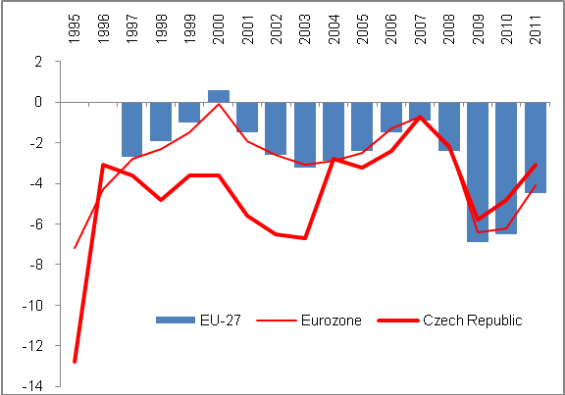 |  | 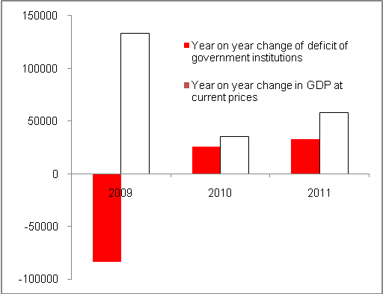
Source: CZSO

- … at the expense of the pace of GDP growth | The gradual reduction of the annual deficit of the government sector in the Czech Republic since 2009 from 5.8% of nominal GDP to 4.8% in 2010 and down to 3.1% in 2011 is a positive trend with regard to the paradigm of the adopted economic policy preferring only the reduction of deficits. However, this has been achieved at the expense of future weak growth impulses for the economy, where measures reducing the effective demand of Czech households and also the slump of large investments financed from public sources have the most negative impact.

- Significant drops of government sector investments in an effort to reduce deficits… |  | The government sector seeks to reduce deficits by lower investments. In 2011, the gross formation of fixed capital was lower for the second consecutive year. While in 2009 the investments of the government sector were CZK 15.7 billon higher than in 2008 and reached CZK 191 billion – which at that time worked to reduce the drop in the economy under the crisis – the next two years were impacted by restrictions in this regard. In 2010, the formation of gross fixed capital fell year on year almost by 28 billion and in 2011 for another CZK 25 billion. Compared to 2009, the investments of the government sector were CZK 53 billion lower in 2011. This development was reflected in the transport infrastructure.
- … contributed to growth inhibition |  | Therefore, it is clear that the government sector did not participate in the growth of the economy in the year of economic recovery (2010) as far as investments are concerned. Subsequently, by forming less gross fixed capital the government further deepened the slowdown of the economy in 2011.
- In the European context, there was a strong long-term level of investments of the government sector of CR with a drop in 2011 |  | However, surprisingly enough, the proportion of investment to nominal GDP in the Czech Republic is, in the European context, among the highest, even from a long-term perspective. In 2001–2011 the annual average of this indicator stood at 4.3%, which was the third highest relative proportion of government investment in GDP in the EU after Bulgaria and Estonia (4.7 and 4.5%). For the EU-27, it was 2.5%; the least investments in relation to GDP were provided by Denmark and the UK (1.9% of GDP), followed by Germany and Belgium (1.6%) and particularly Austria (1.2%). The difference cannot be attributed to the organisation of individual countries (federal countries in Germany or Austria), as the indicator is consolidated for the entire government sector. Therefore, a more significant share of private investments in the development of these countries can be assumed.  As late as in 2009, the Czech Republic ranked in the third place in the EU in the amount of government sector investments in relation to GDP with 5.1% after Romania and Poland, but the Czech Republic dropped to seventh place in 2011 with 3.6%. The decrease of the investment ratio was characteristic for the whole of the EU-27 (from 2.9% to 2.5%) and can partially be explained by debt-related budget difficulties of the countries of Southern Europe, or countries providing aid respectively.
Chart No. 18 | Structure of government sector deficit (in million CZK) |  | Chart No. 19 | Structure of 2009 deficit (internal circle) and 2011 (external circle), in % of the total deficit of the Czech government sector
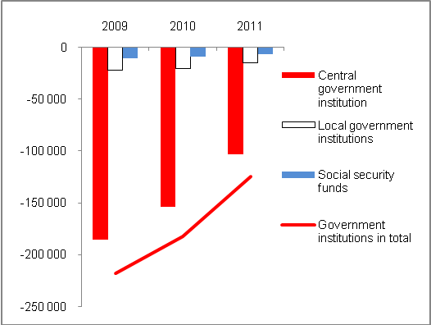 |  |  | 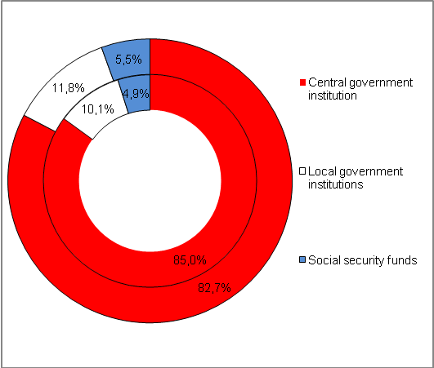
Source: CZSO

- European context |  | In the European context, the deficit of the government sector was fairly adequate in 2011 when it only slightly exceeded the Maastricht convergence criterion limit (3%) with 3.1% of nominal GDP. In the ranking of the EU-27, the Czech Republic was positioned in the second third of the ranking when three countries recorded an economic surplus in their government sectors (Sweden, Estonia and Hungary) as can be seen in Chart 20. Another seven countries had more favourable deficit than the Czech Republic (Malta, Austria, Bulgaria, Denmark, Germany, Luxembourg and Finland).  On the contrary, in 2011 the worst economic result was reported by Ireland where guarantees given by the Irish government for risk balances of banking sector entities were probably reflected in the result. On average, the government deficit for the EU-27 was 4.5% of the nominal GDP of the union, and 4.1% in the Eurozone. The deficit for both European groups posted significant year on year improvement (-6.5% and -6.2% respectively in 2010) particularly due to the reduction of the government sector deficit of the largest European economy – in 2011 the German deficit stood at only 1% of the German GDP in nominal terms and improved year on year by 3.3 p.p.
Chart No. 20: Government sector deficit of EU-27 countries in 2011 (in % of nominal GDP)

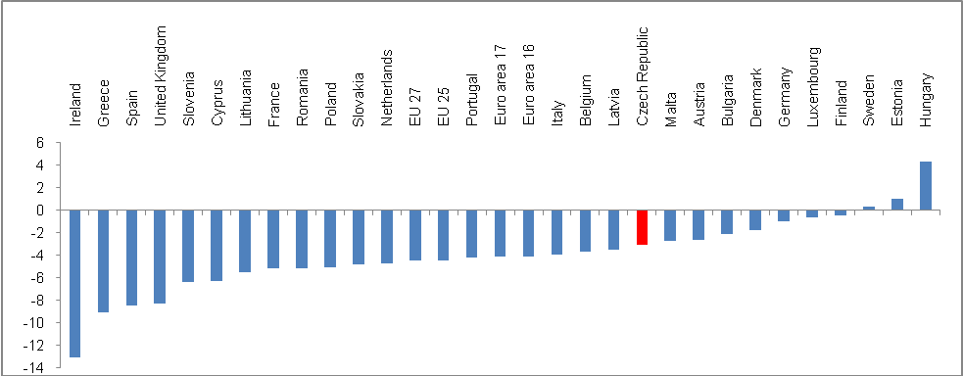
Source: Eurostat

    - Government gross consolidated debt

- Czech government sector debt is the highest in history in both nominal and real terms… |  | For the first time, the government gross consolidated debt of the Czech Republic exceeded the threshold of two fifths (41.9%) of nominal GDP in 2011 and in this relation was the highest since 1995. Against 2010, the consolidated debt increased by 3.1 p. p., which represented a year on year increase by billions of CZK. In 2000, the government sector debt of the Czech Republic was only 17.8% of nominal GDP, which represented the fourth lowest debt of all EU-27 countries (after Estonia, Luxembourg and Latvia).
- … but in the European context in relation to GDP, the Czech Republic is among the least indebted countries |  | However, in the context of the large relative debts of European countries, even in 2011 the Czech government debt represents the seventh best figure (after Estonia, Bulgaria, Luxembourg, Romania, Sweden and Lithuania). As is apparent from the list of the countries given above, Bulgaria and Sweden have significantly improved their relative indebtedness to 16.3% and 38.4% of GDP respectively, while in 2000 the debt of Bulgaria was 7.5% of its GDP back then and 53.9% in case of Sweden  However, the Czech government debt has been constantly increasing since 2009, following approximately the same trend as the gross debt of the EU-27.
- In the period of strong growths, the EU-27 as a whole reduced debt faster; the relative position of the Czech Republic in the ranking of the countries by indebtedness declined despite strong prosperity |  | If we examine the development of the relative debt of the Czech Republic (i.e. gross debt/GDP) by the place that the country occupied in the European ranking, it is clear that the strong prosperity of the Czech economy in 2005–2007 meant that the Czech Republic lost its position as one of the least indebted countries among the EU-27.  However, it also means that the majority of the EU countries managed to achieve better economic results in the period of strong growth – their governments reduced their deficits faster, at such a pace that in 2007 and 2008 only eight and nine countries of the EU respectively, had higher relative debt than that allowed by the Maastricht criterion. Although the situation was not as positive as in the beginning of the decade when only six EU countries had over-limit debt in 2000 and 2002, it was much better than in 2009–2011 when more than half of the EU countries reported higher debt than is permissible under the rules of the Maastricht Treaty. The position of the Czech Republic in the ranking improved with moderate worsening of the position in 2011.
Chart No. 21 | Gross consolidated debt of the government sector to nominal GDP (in %) |  | Chart No. 22 | Position of the Czech Republic regarding the debt of EU-27 countries EU-27 (by gross consolidated debt /GDP at c.p.)
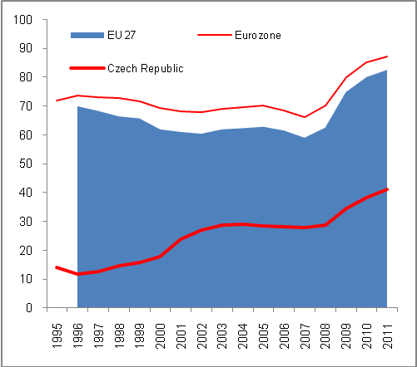 |  |  | 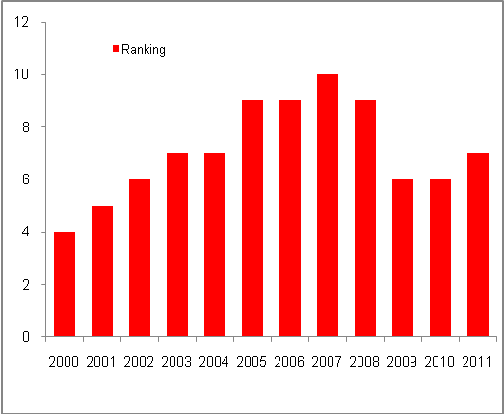
Source: Eurostat, own calculations

- Government sector debt of the Czech Republic rises irrespective of the movement of nominal GDP… |  | As shown in Chart 20, in 2008–2011 the government sector debt rose irrespective of the GDP development. Significant surge of the deficit increasing the debt was a logical result of the crisis development of the economy in 2009. However, the gross debt rose significantly even in 2010 and 2011, and in spite of moderate reduction of deficits; these deficits were too high to reflect positively on the amount of gross debt of the Czech Republic.
- … and in 2011 during nominal growth of economy by 0.9% the debt of the Czech Republic rose by 9.1% |  | The above-mentioned Chart 20 shows the development of GDP and the debt of the Czech government sector in nominal terms. The development in percentage increases then shows that during decline of the Czech economy in 2009 by GDP at c.p. by 2.8% the gross debt rose year on year by an extreme 16.4%. In 2010, during the post-crisis recovery (The nominal GDP rose by 1%) the dynamics of gross debt dropped to +11.7%, however this still represented very strong year on year growth of the government debt. When GDP at c.p. actually recorded a year on year stagnation in 2011 (+0.9%), the Czech government gross consolidated debt rose almost by one tenth (+9.1%).
- Gross government debt increased to CZK 156.8 billion in 2011, and 79% of the debt consists of securities with long-term maturity |  | The debt of the Czech Republic in form of a government gross consolidated debt rose by CZK 131.2 billion in 2011 and exceeded CZK 1.5 trillion (CZK 1567.8 billion), which is logically the highest debt in history of the country. However, as a result of harsh restrictions the increase of the debt stood lower than in 2010 (+151 billion Czech koruna) and even against 2009 (+181.2 billion Czech koruna). It goes without saying that the increase of government sector deficit reported record values in the crisis year of 2009.  By vast majority, the debt consists of issued debt securities (CZK 1388.2 billion, that is from 89%), and bonds with long-term maturity (CZK 1243.8 billion), that formed 79% of the total government sector debt in 2011.
- Growth of the debt of central government and stagnation of the debt of local governments in the structure |  | The central government (state budget) has long significantly contributed to the aggregate of the government gross consolidated debt of the CR. According to the state budget current performance, the reduction of budget expenditures is accompanied by problems on the income side caused both cyclically and by structural balance. As opposed to central government debt, local government debts are much lower (CZK 98.9 billion in 2011 compared to CZK 1470.5 billion) and their debt shows only slight year on year changes (See Chart 25).
Chart No. 23 | Debt of selected countries (gross government debt (GDP at c.p., in%) |  | Chart No. 24 | Gross consolidated government debt of the CR and GDP (in million CZK)
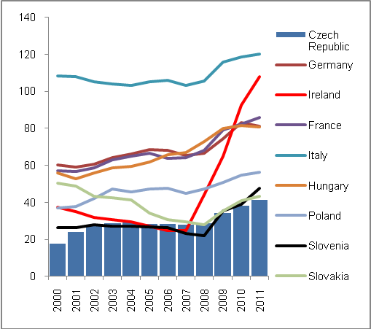 |  |  | 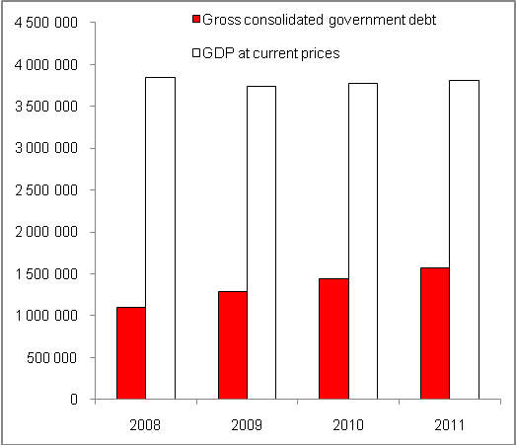
Source: CZSO

- Debt of the central government rose to CZK 1470.5 billion, the debt of local governments to CZK 98.9 billion | The central government gross consolidated debt rose by CZK 128 billion in 2011 and reached CZK 1470.5 billion. Despite the fact that it did not represent such a strong increase as in 2009 and 2010 (CZK +173.8 billion and 153.1 billion respectively), this increase rose the debt of the entire government sector decisively to CZK 1567.8 billion.  The contribution of local governments to the growth of the debt of the entire government sector was almost CZK 100 billion in 2011 (CZK 98.9 billion) and its amount rose by CZK 2.2 billion against 2010. On the contrary, in 2010 the debt of local governments dropped year on year by two billion, as in the crisis – with the need to pay more social benefits in the competence of municipalities – on the contrary the debt of local government rose year on year by 6.8 billion in 2009.  As opposed to government subsectors, the gross debt of social security funds is insignificant, in 2011 it was merely CZK 0.076 billion. While having been on decline in 2009 and 2010, the debt rose by CZK 0.052 billion in 2011 and contributed to the growth of the government gross consolidated debt of the Czech Republic already by CZK 52 million in total.
- Interest from gross government debt remained on the same level in 2011 as in 2010, i.e. CZK 53 billion and 1.4% of GDP | Debt service requirements can be described as the risk of the bonds issued related to their placement on the market (Apart from institutional investors, the Ministry of Finance started allowing purchase of government bonds also for individual investors in 2011), and also as the price that must be incurred in a form of interest costs to issues of securities by government sector.  In spite of high increase of the government sector debt of the Czech Republic, the issues of bonds were successfully placed both in 2010 and 2011 while being demanded by foreign investors mostly. The debt service in a form of consolidated interests remained practically on the same level (53 billion) in 2011 as in 2010 (53.1 billion Czech koruna). The ratio of interests in relation to GDP also remained the same (1.4%).

Chart No. 25 | Structure of the deficit (in billion CZK, in%); 2008 (internal circle) and 2011 (external circle) | Chart No. 26 | Development of the debt of Czech government sector units (in million CZK)
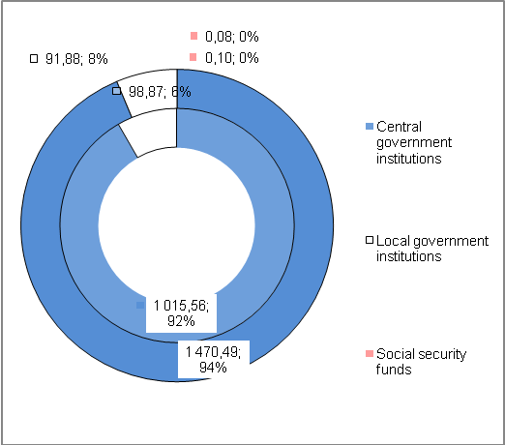 |  | 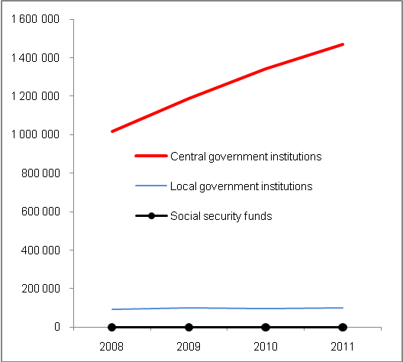
Source: CZSO

- Interest/deficit ratio |  | The interests paid from the government sector debt increased year on year from 40.4 to CZK 48.4 billion in 2009 and by another 4.7 billion to 53.1 CZK in 2010. If we compare the volume of these interests with the size of deficit in each of the years, they represented more than one fifth of the deficit (22.5%) in 2009, and almost one third (29%) in 2010 and almost one half (45%) of the government sector deficit in 2011. However, we should remember that the deficit has been on steady decline, but the debt has grown with debt service requirements, which were also naturally affected by the development of the above-mentioned interest/deficit ratio.
Chart No. 27 | Debt service costs and government sector deficit (in billion CZK) |  | Chart No. 28 | Interest to deficit and interest to nominal GDP ratios (v%)
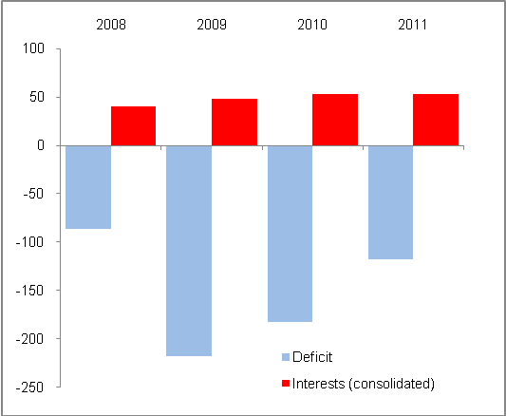 |  |  | 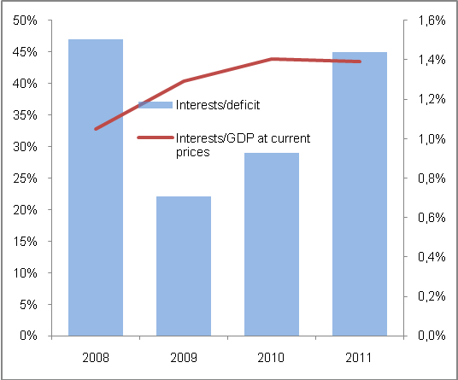
Source: CZSO, own calculations

    - Private debt, public tenders, state aid, guarantees and social benefits

In connection with internal imbalances related to government sector, there are also less frequent sectors generating these imbalances or contributing to their intensity. However, let us also compare the level and development of the debt of private entities that together with the gross debt and government sector deficit gives a picture of the country debt.

      - Private sector debt

- Private sector debt of the Czech Republic rose to the highest level in history in 2010… | The private sector debt may be defined as liabilities of other institutional (other than government) sectors, that is, of non-financial enterprises, households and non-profit organisations serving households. Based on the data of Eurostat comparing such debt in relation to nominal GDP, the private sector debt of the Czech Republic increased according to available data to 71.6% in 2010 and was the highest in time series since 2003, since when the data are published for the Czech Republic.
- … but in European context, it is practically the lowest of all countries | However, the private debt of the Czech Republic in relation to GDP (71.6%) belongs among – despite its growing share resulting from rapid surge of loans provided to households – the lowest in Europe. The only lower relative debt was reported by Slovakia (69%) in 2010 while Poland was practically on the same level (71.1%). In European context, these figures are extremely low (Please see Chart 29). For example, Ireland would need up to the three times value of its nominal GDP generated in 2010 to redeem its private debt. The same applies to Cyprus.  It is clear that reasons behind the high private sector debt in different countries may lie in loan expansion of countries that develop from lower costs (Bulgaria with corporate loans) or the other way around, in countries where households have accumulated debt over the last decades (In particular, the developed EU-15 countries states with a long tradition of taking loans). But e.g. the data concerning the private debt in the United Kingdom, where significant debt of households given the tradition of acquisition of houses through mortgages may be expected, are not available in Eurostat tables in the time series, while the above-mentioned thesis would be the most self-evident for this particular country.  In 2010, the Baltic states, Sweden, Belgium, Denmark or Germany managed to decrease the private sector debt. On the contrary, the Czech Republic belongs to countries whose private debt has increased and is growing over time (Chart 28).

Chart No. 29 | Private debt of selected countries (in % GDP in c.p.) | Chart No. 30 | Private debt of EU-27 countries in 2010 (in % GDP in c.p.)
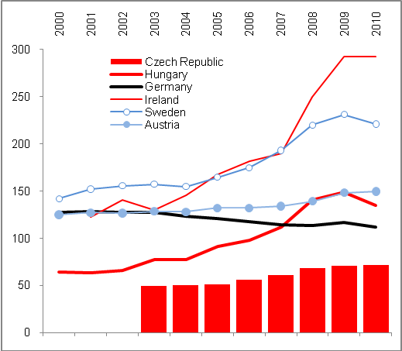 |  | 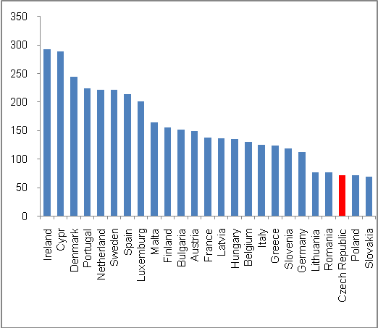
Source: Eurostat

- Causes of the growth of private sector debt in the Czech Republic | In the Czech Republic, the private sector debt grows predominantly as a result of debts of households that particularly in 2002–2008 used loans for housing on a massive scale. The debt of non-financial enterprises in the Czech Republic has not developed expansively, both by effects of the economic cycle phase (however, even in years of strong prosperity the loans provided to business did not grow as fast as loans provided to households) and by alternative forms of financing that have developed extensively in the Czech Republic and that are mostly used by exporters.
- Relation of the government debt to private debt | There are countries with significant disproportion of government and private debt. In Sweden where the government debt in relation to GDP is very low (39.4% GDP) in the European context – when the country has one of the few reported surplus economic results of the government sector in the past decade – on the contrary in 2010 the private sector debt exceeded by 2.2 times the Swedish GDP level, which manifests intensive private sector debt. A similar situation can be found in Slovenia (Chart 30).
Chart No. 31: Gross consolidated government debt and consolidated private debt of EU-27 countries in 2010 (in % of nominal GDP)

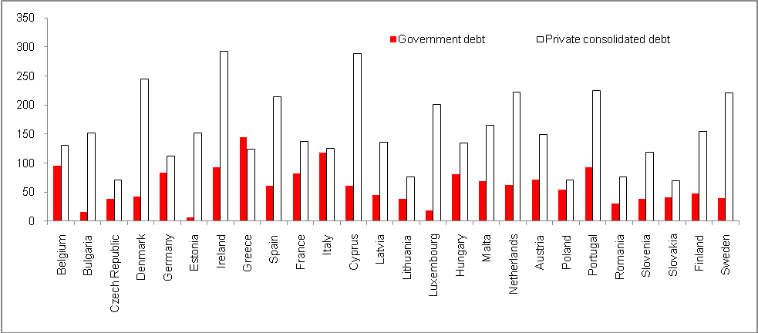
Source: Eurostat

- In 2010, the Czech government and private debt was the second lowest in Europe | When analysing the government debts and private debts, not only is there an issue of their mutual proportionality, but also an issue of the size (aggregate) of the total debt for both sectors. Regarding the combination of government sector debt and the debt of other (private) sectors, the Czech Republic is among the countries with the lowest “complex” debt in the European context. Its government and private debt made up only 109% of nominal GDP in 2010 (see Chart 31). The only lower debt in the EU-27 was reported by Romania (107.2%) and only Slovakia and Lithuania were within the same group, i.e. with government and private debt up to 110% GDP.  Ireland, having an extreme aggregate debt (385.3% GDP), is a high risk country with regard to a continuous recession it cannot escape and failing to either partially redeem the debt by faster growth or prevent its escalation. On the other hand, Greece and Italy – which have, as a result of the high debt of their governments, become a synonym for “European Sovereign Debt Crisis” confronting the Eurozone throughout 2011 – are in the ranking in the second quarter of the countries with the highest complex debt (with 269%, 244% GDP respectively). From this perspective, even Portugal has more debt (318% GDP).

- Very positive state of imbalance and growth | As far as imbalances are concerned, it can be said that the Czech growth is saturated by both government debts and private debts to a much smaller extent than in other EU-27 countries.

Chart No. 32: “Complex” debt of EU-27 countries in 2010 (gross government debt plus consolidated private debt; in % of nominal GDP)

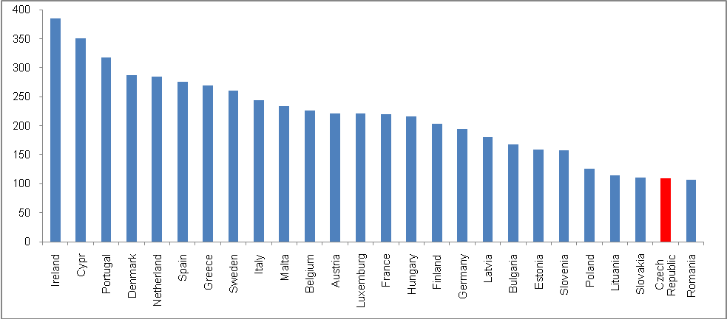
Source: Eurostat, own calculations

3.1.3.2. Public tenders
- Value of the Czech public tenders announced in relation to GDP higher than in EU-27…, |  | In 2011, the value of public tenders that were publicly announced stood at 5.6% of the nominal GDP in the Czech Republic. This was more than the EU-27 average (3.6%). This proportion was very low in 2004 and 2005 (0.4%, and 2.7% of GDP), which was less than the above-mentioned European average (2.6% in 2005, in the EU-15 as little as 2.7% in 2004). However, from 2006 the value of public tenders started to rise rapidly, also with regard to the fact that GDP grew significantly as well, therefore the public tenders announced grew even faster.
Chart No. 33 | Value of public procurement (in % GDP at current prices) |  | Chart No. 34 | State aid in CR and EU-27(in % GDP at current prices)
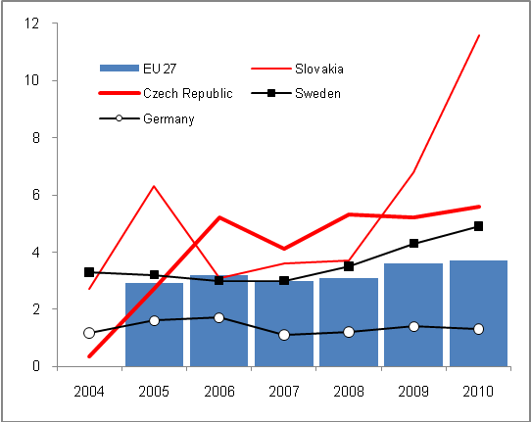 |  |  | 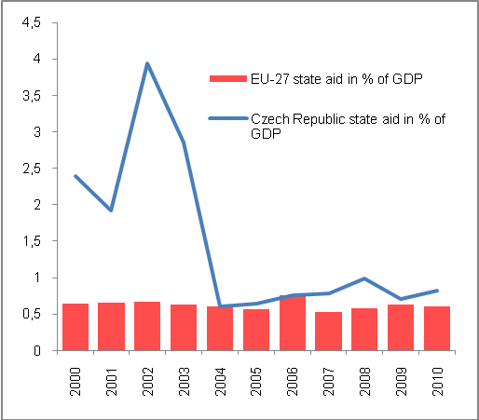
Source: Eurostat

- … but significantly lower than in fast-developing countries | This fact can partially be interpreted as follows: the government sector started to announce more and more new tenders, which could be understandable with regard to the boom in Europe. Moreover, in the European context their proportion to GDP was the highest in the countries whose economies were prosperous in 2010; the value of public tenders in Slovakia reached 11.6% of GDP in 2010, 10.4% in Estonia, 11.5% in Latvia and 8.5% in Poland.  On the other hand, in the long-term the value of public tenders in proportion to GDP is relatively low in Germany (in 2010 it was 1.3%, the lowest figure in the EU-27).  On the contrary, the value of public procurement in proportion to GDP is surprisingly high in the UK in the long-term (from 1993 to 2010 this relationship had been at 4.3% annually, 6.2% in the crisis year of 2009 and 6.5% in 2010). This policy is a result of an effort to stimulate the economy through investments financed by the government sector.

      - State aid

- Average expenditures for state aid in 2000–2010 higher than for EU-27… | The state aid item that can be found in the Eurostat statistics concerns the government sector deficit, as it is one of the factors increasing expenditures. As shown in Chart 34, the Czech Republic was among countries with a relatively high share in relation to GDP in 2000–2010 (1.37%). It was approximately 2.5 times more than the average for the EU-27 in this period. Costly state aid after the catastrophic flooding in 2002 significantly contributed to this figure.  However, after 2002 the share of state aid in relation to GDP has been declining significantly, and until 2010 the Czech Republic had spent on state aid from the government sector relatively the same amount as the EU-27 in aggregate (Chart 33). It is also clear from Chart 34 that there was a change concerning state aid in relation to GDP in 2010 against the average share in 2000–2010.
- … in 2010 significantly under the EU-27 average | In the long run, the Czech Republic has been one of the countries with a high share of state aid in relation to GDP (1.37%), but at the same time according to data for 2010, it is among those states whose aid was relatively significantly under their long-term averages in 2010 (0.82% GDP). In the Czech circumstances, this came about by budget restrictions, which were in a year on year comparison significant particularly in 2010. On the contrary, the EU-27 as a whole reported slightly higher state aid in relation to GDP than the long-term average in 2010.

Chart No. 35: State aid in relation to nominal GDP (EU-27 countries, in %)

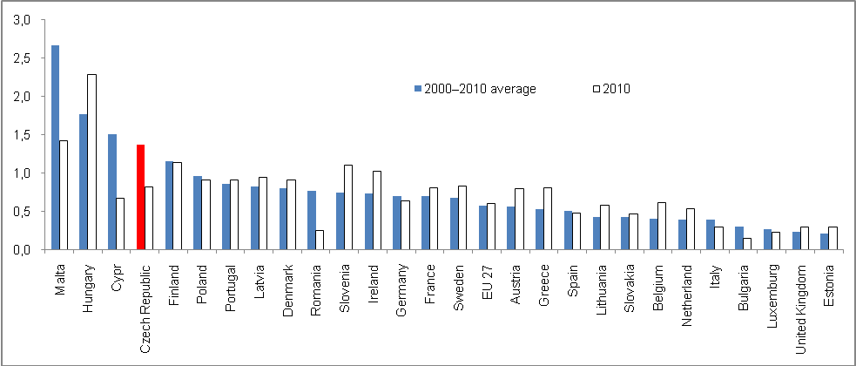
Source: Eurostat

      - Guarantees

- Guarantees provided by the government of CR are among the highest in the EU | Although data concerning the volume of guarantees of the government sector in relation to GDP are not available for all countries in the European context, it follows from the accessible sample that the government sector of the Czech Republic provided guarantees of 8.2% of nominal GDP in 2010. Since 2008, this ratio has increased in the Czech Republic (from 5.4% in 2008 to over 6.6% in 2009). In 2006, the guarantees of the government sector were 6.6% of nominal GDP.  There was a rapid increase of government-provided guarantees in e.g. Belgium (from 1.8% of GDP in 2006, when Eurostat data became available, to 21.3% in 2010), which was possibly a result of guarantees provided to banks in this country. The Czech Republic did not have to prop up healthy and well-capitalized banks in the country from government sector funds, but the amount of guarantees provided has been relatively high in the entire period – already in 2006 their volume was 6.6% of GDP and, as mentioned above, this was the second highest relationship after Malta (11.5%). Also in 2010, the Czech Republic was among the countries with the highest relative share of government-provided guarantees after Malta and Belgium. The governments of Slovakia and Estonia with the lowest volume of state guarantees in relation to GDP applied a different “guarantee” strategy (0.1% and 0.2% respectively).

      - Social benefits

- The amount of social benefits in relation to GDP paid in the Czech Republic is below both the EU and Eurozone average | The relative amount of social benefits in the Czech Republic, i.e. the amount paid in relation to nominal GDP, is below average in the European context – in 2011 it was 14% in the Czech Republic, while it stood at 16.7% in the EU-27 and 17.4% in the Eurozone. This has been the case for the whole period since 2000 (Chart 36). The same logic is followed by their decrease or their significantly lower dynamics respectively, pursued as part of restrictive measures by the Czech government aimed at further enlargement of the gap as opposed to the development in the EU.  Chart 36 also shows that social benefits in Greece, which had followed the same dynamics in relation to GDP as in the EU-27 until 2004, saw a rapid change in pace following this year and were the highest in Europe in 2011. There was a year on year increase despite harsh budget restrictions dictated by the European Commission, the reason being that Greek GDP dropped sharply, which also changed the relevant proportion of social benefits.

Chart No. 36 | Guarantees provided in relation to nominal GDP (in %) | Chart No. 37 | Social benefits paid in proportion to nominal GDP (in %)
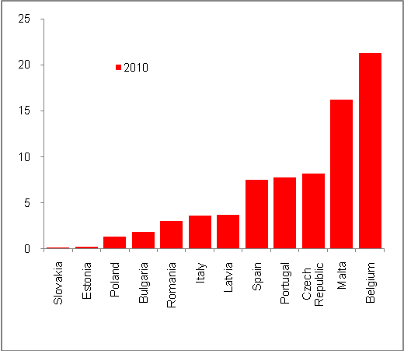 |  | 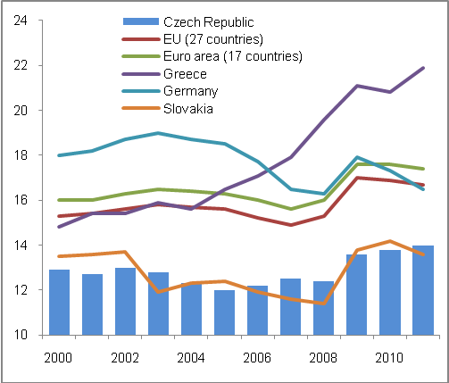
Source: Eurostat

    - Imbalances with institutional sectors

- Sector surpluses and deficits | Surpluses and deficits of individual institutional sectors are a result of the relationship between their source and utilization in a given year (the situation in the Czech government sector was discussed earlier in this chapter).
- Significant worsening of government deficits due to the sovereign debt crisis in the Eurozone | In the time series of 2000–2010, the government sector of EU-27 and Eurozone reported a deficit in their economic results in each year. In 2008, only six, mostly Scandinavian countries, posted surpluses. In 2010, a moderate surplus was reported only by Estonia. A sharp drop into deficit was recorded by Germany in 2010, which reported a deficit of a mere 1.4 billion euro in 2008. However, in 2009 Germany reported a deficit of as much as 76.1 billion euro and in 2010, when the debt-related problems of the Southern countries of Europe began and subsequently support from other countries in the Eurozone was provided, the German deficit exceeded the threshold of 1 hundred billion euro (106 billion).
- Deficit follows the same trend as the rest of Europe | The economic results of the Czech government sector showed a sharper drop than in Hungary or Slovakia, but lower than in Austria, which is a member of Eurozone and is affected by the requested support (contributions to EFSM, a fund ready to saturate the budgets of the most jeopardized countries).
- Surplus in the sector of non-financial enterprises and reasons behind it | Following the permanent deficit of the sector of non-financial enterprises, which can be understood as the “standard” position of the sector given the character of its activities (it uses third party lending sources), the sector reported in both the crisis year of 2009 and the post-crisis year of 2010 a surplus in its economic result. The same situation occurred in the non-financial enterprises sector in the European context.  While under usual circumstances a business uses working capital and makes investments, in periods of depression or slump of activities, this “normal” use of resources undergoes some changes. In the Czech Republic, the sharp drop of foreign demand particularly in the last quarter of 2008 and subsequently in 2009, was responsible for the decline in industry and later also for stagnation of services. Businesses did not need as much working capital as during periods of strong prosperity and, fearing future developments, they stopped making investments. This resulted in the surplus of resources that would have been used (invested) under different circumstances.  The fact that this situation lasted also into 2010 can be evidenced by yet another surplus reported, despite the fact that it stood at 2/3 of the figure for 2009. On the contrary, in the EU-27 the surplus of the sector of non-financial enterprises posted a year on year growth. This can be explained by the significantly greater uncertainty of the European economy, particularly the economy of the Eurozone shaken by fiscal problems arising from the debt situation. In the sector of non-financial enterprises, this crisis was reflected in the surplus reported.
- Financial institutions of the Czech Republic in surplus for the entire period of 2001–2010, although moderate in 2009 and 2010 | The economic result of the financial institutions sector in the Czech Republic has been positive for the entire monitored period. The recorded surpluses of resources over their use were highest in the first years of the last decade, in the period that saw the so-called credit-crunch that dampened the volume of client loans provided. In the Czech Republic, significantly higher surpluses were achieved by financial institutions in the period of subsequent boom. This can be explained by the saturation of the economy by financial resources with regard to the sector and their utilization.  Consequently, the crisis period in 2009 resulted in the decrease of surpluses. Even with a lower volume of client credit (the loans provided to non-enterprises even recorded a year on year drop), the financial institutions in the Czech Republic had enough opportunities to place their funds, particularly by purchasing securities issued by the Czech state to cover its high deficit.  Even during the financial crisis, the financial institutions of the EU-27 countries reported on the whole economic results with a surplus of resources that was even higher than before the crisis. This can again possibly be explained by the fewer opportunities for risk-free placement of these resources.

Chart No. 38 | Surpluses and deficits of the institutional sectors in the CR (net loans (+)/net borrowings in million CZK) | Chart No. 39 | Deficits in total economy (in billion EUR, net lending(+)/net borrowing (-))
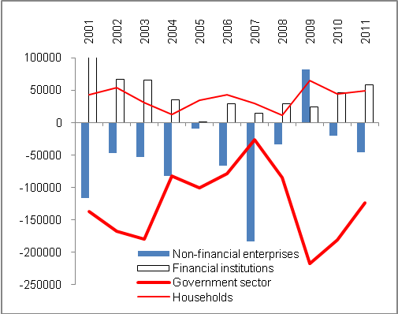 |  | 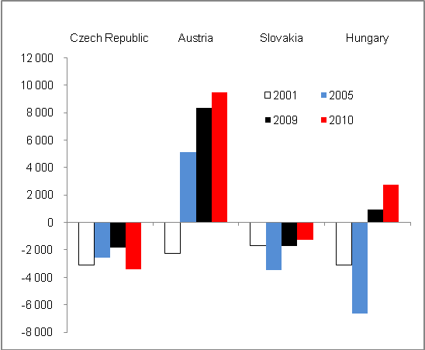
Source: Eurostat

- The surplus of households was influenced by legislative changes in the crisis year of 2009 | According to the revised time series, households posted surpluses for the entire monitored period, despite the fact that by massive purchasing of non-financial activities, mostly by investments into housing, the level of their liabilities was increased. In spite of this, the growth of components of their gross disposable income, i.e. particularly salaries and wages, but also net income from ownership, gross operating surplus and mixed income of entrepreneurs, income and balance from redistribution, managed to exceed the use of these resources. In 2009, the surplus of the household sector was the highest since 2000 as a result of legislative changes (introduction of equal tax, changes in tax-deductible fixed expense for entrepreneurs and so on), particularly in the sphere of redistribution which allowed households to dispose of more money (that is, changes in their income and expenses in relation to the government sector).  In the European context, there is generally rather an excess of resources over their utilisation, despite the fact that six countries of EU-27 reported a deficit in 2010 and four countries in 2009. In the long-term, deficits have been reported by households of poorer EU countries (Romania, Bulgaria, Lithuania), but also by households in Finland, the Netherlands and Greece.
- Mutual ability to finance | In aggregate, in the long-term the financial institutions and households have been able to finance by their surpluses those sectors, which recorded deficits in their economic results in the monitored period (government sector) or at least for many years in the times series of 2000–2010. The crisis of 2009 and continuing uncertainty in 2010 were responsible for surplus in the sector of non-financial enterprises.

  - External imbalance

External balance or imbalance of the economy is caused by the combination of inbound and outbound cash flow combinations. The statistics given in the balance of payments provide such information. The parameter to assess whether or not the country is deviating from an external balance, and to what extent, is a proportional indicator of the balance of payments current account and nominal GDP. The second parameter is a mutual comparison of results (balances) of the most important components of the balance of payments and the ability to compensate deficits by surpluses achieved.

    - Deficit of the current account of balance of payments

- Imbalance improved in 2011 | The external imbalance of the Czech economy measured by the deficit of the balance of payments current account to nominal GDP improved in 2011. This ratio reached 2.9% of GDP at c.p., which was less than the average for the previous five years (3.1%) and even for the period of 2000–2011 (3.7%). There was also a year-to-year improvement, as the current account reached 3.9% of nominal GDP in 2011.
- Unfavourable development of external relationships in the beginning of the last decade, i.e. in 2000–2004… | When looking at the development of external imbalance in the last decade including 2011, it is clear that the ratio of current account deficit to GDP at c.p. was less favourable in 2000–2004 when it was mainly affected by a negative trade balance. Its development was influenced by massive imports of investments in connection with the development of foreign-controlledforeign-controlled. These equipped their newly acquired capacities with technologies, and a transition to a strong expert orientation was achieved through them affecting the structure of economy – either by establishment and the strong impact of foreign-controlledforeign-controlled in the Czech economy, and by new ties to domestic suppliers, or by their increasing intensity respectively.
- … was replaced by improvement following the accession to the EU and high export orientation of companies led by foreign investors in the Czech Republic | For the above-mentioned reasons, a significant deviation from the external balance of the Czech economy occurred in 2000–2004 when on average the balance of payments current account deficits reached 5.2% of nominal GDP in annual average.  Subsequently, there were several influences at work, which gradually improved the external balance. The entry of the country into the EU and the sharp increase of mutual ties, especially trading and related ones, resulted in a gradual improvement of trade balance. This was also achieved as a result of transformation movements with businesses under foreign control from the previous era. These, when the strongest wave of foreign imports wore off, started production mostly for export. To achieve this, they also used their ties to their parent companies based in countries from which these direct investments were made, or the global reach of some foreign investors respectively.

Chart No. 40 | Deficit of the balance of payments current account to GDP at c.p. (in %) | Chart No. 41 | Structure of the balance of payments current account (in billion CZK)
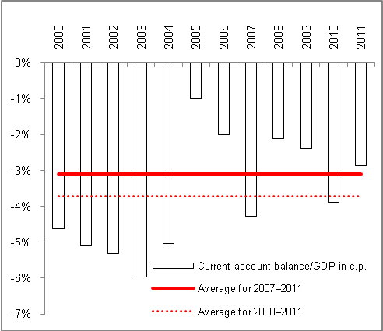 |  | 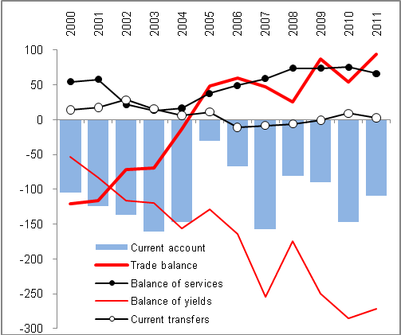
Source: CNB, own calculations

- Even in the “strong” year of 2007 the external balance worsened as a result of high repatriated income | In addition, it is clear from the time series that the external balance of the Czech economy worsened even in the year of the strong boom – in 2007 there was a slump in balance of payments resulting from an extreme balance of yields (Chart 39) caused predominantly by cash outflow in the form of repatriated income of businesses under foreign control operating in the Czech Republic. However, this was not caused by fear of upcoming risks related to the global financial crisis – as these dominated two quarters later – but rather by “pulling off” of high income generated in the Czech Republic in the year of peaking economic growth (in 2006, GDP grew year on year in real terms by 7%).
- In 2011, the yield net outflow was not less than in the record year of 2010…, | In 2011, the cash net outflow in the form of yields (CZK 271.9 billion) was not as significant as in 2010 (CZK 285 billion) when it reached the record level. Clearly enough, there was a classic cycle of direct investments in the Czech Republic. Until 2003, the reinvested income of foreign-controlled prevailed over the amount of dividend paid to foreign owners; in 2004 and 2005 their proportion was roughly equal. After that, investors started to transfer a higher share of their income to the parent countries.
- … but the outflow of the dividend itself was historically highest | If it were not for the increase of the surplus in the merchandise trading balance, undoubtedly this historically highest outflow of the dividend itself – although in aggregate the balance of yields was lower as a result of more favourable development with regard to employee compensations (foreigners working in the Czech Republic), the deficit of which was more moderate – would deepen the balance of payments current account of the Czech Republic also in 2011.

Chart No. 42 | Current account balance and its long-term average (in % of GDP at current prices) | Chart No. 43 | Contribution of current account components in the final balance  (in billion CZK)
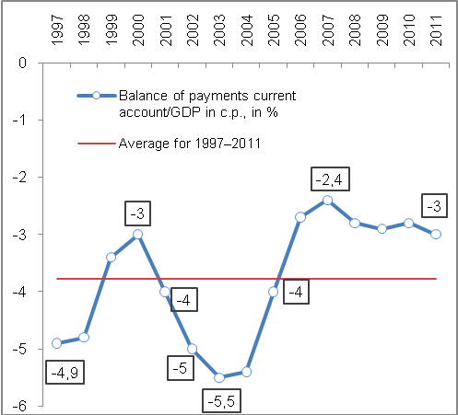 |  | 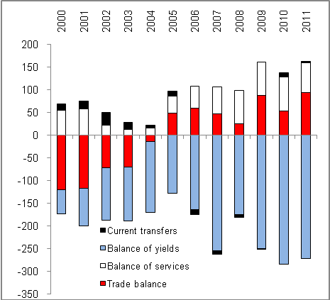
Source: ČNB

- In the long-term, the prevailing outflow of cash over the inflow despite relatively positive relative balance | The relationship of the Czech Republic towards foreign countries records deficit in the long-term, every year the outflow of cash from the country is higher than its inflow. This imbalance was first generated by merchandise-related trade balance deficits, and later – as the country was passing through the individual phases of the direct foreign investments cycle – particularly by outflow of cash in the form of dividend from income of companies of foreign owners achieved by their operation in the Czech Republic.  Contributions of each of the components of the balance of payments current account in the amount of deficit in 2000–2011 are illustrated by Chart 42. At the same time, the development of deficit of some current account components can be seen in the Chart as well, with their amount in relation to GDP being in aggregate – and the size of external imbalance of the Czech economy – relatively positive in the entire period.
- Against the countries compared, the external imbalance of the Czech Republic is stable, but it has not improved against Hungary, Slovakia and Slovenia | The ambivalence of the external relationships of the Czech Republic is not too high against some countries that it is traditionally compared with. As opposed to surpluses of the balance of payments current account to nominal GDP, which have not been achieved under Chart 43 by the Czech Republic like Germany or Austria, these relative deficits of the current account are less volatile than in Slovenia or Hungary, which managed to leave the negative zone in 2011 for the first time. As opposed to the Czech Republic, notably Slovakia has recorded a deeper external imbalance over the last 15 years. However, since 2007 Slovakia has been making gradual progress in this regard. (In 2011, the measured condition of external economic relationships in Slovakia was even better than in the Czech Republic, while Poland posted slightly worse results.)

Chart No. 44: Comparison of the external imbalance of selected countries (current account balance to GDP at c.p. in %)

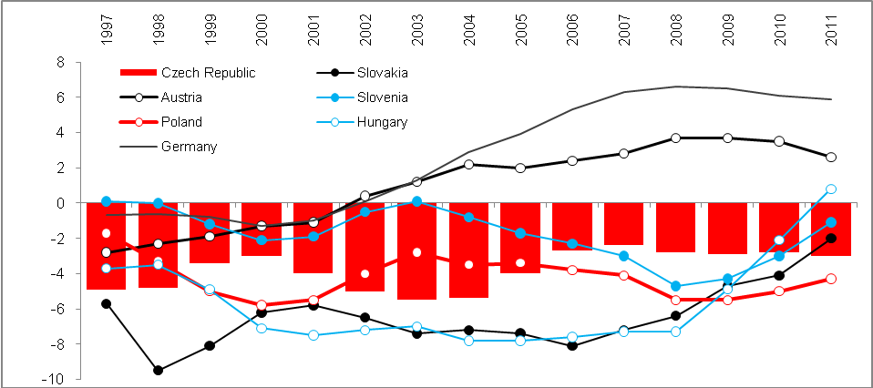
Source: Eurostat

- Convergence of the Czech Republic to average EU level

  - Real convergence

- HDP per capita in purchasing power parity by national accounts data (CZSO) decreased in 2010 | A complex look at the performance of the economy of the Czech Republic from socio-economic perspective through GDP per capita in purchasing power parity (PPP) according to data of the Czech Statistical Office from regional national accounts showed that following the permanent growth of relative position of the Czech Republic by GDP per capita based on PPP against EU-27 average that had been evident since 2001, there was a drop in 2010. Therefore, the trend shows that the Czech Republic trails behind regarding to the convergence to the EU average level.  GDP of the Czech Republic per capita based on purchasing power parity (PPP) according to data of the Czech Statistical Office derived from regional national accounts increased against the EU-27 average to 82.2% in the crisis year of 2009 from 81% in 2008 – therefore the Czech economy still converged to average economic level of the European Union. However, its relative position worsened in 2010, to 79.6%.

- Decline from relative position of CR regarding GDP per capita in PPP in the period of post-currency crisis…, |  | The decline from relative position occurred particularly in 1997–2000 when the Czech economy was recovering from the previous currency crisis having undergone a minor recession. Other European countries remained unaffected by this crisis therefore the reasons for imbalance in Europe were specific for the Czech Republic (significant excess of short-term foreign capital that was leaving the country over the short period of time and after years of recorded surpluses the state budget found itself in a significant deficit). Subsequent restrictions aimed to improve these imbalances were steps inhibiting growth.
- …Thus, in the period 1995–2011, the Czech Republic converged to average level only in 2001–2009 |  | Therefore, it can be said that in the time period of 1996–2011 the Czech Republic converged to the average European level under the time series devised by CZSO only in 2001–2009 when the second part of this successful wave represented the strongest boom of domestic economy since the independence of Czech Republic ever. It was a successful period with regard to the fact that the EU economy as a whole was growing as well.  However, as in the second half of 1990s the recession was a result of internal not external reasons, also in 2011, or already in 2010, the reasons consisting in the significant restriction of growth stimuli were behind the loss of dynamics of the economic development in the Czech Republic – the implication of which was the stagnating convergence.
- With regard to convergence, apart from the Czech Republic, unfavourable development was also recorded by Slovenia |  | Countries, the Czech Republic is traditionally compared with, especially in case of Poland and Hungary, were not losing with regard to convergence to the EU average level (Please see Chart 46). Similarly as in the Czech Republic, the convergence to the EU level is not convincing in Slovakia in recent years. The debt-related problems of Portugal were responsible for lower GDP per capita in PPP in 2011. On the contrary, the loss of Slovenia seems to be unchanged since 2009 – however from the monitored countries it holds the best position – it is also connected with the lost dynamics of Slovenian economy which was less than in case of the Czech Republic.
Chart No. 45 | GDP per capita based to purchasing power parity (in CZK, preliminary data for 2010 and 2011) |  | Chart No. 46 | GDP per capita with regard to purchasing power parity (PPP, EU27 average=100)
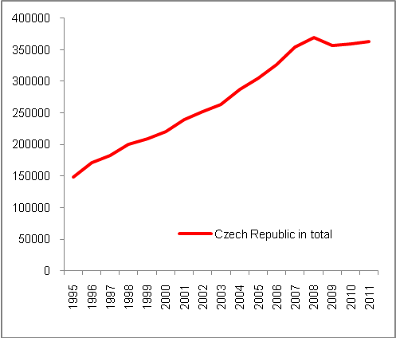 |  |  | 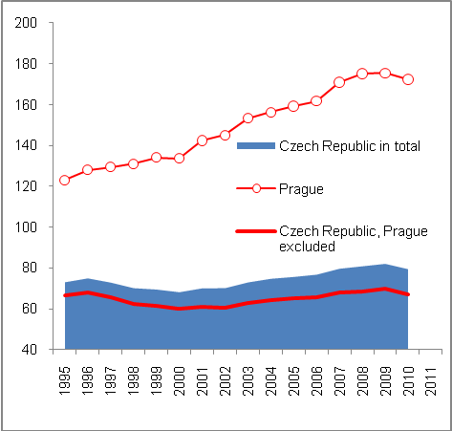
Source: CZSO, Eurostat

- Growth of GDP per capita with regard to PPP in Prague is responsible for convergence of the Czech Republic to EU average level in 1995–2010… | For the development of real convergence of the Czech Republic to the EU average level, a high disproportion concerning the development of GDP per capita in PPP in the capital city of Prague and regions as a whole is characteristic for the entire period of 1995–2010. While, according to CZSO, relative GDP per capita in PPP to the EU-27 average rose in 1995–2010 in Prague by 40 p.p. to 172.3%, in the Czech Republic, with Prague excluded, it rose by only 0.8 p.p. (67.1%). In total, the indicator for the Czech Republic increased by 8.7 p.p. and reached 79.6%.  The huge gap between Prague and the rest of the country can be explained not only by the level of income, the character of salaries and wages (the average nominal salary in Prague was CZK 36,000, while the average for the whole country was approx. CZK 24,000). According to CZSO experts specializing in regional GDP, natural regional disparities that have been previously suppressed are responsible for this gap (as well as for the people’s income). Another reason might be the fact that the regional level only catches up with the development at current prices where Prague due to industrial structure shows better dynamics (services at current prices grow while industry in other regions shows stagnation with regard to prices.). The effect of commuting for work is also significant as given its employment capacity Prague also absorbs a large number of workers from other regions. The employment of foreign nationals concentrated in Prague is also on the rise.
- … because on the whole, regions in the Czech Republic, Prague excluded, have not converged to the EU average level at all | Both the drop in GDP per capita in PPP in the capital city of Prague and in the regions as a whole, contributed to a discontinuation of the Czech Republic’s convergence to the average EU level seen on the whole national level in recent years. In the case of Prague, the term “convergence” is not an adequate one, because its GDP per capita with regard to PPP has been increasingly exceeding the EU-27 average (it was by one fourth higher as early as 1995). On the contrary, it is clear from Chart 45 that the Czech Republic, Prague excluded, has not made any progress regarding the convergence in 1996–2010: GDP per capita in PPP of the “rest of the country” remains at two thirds of the EU-27 average with 67.1% in 2010, while the proportion was 66.6% in 1995.

Chart No. 47: Development of real convergence by GDP per capita in PPP in selected countries (EU-27=100)

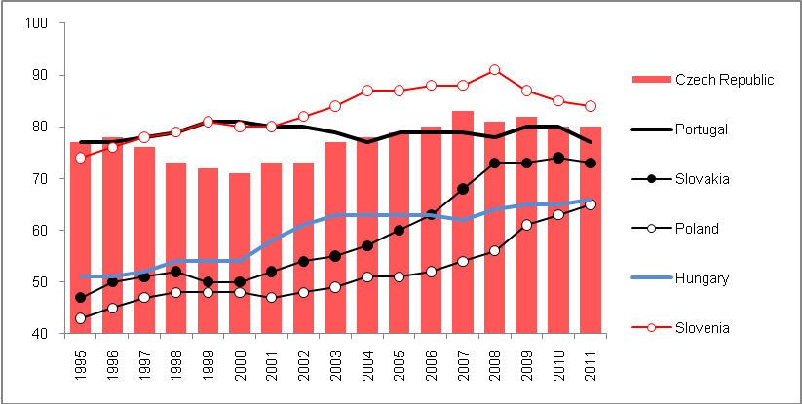
Source: Eurostat

- Regions outside Prague remained at two thirds of the EU-27 level in 1995–2010 |  | However, this does not mean that the development of regions outside Prague reflected in the comprehensive indicator of GDP per capita with regard to purchasing power parity was weak. In 2010, GDP per capita expressed in CZK stood at CZK 302,000 on average according to CSO, and compared to its level from 1995, it was 124% higher (for Prague, the analogical figures were CZK 777,000 in 2010 with growth of 211% against 1995). For the entire Czech Republic, GDP per capita grew in 1995–2010 by 142% to CZK 359,000. The stagnation reported in the convergence of regions outside Prague thus follows from the fact that the European average has been growing with the same dynamics. At the same time, the spread of regional GDP stands at approximately the European average.
Chart No. 48 | Disproportion of real convergence in Prague and the rest of the CR (GDP  per capita in PPP, EU27=100) |  | Chart No. 49 |  | GDP per capita in CZK
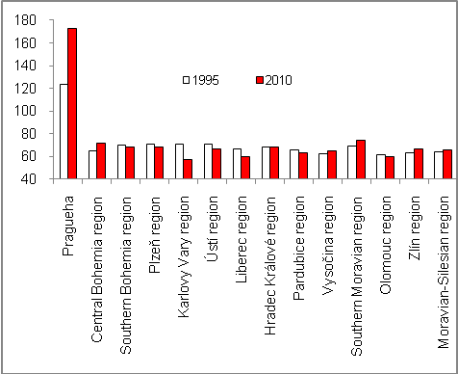 |  |  |  | 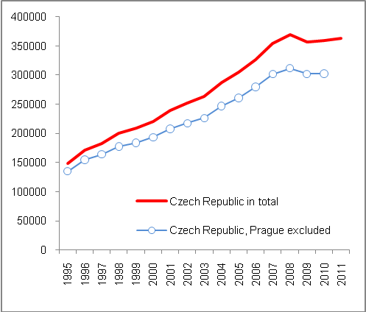
Source: ČSÚ

- In 1995–2010, besides Prague, only five regions had converged | With the exception of Prague, GDP per capita in PPP of which was as early as in 1995 almost by one quarter higher than EU-27 average (123.1%), less than half of the rest of the total of 13 regions converged in 1995–2010 (Chart 47).  The Central Bohemian region posted the most significant growth (from 64.7% to 71.6% of the EU-27 average), probably also a result of strong direct foreign investments. This was followed by the South Moravian region (from 69.4% to 74.5%) and also – by 3 p.p. or more – Zlín region (from 63.2 to 66.8%) and Vysočina region (from 61.9% to 64.9%). Regarding GDP per capita based on PPP, Vysočina region was in fact the region with the second lowest performance in the Czech Republic. The progress of Moravian-Silesian region (from 4.4% in 1995 to 65.9% in 2010) was insignificant, but still positive. The Hradec Králové region stagnated in real convergence (at 68.5%).  Other regions were trailing behind the European average in 2010 by more than in 1995. GDP per capita in PPP was slightly lower in South Bohemian region (from 69.6% to 68%), Plzeň region (from 70.5% to 68%) and Olomouc region (from 61.5% to 60.1%). A significant drop occurred in Pardubice region (from 65.5% to 62.9%), Ústí region (from 70.4% to 66.4%), Liberec region (from 66.9% to 59.5%) and particularly Karlovy Vary region, where this indicator dropped from 71% of the EU-27 average in 1995 – which earned the region the position of the second most economically effective region after Prague – to a mere 57.6% in 2010.

  - Nominal convergence

- Maastricht criteria for convergence | Convergence criteria for the European Union are determined by the Maastricht Treaty, and the fulfilment of these shows the success of the given country with regard to the so-called nominal convergence. The nominal convergence reflects whether or not its price development in the field of consumer prices significantly deviates from the price development based on the quantified data for development in EU-27. In addition, it reflects whether the country does not show in similar comparison a significant imbalance with regard to government sector deficit and its gross consolidated debt in relation to nominal GDP. Maastricht stability criteria also determine limits for the development of long-term nominal interest rates and exchange rate volatility of the relevant currencies.
- Long-term success of the Czech Republic regarding the nominal convergence | In the long-term, the Czech Republic has been – particularly in the first half of the last decade – among the countries that did not have significant problems with fulfilling the Maastricht convergence criteria. At the same time, it did not strive to join the Eurozone, as opposed to other Central European countries, which set their deadlines for acceptance of a single currency despite the fact that the volatility of their currencies, interest rates and consumer inflation indicated problems with nominal convergence (Hungary, whose government had an ambition to adopt the euro in the beginning of 2007, was a typical example).
- The crisis in 2009 and subsequent unconvincing performance of the economy did not significantly influence a satisfactory fulfilment of Maastricht criteria | An analysis from 2007–2011 (Table 3) shows that the economic crisis in 2009 and the rather unconvincing post-crisis development of the Czech economy reflected in the discontinuation of the real convergence (see chapter 4.1), did not negatively influence the fulfilment of the Maastricht criteria.  Surprisingly enough, the Czech Republic has fulfilled nominal convergence criteria since 2009, with the exception of the fiscal criterion (the proportion of deficit of the government sector to nominal GDP). Determining whether the Czech Republic also fulfils the criterion of stability of the CZK exchange rate is not possible, because the country is not yet a member of the ERM II system, in which the country must operate for at least two years before the anticipated deadline for the adoption of the single currency. However, given the fact that the volatility range (+15%/-15%) is relatively wide, it can be assumed that fluctuations in the CZK exchange rate have not exceeded this range in recent years.

Table No. 3: Nominal convergence of the Czech Republic – Fulfilment of Maastricht criteria (values in %)

 | 2007 | 2008 | 2009 | 2010 | 2011
Inflation criterion (HICP) in % | 3.0 | 6.3 | 0.6 | 1.2 | 2.1
 | No | No | Yes | Yes | Yes
Fiscal criteria

deficit (< 3% GDP in c.p.) | -0.7 | -2.2 | -5.8 | -4.3 | -3.1
 | Yes | Yes | No | No | No
debt (< 60% of GDP in c.p.) | 27.9 | 28.7 | 34.4 | 38.1 | 41.7
 | Yes | Yes | Yes | Yes | Yes
Stability criteria

Interest rates in % | 6.2 | 6.0 | 5.3 | 4.9 | 4.7
 | Yes | Yes | Yes | Yes | Yes
Exchange rate | The Czech Republic does not participate in the ERM II system.

Source: Eurostat, own calculations

- Competitiveness of the Czech economy

- Analysis narrowed down to selected parameters | Given the high number of parameters that might be used to assess the ability of any country to compete with other countries with regard to results of economic development, their range was narrowed for the purposes of this analysis. The competitiveness of the Czech Republic is monitored based on the price factor, that is, by the development of labour costs (particularly using changes in real unit labour costs). From non-price related factors, the support of sophisticated activities is chosen (relative expenses on research and development), then employment in knowledge-intensive activities and, last but not least, the share of population with a tertiary education degree. In addition, the development of the share of export from the Czech Republic in global export is monitored as a more complex parameter of competitiveness, in which both price and non-price related factors are joined together to some extent.
  - Change in the share of export of the Czech Republic in global export
- Increases in the exports share of the Czech Republic in global exports have been declining since 2004 as a logical consequence of extreme share increases following the accession of the Czech Republic to the EU |  | If we evaluate the competitiveness of the country based on its “ability” to strengthen its participation in global trade (export), we can use the indicator of its export share in the total value of global exports. Given the fact that year on year changes of these shares are very small, it is convenient to use the comparison for the given year, i.e. with the situation five years ago. The competitiveness of the Czech Republic regarding this indicator is evaluated through this prism.  In 2011, the decline of increases achieved in aggregate by exporters from the Czech Republic in the total value of global exports continued. In spite of this, it was still an increase, which was not the case for all European countries. In 2011, the share of the Czech Republic in global export increased by 9.3% against 2006, by 10.1% in 2010. However, in the year when the Czech Republic joined the EU and in the following years the share increases were, when compared to the level five years ago, very high – 44.1% in 2004, 42.1% in 2005, and also in 2006 and 2007 the growth was higher by as much as one quarter (26.6%, and 25.8% respectively).
- Very favourable factors influencing the share increase since 2004… |  | The potential connected with the removal of current barriers, constitution of the Czech Republic as one part of the single market together with a favourable time period when the country could benefit from the fact that the strengthened business segment started shaping significantly with regard to exports and all that probably increased the share of the the Czech Republic in global exports.
- … decreased intensity and increase of the Czech Republic share’s in global export as in other European countries |  | However, over time these effects have been gradually and logically weaker and the Czech Republic’s share in global export has declined. This phenomenon was seen by Hungary, however, as early as 2011 and Slovakia in 2007. It has been seen also by such a strong economy as Germany, whose trade surpluses are generated mostly by strong export, which recorded a decline in its share in global export. Since 2008 the share has been on a steady decline (Chart 49).  These changes must be understood in the context of the changing proportions of the trade on a global scale and are predominantly influenced by the export expansion of China and many other Asian economies, but also fast-growing economies in other parts of the world. Despite the fact that the “European” export records growth, it is not sufficient enough to combat the competitive edge of the above-mentioned countries, which consists mainly in their low cost of labour (for example, in China employees and employers are not subject to social and health insurance contributions, though this should change according to the new budgetary policy of the country).
- Competitiveness by the increase of share maintained by most of the “new” countries, drops in the case of Germany |  | In spite of declining increases of its share in global export, the Czech Republic managed to stay among the group of EU-27 countries in 2011 that achieved an increase (Chart 50), together with Estonia, Poland, Bulgaria, Slovakia, Romania, Latvia and Lithuania. However, the position of the Czech Republic, and Slovakia as well, cannot be evaluated against other countries in the group as a “better one", as these are countries with a strong export orientation (highly open economies). Maintaining their position, or a steady increase of their share – even though to a much smaller extent than in the past – can be seen as very positive (other countries may benefit from lower comparison base with regard to the dynamics of the positive change of this share.
Chart No. 50 | Change of share in global export of goods and services (year Y against Y-5; in %) |  | Chart No. 51 | Change of share in global export of goods and services (2011 against 2010, in %)
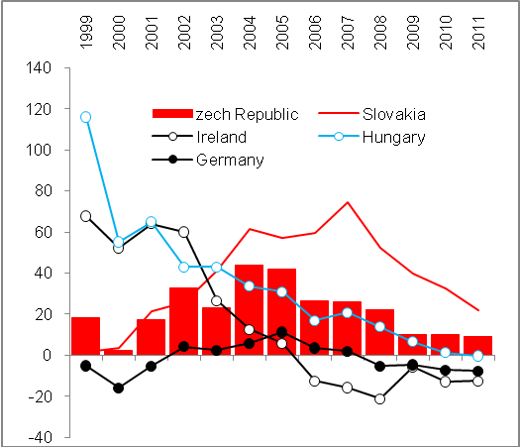 |  |  | 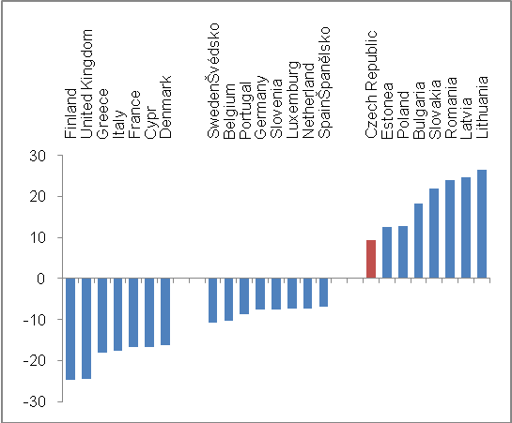
Source: Eurostat

  - Cost competitiveness by labour costs

- By real unit costs of labour, labour costs have risen most in the Czech Republic in 1995–2011 of all EU-27 countries… | By real unit costs of labour – i.e. by product intensity for wages and workforce-related costs – the Czech Republic is in the EU context among the countries with the highest increase.  In 2011, the increase of real unit costs of labour in the Czech Republic when compared to 1995 was the highest in the EU-27, when the index stood at 111.5. Apart from the Czech Republic, the increase for the given period was also achieved by Slovakia (104.4), Denmark (104.1), the United Kingdom (102.3), Malta (101.5) and France (101.2).
- And resulted in the loss of cost competitiveness | In most of the EU-27 countries, the real unit costs of labour for 1995–2011 dropped, most significantly in Poland, Hungary and Spain. This can be interpreted as follows: the cost competitiveness expressed by the change of real unit costs of labour in these countries recorded the largest increase with regard to this indicator. As a matter of fact, the competitiveness of the Czech Republic decreased according to this indicator. On average, the real unit cost of labour in the EU-27 decreased (94.9), in the “old” countries of the EU (EU-15) more moderately (96.6) and more significantly still in the Eurozone (95), while this change was influenced by a more significant drop in Germany as an economy with the strongest impact on calculations of European averages (94.4), in Ireland (93.8) and Austria (92.6).
- Risk connected with keeping labour cost low | However, when evaluating the loss of cost competitiveness of the Czech economy with regard to the highest real unit costs in EU-27 in 1995–2011, we cannot generalize that this is a negative phenomenon. In the long-term, keeping labour costs low would lead to lagging in the social and economic area (despite the weakening of household demand).

Chart No. 52: Real unit costs of labour – change as of 2001 against 1995

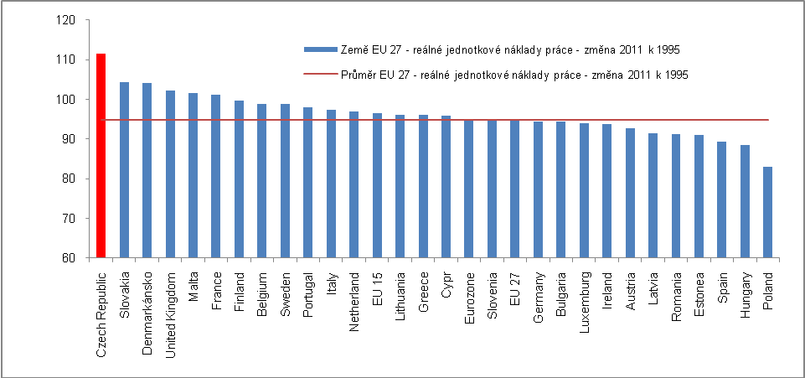
Source: Eurostat

- Risk connected with keeping labour cost low | However, when evaluating the loss of cost competitiveness of the Czech economy with regard to the highest real unit costs in EU-27 in 1995–2011, we cannot generalize that this is a negative phenomenon. In the long-term, keeping labour costs low would lead to lagging in the social and economic area (despite the weakening of household demand).

  - Non-price factors of competitiveness

- The role of non-price related factors of competitiveness | Apart from labour costs as an important attribute of a country’s competitiveness, its position in this regard is affected as opposed to other countries also by non-price related factors, such as quality of infrastructure (other than transport infrastructure as well), technology and education.
- Infrastructure and the need for investments | The favourable location of the Czech Republic in the centre of Europe, i.e. in the territory with a high concentration of purchasing power, requires the best infrastructure. As far as traffic construction and reconstruction are concerned, they require investments that were ensured by the government sector through large public tenders, and with the help of funds from the EU budget.  Restrictions of public finances, present since 2010 and enacted in reaction to the worsened situation in the crisis year of 2009 that continued further on, also affected development programs, including the development of transport infrastructure. Therefore, the sphere of civil engineering was struck by the lost production rate and subsequent slumps. From this perspective, the slump in large traffic construction can be regarded as an influence reducing the competitiveness of the Czech Republic.

    - Employment in knowledge-intensive activities

- The competitiveness of the Czech Republic by the share of employees in knowledge-intensive activities is low against the EU…. | Regarding the non-price related factor for evaluation of competitiveness, namely the share of employees in the sphere designated by Eurostat as “knowledge-intensive activities” (selected industries of manufacturing industry and services), the Czech Republic occupies a rather unfavourable position.  In 2008, for which the last data was available when this analysis was being compiled, less than one third of the total of employees (32.4%) were employed in knowledge-intensive activities in the Czech Republic according to Eurostat. Despite the fact that it represents an improvement over 2000 with 30.4% and in comparison with 2004 with 31%, the change achieved is insignificant for improving the position of the Czech Republic in the European context. In 2008, the Czech Republic stood with this share in the ranking of European countries in the 7th place from the last position with the same result in 2004. Therefore, its position has worsened since 2000 (9th place from the last position).  Thus, the competitiveness of the Czech Republic with regard to knowledge-intensive activities continues to be weak.
- … and has not improved | On the contrary, in 2008 more than half of the total number of employees were absorbed by knowledge-intensive industries in Luxembourg (60%), Norway (51.3%), Switzerland (57.2%) and Belgium (50.1%). However, we can assume that Sweden, for which the figure for 2008 is not available, but which achieved a share of 53.3% in 2007, is also a member of this group and has been the only European country employing annually since 2000 over half of its working population in knowledge-intensive activities. In 2008, nine other European countries posted a share between 40–50% (Germany 44.6%, the Netherlands 49.4%). In 2000, Sweden stood at the top of the ranking (51%), but in 2004 it was replaced by Luxembourg (55.6%).  The lowest share of employees in knowledge-intensive activities was recorded by Romania (21.2%) with a huge gap after Portugal which was second to last (31.1%). The average for the entire EU-27 group is only known for 2004–2007 when it ranged from 39.9% to 40.4%, so even here the movements are insignificant. The competitiveness of Europe as a whole in the global context, particularly with the USA – which would provide very interesting information – cannot be evaluated, however, given the non-existent comparable data.
Chart No. 53: Employment in knowledge-intensive activities (in % of total employment)

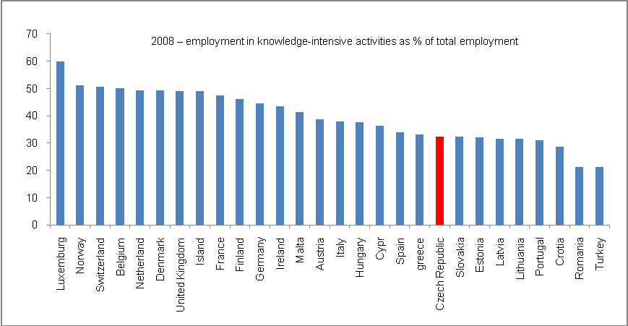

Source: Eurostat

    - Support of sophisticated activities

- Until 2006, relative expenses for research and development had grown faster in the Czech Republic than in the EU-27… | Expenses for research and development as one of the traditional measures of a country’s non-price related competitiveness had grown in the case of the Czech Republic in relative terms to nominal GDP in the time series from 1996 to approx. 2006 faster than in the same period in Europe (Chart 53). In 1996, the total research and development expenditure stood at 0.92% of the nominal GDP in the Czech Republic, and 1.75% of GDP in the EU-27. In this year, the difference between the Czech Republic and EU-27 was the most significant (0.83 p.p.).  Even moderately improving competitiveness of the Czech Republic during this period reached its peak in 2006 when research and development expenditure in the Czech Republic was 1.49%, while in the case of the EU-27 it stood at 1.85% of nominal GDP following factual stagnation.
- … then the positive trend of competiveness started to fade away | The relative share of research and development expenditure in 2007 and 2008 in the Czech Republic was falling (to 1.48%, and 1.41% respectively), but in the EU there was no drop; on the contrary, this share increased in 2008 in the EU and exceeded 2% in 2009. It must be noted, however, that the data could have been mathematically distorted by the drop of GDP as a denominator of the said proportion, and by this the drop in the share of research and development expenditure in the Czech Republic cannot be justified – the drop of GDP in the Czech Republic was approximately the same as in the EU-27 as a whole. The stagnation of the share in the European Union occurred already in 2010 when this share recorded a year-to-year increase in the Czech Republic.
- Europe did not live up to its ambition from the Lisbon Strategy | In trend terms, the share of research and development expenditure in relation to GDP had grown faster than in the EU-27 in 1995–2010 where their share in GDP in fact stagnated (or increased by a mere 0.2 p. p., in 2000–2010, even only by 0.1 p.p.). The European ambition embodied in the so-called Lisbon Strategy – a concept document preceding the Europe 2020 vision – regarding the creation of knowledge economy has not been fulfilled.  As opposed to 1995, only Finland, Sweden and Germany remained among the five countries with the highest share of research and development expenditure in 2010, with the drop of France and the Netherlands whose favourable positions in the European context were taken by Denmark and Austria. The share of these five countries oscillated from 2.76% (Austria) to 3.87% (Finland) of nominal GDP in 2010  It follows from Chart 55 that a lower share than that of the Czech Republic is recorded, apart from two Baltic states and two of the most recent EU additions, also by Poland (0.74%), Hungary (1.16%) and Slovakia (0.63%). The Czech Republic stands better even in comparison with Italy (1.26%) or Spain (1.39%). In spite of this, it seems that growth in the competitiveness of the Czech Republic is not very fast in this regard. As opposed to the Czech Republic, more funds are spent on research and development in relation to GDP, apart from the majority of “old” EU countries, by Portugal (1.59%) and Estonia (1.62%).

Chart No. 54 | Total research and development expenditures (in % GDP in current prices) | Chart No. 55 | Research and development expenditures and their use in business sector (in %)
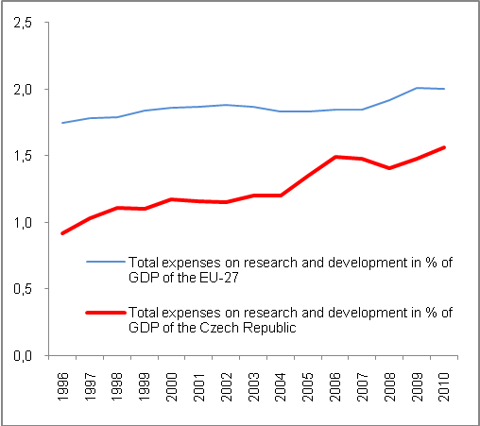 |  | 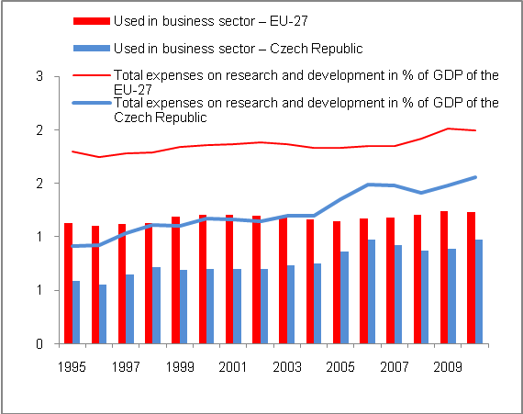
Source: Eurostat

- Approx. two thirds of total research and development expenditure are used by companies as in the EU-27 | The use of the research and development expenditures in the business sector in 1995–2010 is shown in Chart 54. On average, both in the EU-27 and in the Czech Republic, approx. two thirds of total relative research and development expenditures are used in businesses. Concerning this proportion, the Czech Republic recorded the closest gap managed with regard to the convergence to the EU average in the strong year of prosperity in 2006, when the business sector was able to absorb 65% of these relative expenditures, while only 63% in the EU. In the following years, this proportion declined in the Czech Republic as opposed to the EU and some recovery occurred as late as in 2010.
Chart No. 56: 2010 – Share of total research and development expenditure to nominal GDP (in %)

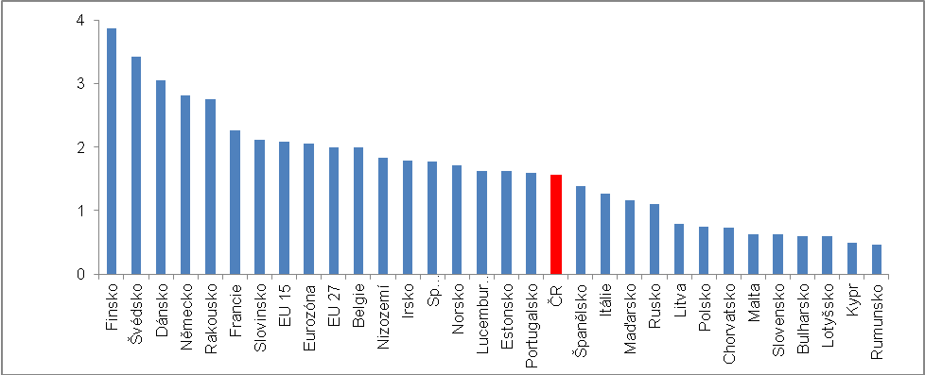
Source: Eurostat

    - Tertiary education

- Lost competitiveness despite fast growth in the number of graduates of tertiary education in 2000–2011 | Education by tertiary education and its development in 2000–2011 is not very positive for the Czech Republic in the European context, despite the fact that the growth in young people is much faster than that achieved on average in the EU-27.  In 2000, a total of 17.3% of the population in the age group over 25 had tertiary education in the EU-27, but in the “old” European countries (EU-15) this proportion was nearly one fifth (18.8%). On the contrary, the share of people with this type of education in the Czech Republic was significantly lower in 2000, and stood at approximately one tenth (10.6%). In the European context, a worse situation was found only in Slovakia (9.2%), Italy (8.6%), Romania (8.3%), Portugal (7.3%) and Malta (4.7%).
- In 2011, almost one quarter of population in the 25+ age category had tertiary education in the EU-27 and more than one third in the north of Europe… | However, the position of the Czech Republic had not improved in 2000–2011 against the EU-27 average – the share of people with tertiary education in the 25+ age category rose by 5.9 p.p. to 16.5%, but on average the share in the EU-27 rose more significantly – by 6.2 p.p. to 23.5%. Therefore, almost one quarter of the European population (EU-27) over 25 years has a tertiary education, but only 16.5% in the Czech Republic.  In 2011, the highest share of people with tertiary education, that is a share exceeding one third, was recorded in Scandinavia and island countries of Europe – Norway 35.6%, Finland 34.5%, Sweden 33.5%, as well as also Estonia with 35.6%, followed by Ireland with 33.4%. The absolutely highest share of people with tertiary education was recorded by the United Kingdom, i.e. 36% of the population over 25 years. The share in the Czech Republic is half this figure.
- … while only 16.5% in the Czech Republic despite the increase by 5.9 p. p. in 2000–2011 | The increase of the so-called new EU-27 countries with regard to the share of population with tertiary education, was, with the exception of Romania and Bulgaria, faster than in the old EU-15 countries where the share increased by +5.8 p.p. in 2000–2011. Only eight countries of the EU-27 posted a smaller increase of the share of the population with tertiary education in the entire population in the 25+ category than the Czech Republic – these are mostly countries (except for Italy, Romania and Bulgaria) where the shares are significantly higher than in the Czech Republic, thus the increase for the given period is also influenced by the comparative base.
- The position in education of the population by the share of people with tertiary education is best in comparison with EU-27 | The fact that the Czech Republic – despite rapid growth of graduates who can be included in the tertiary education category, which is notably visible in the age group between 25–34 – has not made progress with regard to this parameter in the European context, is apparent from the fact that the difference of approx. seven percentage points between the Czech Republic and the EU-27 from 2000 remained constant also in 2011.  Education by the share of people with tertiary education has not grown against the European average in the Czech Republic.

Chart No. 57: Share of people with tertiary education in the population of relevant age category (in %)

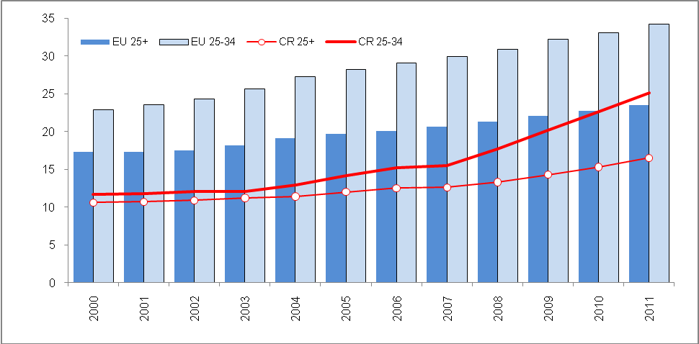
Source: Eurostat

- Risk of evaluation | The low share of people with tertiary education in the Czech Republic was also influenced by the character of the education system where bachelor’s programs had not long been functional as opposed to the majority of European countries with this tradition, which subsequently influenced the reported number of people with such education. This module started to be implemented in the Czech Republic no sooner than the 1990s and numbers of graduates of these programs had an immediate influence on the growth of the share of people with tertiary education in the age group between 25–34 (Charts 57 and 58).
- In the long-term, the situation is worse than in Europe also with young people | The situation in the age group of 25–34 where the share of people with tertiary education in the Czech Republic is lower than on average in the EU-27 is no different. In 2000, it stood at half of the EU-27 share (11.7% against 22.9% in EU-27) and due to the smaller proportion in the new EU countries than in the group of old countries (EU-15) where as early as 2000 one quarter of young people aged 25–34 (25.3%) had such education, the share is even worse.
- Rapid growth of the share of people with tertiary education in the age group 25–34 in the Czech Republic in 2000–2011…, | In 2000–2011, the share of people with tertiary education in the age group 25–34 had risen faster in the Czech Republic than in the EU-27 (+13.4 p.p. against +11.3 p. p.) and particularly against the old EU-15 countries (+9.7 p.p.). In 2011, it subsequently exceeded the threshold of 25% (25.1%). However, the EU-27 average stood at 34.2%, while in the EU-15 it was 35%.  The share of young people with tertiary education in the population between 25–34 was 40–50% in Belgium, Sweden, France, the United Kingdom, Norway, Luxembourg, Ireland and Lithuania, while a share exceeding 50% (50.1%) was reported by Cyprus according to Eurostat.

Chart No. 57 | Share of people with tertiary education in the age group 25–34 in the Czech Republic (in %) | Chart No. 58 | Share of people with tertiary education in the age group 25–34 in the EU-27 (in %)
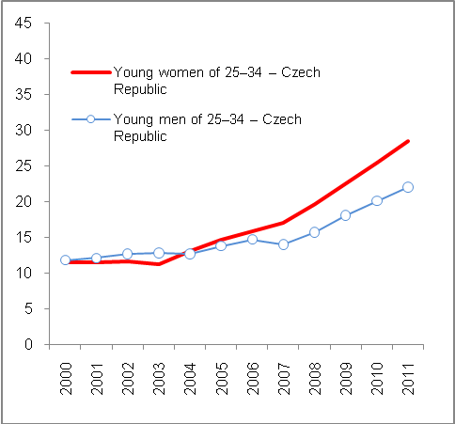 |  | 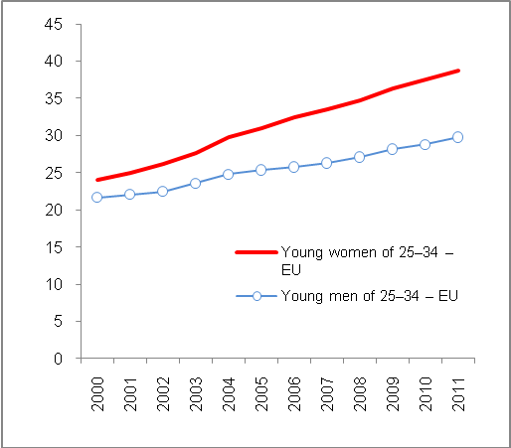
Source: Eurostat

- …but slower against comparable new EU countries, Poland in particular | Despite the fact that the share of young people with tertiary education had grown faster in 2000–2011 in the Czech Republic than on average in EU-27 and EU-15, its dynamics was weaker than in the most of countries that joined the EU together with the Czech Republic in 2004 (Lower growth than in the Czech Republic was posted only by Estonia, which already had a strong share, and Bulgaria, which had a higher share of young people with tertiary education than the Czech Republic in 2011).  Therefore, the Czech Republic was not able to keep pace with economically comparable countries even with regard to the growth dynamics of this share – despite the fact that the difference against the overall EU-27 average in p.p. has dropped from 11.2 p.p. to 9.1 p.p. against 2000 – and not even with regard to its final figure, as it has grown by one quarter in Poland to 39.2%, by 17.7 p.p. in Cyprus to 50.4%, by 14.5 p.p. in Slovenia to 33.8%. In 2011, Slovakia had approximately the same share as the Czech Republic (+14.6 p.p. to 25.7%); Hungary had a slightly higher share (28.4%) where the share of young people with tertiary education in the total population in the age group of 25–34 had risen similarly in 2000–2011 (+13.5 p.p.) as in case of the Czech Republic.
- Quality issues regarding tertiary education | Therefore, the Czech Republic has not been increasing its competitiveness in a situation when the share of young people with tertiary education has been rising. Unfortunately, its dynamics are slower than the dynamics of practically all the countries of the EU-27 that joined the EU together with the Czech Republic. Some concerns are also raised by the quality of such education provided to a great extent also by new private schools producing graduates and the impact of this quality on their ability to compete in the labour market. However, this is not a subject of this analysis.

- Since 2004, the share of young women with tertiary education has risen faster than the share of men with this type of education | Equally as in Europe, there was a higher share of women with tertiary education in the age group of 25–34 (28.5%) than in the same age group of men (22%) in 2011. The same is true for the EU-27, but these proportions are higher (38.7% and 29.8% respectively).  The same could be said already in 2000 when the share of women with tertiary education stood at 24.1% while it was only 21.7% for men in the EU-27 (22.9% in total in both categories). It was also true that the share was roughly 2 p.p. higher in the old EU countries.  On the contrary, in the Czech Republic the shares of young men and women with tertiary education in the share of people in the relevant age group were approx. the same in 2000–2004 (In 2000, men at 11.8%, women at 11.5%, in 2004 men at 12.7%, women at 13.1%). Since 2005, there has been a clear trend of an increasing share of women with tertiary education – however, given the increased dynamics in both of these categories, the share significantly deviated to the above-mentioned 28.5% in the case of the share of women in the given age category and 22% in the case of men. To some extent, tertiary education has begun to be the domain of young women in the Czech Republic. This proportion towards a greater number of young women with tertiary education is also apparent in the EU-27 (see Chart 58).

At that time, this fact was commented on as “the highest unemployment in the last 16 years”.
4 The IMF estimates that measures aimed to reduce the deficit by 1 percentage point in relation to GDP will cause the slowdown of economic growth also by 1 percentage point.
The official name of the program is Long-Term Refinancing Operation (LTRO).
This is the European Financial Stability Facility (EFSF), a special institution to help states struck by the debt crisis with a seat at Luxembourg. It may issue bonds, from the sale of which it may provide loans to countries in the Eurozone in trouble or use them for recapitalization of commercial banks and for the purchase of risk assets. The bonds issued by EFSF are guaranteed by Eurozone member states in the same proportion to their capital deposits in the ECB.
European Financial Stabilization Mechanism – EFSM.
Recipients of these cheap loans are Eurozone member states that asked for help and whose programs to recover public finances have been discussed with the EC and IMF and approved by the ministers of finances of the Eurozone countries. Another condition is that the applicant is not able to obtain the money required on the financial market under acceptable conditions. In November 2010, support of Ireland was approved. Ireland asked for EUR 85 billion (23 billion from EFSM and 18 billion from EFSF – the first issue of bonds of the EUR 5 billion was offered on the market by EFSF in January 2011). The second country to ask for help was Portugal (April 2011), therefore in total the support will reach EUR 78 billion. The support for Greece in the amount of the EUR 110 billion from 2010 was not an operation of EFSF, but is backed by bilateral agreements between Greece, the IMF and the Eurozone member states. Slovakia and Estonia (which were not yet members of the Eurozone) did not participate in the agreement.
Unless stated otherwise, figures adjusted for price influence and number of calendar days are given both here and further in the text.
The Czech government sector consists of organisational units of the state, territorial self-governing units, selected allowance organisations, state and other non-budgetary funds (Land fund, Supporting and guarantee forestry and farming fund, Winemakers’ funds and so on), Railway infrastructure administration, the transformation institution Prisko, PPP Centrum, public universities, public research institutions, health insurance companies, the association and union of health insurance companies and the Centre for International Reimbursements. Since 2010, several public non-financial enterprises have been, based on a test, transferred to the government institution sector, while at the same time some selected allowance organisations were transferred to sectors of non-financial enterprises and government institutions.
Regarding the instruments, securities other than stock are included in the private debt (Item F. 3 in the national accounting) and loans (F. 4), i.e. without other instruments. These are given on consolidated bases, which means that they do not include transactions in the framework of one institutional sector.
This comprises both regular aid in the form of e.g. farming subsidies and ad hoc help during natural disasters. Apart from that, it is also a support of the state in ensuring its long-term objectives (e.g. support of research and development, protection of the environment, energy savings, support of small and medium enterprises, creation of jobs and positions, support of education and regional development aid).
In the form of net lending to or borrowing by the sector.
In the time series since 2005, there has been a methodical influence when the reporting of export and import of goods and services is carried out by the so-called national approach, i.e. not by cross-border statistics of these flows, but according to the ownership.
From this perspective, other components of the balance of yields are relatively insignificant – while in 2007, CZK 281.4 billion were drawn from the Czech Republic as a net yield from direct investments, the net outflow in the form of work abroad (i.e. the wages of or allowances for employees/residents working outside the Czech Republic) stood at CZK 5 billion. The yields from portfolio investments and yields from other investments posted a positive net result (in total, a yield of almost CZK 23 billion).
For more see Dubská, D. [2011] Firmy se zahraniční majetkovou účastí v ekonomice ČR: oslabily nebo dále sílí? Praha, Český statistický úřad. 2012. http://czso.cz/csu/2011edicniplan.nsf/publ/1158-11-n_2011
According to ČNB, in 2008 CZK 183 billion were drawn and only 41 billion were left for reinvestments. In the same year, 74 billion were drawn from the manufacturing industry and 28 billion from the finance industry.
GDP per capita based on purchasing power parity generally reflects not only changes in GDP dynamics but also movements of comparable price levels and parities. Eurostat websites show slightly different data concerning the relative position of the Czech Republic with regard to GDP per capita based on PPP. According to them, the Czech economy stopped converging to the average level of the EU already in 2008. According to Eurostat, at that time there was a drop in GDP per capita based on PPP to 81% from 83% in 2007 when the position of the Czech Republic was the best in the entire period 1995–2011 concerning this relative comparison. In 2009, the position improved again by one percentage point to 82% of the EU-27 average, but subsequently the indicator dropped again to 80% and in 2011 stagnated at this level. Such a discrepancy between Eurostat and CZSO data caused by the methodology. Following an extraordinary revision of national accounts, there was an increase in the HDP of the Czech Republic since 1995 (predominantly by including the imputed rent). Even though this methodology is reflected by Eurostat, there is still some inconsistency of the time series of the coefficient of purchasing power parities until 2007 (despite repeated requests from CZSO, Eurostat has not revised this time series). On the contrary, the national accounting of CZSO maintains a consistent time series of these parities, but at the same time it does not reflect the change given by the extraordinary revision. According to the opinion of authors from the national accounting unit of CZSO, this version gives a better picture of the development than the Eurostat version. By analogy, according to Eurostat data this trend of discontinuation of convergence was seen in relation to the “old” European countries representing the EU-15 group – i.e. the group before the enlargement to another 10 countries in 2001 and also Romania and Bulgaria. If the HDP per capita based on PPP stood at 75% in case of the Czech Republic in 2007, it dropped to 73% in 2010 and 2011.
However, these are included according to their place of residence into the number of citizen of the given region – therefore they enter the calculations of GDP per capita as an effect reducing this indicator in relevant region (denominator of the fraction is higher), while for calculation for Prague it is the other way round (the numerator is higher for value added by them).
The time series used with the exception given in footnote 17.
Inflation by HICP (in %) at maximum of 1.5 p.p. above the average of three European countries with lowest inflation.
Government sector deficit (in % of nominal GDP) at 3% at maximum.
Gross consolidated government debt (in % of nominal GDP) at 60% at maximum.
Long-term nominal interest rates (in %) of government bonds denominated in national currency at 2 p.p. above the average of three European countries with the lowest positive inflation at maximum.
Exchange rate stability for two years of successful membership in the ERM II system, i.e. without deviation of the course outside the interval set around the officially announced mean value.
The data are compiled by Eurostat from balance of payments data of individual countries. IMF is the source of data for international trade.
The transitional character of the Czech Republic with regard to transport in Europe and the actual and potential benefits it brings; however, there is also a dark side in the form of the strong environmental burden resulting from the transit transport, which was apparent particularly after 2004.

