- Competitiveness of the Czech economy

- Analysis narrowed down to selected parameters | Given the high number of parameters that might be used to assess the ability of any country to compete with other countries with regard to results of economic development, their range was narrowed for the purposes of this analysis. The competitiveness of the Czech Republic is monitored based on the price factor, that is, by the development of labour costs (particularly using changes in real unit labour costs). From non-price related factors, the support of sophisticated activities is chosen (relative expenses on research and development), then employment in knowledge-intensive activities and, last but not least, the share of population with a tertiary education degree. In addition, the development of the share of export from the Czech Republic in global export is monitored as a more complex parameter of competitiveness, in which both price and non-price related factors are joined together to some extent.
  - Change in the exports share of the Czech Republic in global exports
- Increases in the exports share of the Czech Republic in global exports have been declining since 2004 as a logical consequence of extreme share increases following the accession of the Czech Republic to the EU |  | If we evaluate the competitiveness of the country based on its “ability” to strengthen its participation in global trade (export), we can use the indicator of its export share in the total value of global exports. Given the fact that year on year changes of these shares are very small, it is convenient to use the comparison for the given year, i.e. with the situation five years ago. The competitiveness of the Czech Republic regarding this indicator is evaluated through this prism.  In 2011, the decline of increases achieved in aggregate by exporters from the Czech Republic in the total value of global exports continued. In spite of this, it was still an increase, which was not the case for all European countries. In 2011, the share of the Czech Republic in global export increased by 9.3% against 2006, by 10.1% in 2010. However, in the year when the Czech Republic joined the EU and in the following years the share increases were, when compared to the level five years ago, very high – 44.1% in 2004, 42.1% in 2005, and also in 2006 and 2007 the growth was higher by as much as one quarter (26.6%, and 25.8% respectively).
- Very favourable factors influencing the share increase since 2004… |  | The potential connected with the removal of current barriers, constitution of the Czech Republic as one part of the single market together with a favourable time period when the country could benefit from the fact that the strengthened business segment started shaping significantly with regard to exports and all that probably increased the share of the the Czech Republic in global exports.
- … decreased intensity and increase of the Czech Republic share’s in global export as in other European countries |  | However, over time these effects have been gradually and logically weaker and the Czech Republic’s share in global export has declined. This phenomenon was seen by Hungary, however, as early as 2011 and Slovakia in 2007. It has been seen also by such a strong economy as Germany, whose trade surpluses are generated mostly by strong export, which recorded a decline in its share in global export. Since 2008 the share has been on a steady decline (Chart 49).  These changes must be understood in the context of the changing proportions of the trade on a global scale and are predominantly influenced by the export expansion of China and many other Asian economies, but also fast-growing economies in other parts of the world. Despite the fact that the “European” export records growth, it is not sufficient enough to combat the competitive edge of the above-mentioned countries, which consists mainly in their low cost of labour (for example, in China employees and employers are not subject to social and health insurance contributions, though this should change according to the new budgetary policy of the country).
- Competitiveness by the increase of share maintained by most of the “new” countries, drops in the case of Germany |  | In spite of declining increases of its share in global export, the Czech Republic managed to stay among the group of EU-27 countries in 2011 that achieved an increase (Chart 50), together with Estonia, Poland, Bulgaria, Slovakia, Romania, Latvia and Lithuania. However, the position of the Czech Republic, and Slovakia as well, cannot be evaluated against other countries in the group as a “better one", as these are countries with a strong export orientation (highly open economies). Maintaining their position, or a steady increase of their share – even though to a much smaller extent than in the past – can be seen as very positive (other countries may benefit from lower comparison base with regard to the dynamics of the positive change of this share.
Chart No. 50 | Change of share in global export of goods and services (year Y against Y-5; in %) |  | Chart No. 51 | Change of share in global export of goods and services (2011 against 2010, in %)
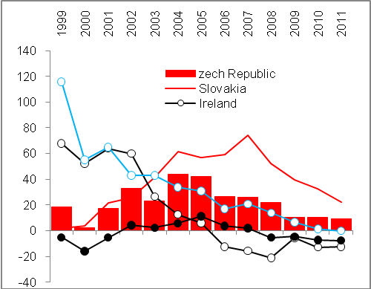 |  |  | 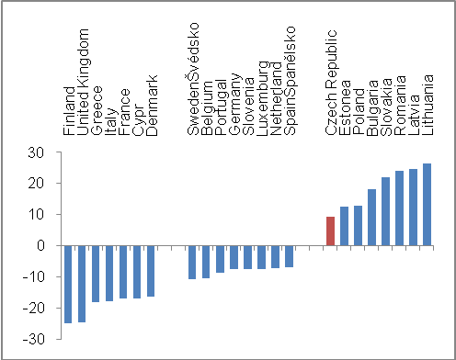
Source: Eurostat

  - Cost competitiveness by labour costs

- By real unit costs of labour, labour costs have risen most in the Czech Republic in 1995–2011 of all EU-27 countries… | By real unit costs of labour – i.e. by product intensity for wages and workforce-related costs – the Czech Republic is in the EU context among the countries with the highest increase.  In 2011, the increase of real unit costs of labour in the Czech Republic when compared to 1995 was the highest in the EU-27, when the index stood at 111.5. Apart from the Czech Republic, the increase for the given period was also achieved by Slovakia (104.4), Denmark (104.1), the United Kingdom (102.3), Malta (101.5) and France (101.2).
- And resulted in the loss of cost competitiveness | In most of the EU-27 countries, the real unit costs of labour for 1995–2011 dropped, most significantly in Poland, Hungary and Spain. This can be interpreted as follows: the cost competitiveness expressed by the change of real unit costs of labour in these countries recorded the largest increase with regard to this indicator. As a matter of fact, the competitiveness of the Czech Republic decreased according to this indicator. On average, the real unit cost of labour in the EU-27 decreased (94.9), in the “old” countries of the EU (EU-15) more moderately (96.6) and more significantly still in the Eurozone (95), while this change was influenced by a more significant drop in Germany as an economy with the strongest impact on calculations of European averages (94.4), in Ireland (93.8) and Austria (92.6).
- Risk connected with keeping labour cost low | However, when evaluating the loss of cost competitiveness of the Czech economy with regard to the highest real unit costs in EU-27 in 1995–2011, we cannot generalize that this is a negative phenomenon. In the long-term, keeping labour costs low would lead to lagging in the social and economic area (despite the weakening of household demand).

Chart No. 52: Real unit costs of labour – change as of 2001 against 1995

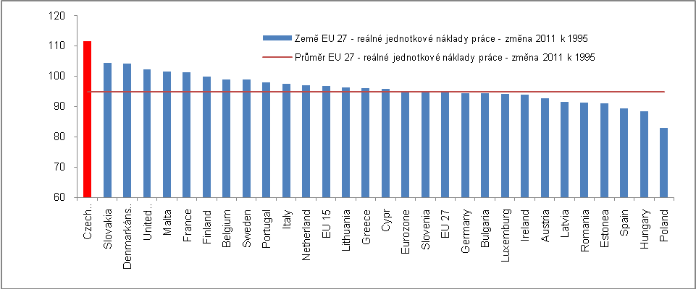
Source: Eurostat

- Risk connected with keeping labour cost low | However, when evaluating the loss of cost competitiveness of the Czech economy with regard to the highest real unit costs in EU-27 in 1995–2011, we cannot generalize that this is a negative phenomenon. In the long-term, keeping labour costs low would lead to lagging in the social and economic area (despite the weakening of household demand).

  - Non-price factors of competitiveness

- The role of non-price related factors of competitiveness | Apart from labour costs as an important attribute of a country’s competitiveness, its position in this regard is affected as opposed to other countries also by non-price related factors, such as quality of infrastructure (other than transport infrastructure as well), technology and education.
- Infrastructure and the need for investments | The favourable location of the Czech Republic in the centre of Europe, i.e. in the territory with a high concentration of purchasing power, requires the best infrastructure. As far as traffic construction and reconstruction are concerned, they require investments that were ensured by the government sector through large public tenders, and with the help of funds from the EU budget.  Restrictions of public finances, present since 2010 and enacted in reaction to the worsened situation in the crisis year of 2009 that continued further on, also affected development programs, including the development of transport infrastructure. Therefore, the sphere of civil engineering was struck by the lost production rate and subsequent slumps. From this perspective, the slump in large traffic construction can be regarded as an influence reducing the competitiveness of the Czech Republic.

    - Employment in knowledge-intensive activities

- The competitiveness of the Czech Republic by the share of employees in knowledge-intensive activities is low against the EU…. | Regarding the non-price related factor for evaluation of competitiveness, namely the share of employees in the sphere designated by Eurostat as “knowledge-intensive activities” (selected industries of manufacturing industry and services), the Czech Republic occupies a rather unfavourable position.  In 2008, for which the last data was available when this analysis was being compiled, less than one third of the total of employees (32.4%) were employed in knowledge-intensive activities in the Czech Republic according to Eurostat. Despite the fact that it represents an improvement over 2000 with 30.4% and in comparison with 2004 with 31%, the change achieved is insignificant for improving the position of the Czech Republic in the European context. In 2008, the Czech Republic stood with this share in the ranking of European countries in the 7th place from the last position with the same result in 2004. Therefore, its position has worsened since 2000 (9th place from the last position).  Thus, the competitiveness of the Czech Republic with regard to knowledge-intensive activities continues to be weak.
- … and has not improved | On the contrary, in 2008 more than half of the total number of employees were absorbed by knowledge-intensive industries in Luxembourg (60%), Norway (51.3%), Switzerland (57.2%) and Belgium (50.1%). However, we can assume that Sweden, for which the figure for 2008 is not available, but which achieved a share of 53.3% in 2007, is also a member of this group and has been the only European country employing annually since 2000 over half of its working population in knowledge-intensive activities. In 2008, nine other European countries posted a share between 40–50% (Germany 44.6%, the Netherlands 49.4%). In 2000, Sweden stood at the top of the ranking (51%), but in 2004 it was replaced by Luxembourg (55.6%).  The lowest share of employees in knowledge-intensive activities was recorded by Romania (21.2%) with a huge gap after Portugal which was second to last (31.1%). The average for the entire EU-27 group is only known for 2004–2007 when it ranged from 39.9% to 40.4%, so even here the movements are insignificant. The competitiveness of Europe as a whole in the global context, particularly with the USA – which would provide very interesting information – cannot be evaluated, however, given the non-existent comparable data.
Chart No. 53: Employment in knowledge-intensive activities (in % of total employment)

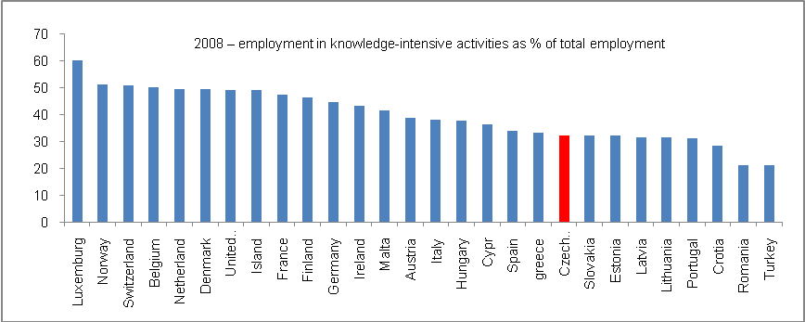

Source: Eurostat

    - Support of sophisticated activities

- Until 2006, relative expenses for research and development had grown faster in the Czech Republic than in the EU-27… | Expenses for research and development as one of the traditional measures of a country’s non-price related competitiveness had grown in the case of the Czech Republic in relative terms to nominal GDP in the time series from 1996 to approx. 2006 faster than in the same period in Europe (Chart 53). In 1996, the total research and development expenditure stood at 0.92% of the nominal GDP in the Czech Republic, and 1.75% of GDP in the EU-27. In this year, the difference between the Czech Republic and EU-27 was the most significant (0.83 p.p.).  Even moderately improving competitiveness of the Czech Republic during this period reached its peak in 2006 when research and development expenditure in the Czech Republic was 1.49%, while in the case of the EU-27 it stood at 1.85% of nominal GDP following factual stagnation.
- … then the positive trend of competiveness started to fade away | The relative share of research and development expenditure in 2007 and 2008 in the Czech Republic was falling (to 1.48%, and 1.41% respectively), but in the EU there was no drop; on the contrary, this share increased in 2008 in the EU and exceeded 2% in 2009. It must be noted, however, that the data could have been mathematically distorted by the drop of GDP as a denominator of the said proportion, and by this the drop in the share of research and development expenditure in the Czech Republic cannot be justified – the drop of GDP in the Czech Republic was approximately the same as in the EU-27 as a whole. The stagnation of the share in the European Union occurred already in 2010 when this share recorded a year-to-year increase in the Czech Republic.
- Europe did not live up to its ambition from the Lisbon Strategy | In trend terms, the share of research and development expenditure in relation to GDP had grown faster than in the EU-27 in 1995–2010 where their share in GDP in fact stagnated (or increased by a mere 0.2 p. p., in 2000–2010, even only by 0.1 p.p.). The European ambition embodied in the so-called Lisbon Strategy – a concept document preceding the Europe 2020 vision – regarding the creation of knowledge economy has not been fulfilled.  As opposed to 1995, only Finland, Sweden and Germany remained among the five countries with the highest share of research and development expenditure in 2010, with the drop of France and the Netherlands whose favourable positions in the European context were taken by Denmark and Austria. The share of these five countries oscillated from 2.76% (Austria) to 3.87% (Finland) of nominal GDP in 2010  It follows from Chart 55 that a lower share than that of the Czech Republic is recorded, apart from two Baltic states and two of the most recent EU additions, also by Poland (0.74%), Hungary (1.16%) and Slovakia (0.63%). The Czech Republic stands better even in comparison with Italy (1.26%) or Spain (1.39%). In spite of this, it seems that growth in the competitiveness of the Czech Republic is not very fast in this regard. As opposed to the Czech Republic, more funds are spent on research and development in relation to GDP, apart from the majority of “old” EU countries, by Portugal (1.59%) and Estonia (1.62%).

Chart No. 54 | Total research and development expenditures (in % GDP in current prices) | Chart No. 55 | Research and development expenditures and their use in business sector (in %)
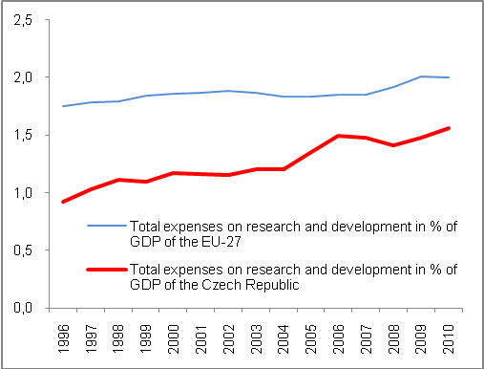 |  | 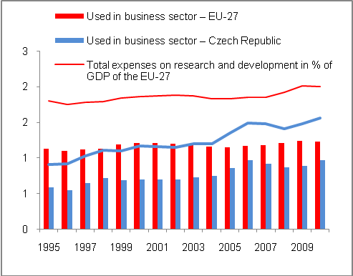
Source: Eurostat

- Approx. two thirds of total research and development expenditure are used by companies as in the EU-27 | The use of the research and development expenditures in the business sector in 1995–2010 is shown in Chart 54. On average, both in the EU-27 and in the Czech Republic, approx. two thirds of total relative research and development expenditures are used in businesses. Concerning this proportion, the Czech Republic recorded the closest gap managed with regard to the convergence to the EU average in the strong year of prosperity in 2006, when the business sector was able to absorb 65% of these relative expenditures, while only 63% in the EU. In the following years, this proportion declined in the Czech Republic as opposed to the EU and some recovery occurred as late as in 2010.
Chart No. 56: 2010 – Share of total research and development expenditure to nominal GDP (in %)

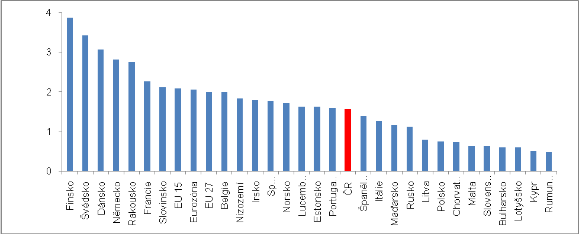
Source: Eurostat

    - Tertiary education

- Lost competitiveness despite fast growth in the number of graduates of tertiary education in 2000–2011 | Tertiary education and its development in 2000–2011 is not very positive for the Czech Republic in the European context, despite the fact that the growth in young people is much faster than that achieved on average in the EU-27.  In 2000, a total of 17.3% of the population in the age group over 25 had tertiary education in the EU-27, but in the “old” European countries (EU-15) this proportion was nearly one fifth (18.8%). On the contrary, the share of people with this type of education in the Czech Republic was significantly lower in 2000, and stood at approximately one tenth (10.6%). In the European context, a worse situation was found only in Slovakia (9.2%), Italy (8.6%), Romania (8.3%), Portugal (7.3%) and Malta (4.7%).
- In 2011, almost one quarter of population in the 25+ age category had tertiary education in the EU-27 and more than one third in the north of Europe… | However, the position of the Czech Republic had not improved in 2000–2011 against the EU-27 average – the share of people with tertiary education in the 25+ age category rose by 5.9 p.p. to 16.5%, but on average the share in the EU-27 rose more significantly – by 6.2 p.p. to 23.5%. Therefore, almost one quarter of the European population (EU-27) over 25 years has a tertiary education, but only 16.5% in the Czech Republic.  In 2011, the highest share of people with tertiary education, that is a share exceeding one third, was recorded in Scandinavia and island countries of Europe – Norway 35.6%, Finland 34.5%, Sweden 33.5%, as well as also Estonia with 35.6%, followed by Ireland with 33.4%. The absolutely highest share of people with tertiary education was recorded by the United Kingdom, i.e. 36% of the population over 25 years. The share in the Czech Republic is half this figure.
- … while only 16.5% in the Czech Republic despite the increase by 5.9 p. p. in 2000–2011 | The increase of the so-called new EU-27 countries with regard to the share of population with tertiary education, was, with the exception of Romania and Bulgaria, faster than in the old EU-15 countries where the share increased by +5.8 p.p. in 2000–2011. Only eight countries of the EU-27 posted a smaller increase of the share of the population with tertiary education in the entire population in the 25+ category than the Czech Republic – these are mostly countries (except for Italy, Romania and Bulgaria) where the shares are significantly higher than in the Czech Republic, thus the increase for the given period is also influenced by the comparative base.
- The position in education of the population by the share of people with tertiary education is best in comparison with EU-27 | The fact that the Czech Republic – despite rapid growth of graduates who can be included in the tertiary education category, which is notably visible in the age group between 25–34 – has not made progress with regard to this parameter in the European context, is apparent from the fact that the difference of approx. seven percentage points between the Czech Republic and the EU-27 from 2000 remained constant also in 2011.  Education by the share of people with tertiary education has not grown against the European average in the Czech Republic.

Chart No. 57: Share of people with tertiary education in the population of relevant age category (in %)

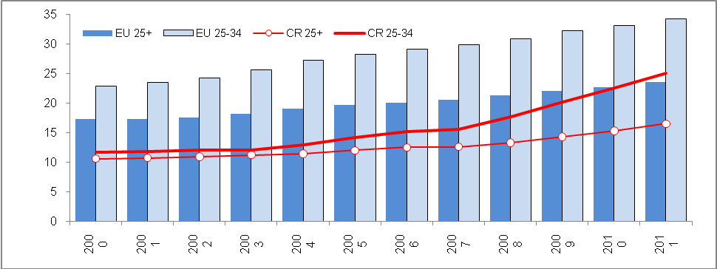
Source: Eurostat

- Risk of evaluation | The low share of people with tertiary education in the Czech Republic was also influenced by the character of the education system where bachelor’s programs had not long been functional as opposed to the majority of European countries with this tradition, which subsequently influenced the reported number of people with such education. This module started to be implemented in the Czech Republic no sooner than the 1990s and numbers of graduates of these programs had an immediate influence on the growth of the share of people with tertiary education in the age group between 25–34 (Charts 57 and 58).
- In the long-term, the situation is worse than in Europe also with young people | The situation in the age group of 25–34 where the share of people with tertiary education in the Czech Republic is lower than on average in the EU-27 is no different. In 2000, it stood at half of the EU-27 share (11.7% against 22.9% in EU-27) and due to the smaller proportion in the new EU countries than in the group of old countries (EU-15) where as early as 2000 one quarter of young people aged 25–34 (25.3%) had such education, the share is even worse.
- Rapid growth of the share of people with tertiary education in the age group 25–34 in the Czech Republic in 2000–2011…, | In 2000–2011, the share of people with tertiary education in the age group 25–34 had risen faster in the Czech Republic than in the EU-27 (+13.4 p.p. against +11.3 p. p.) and particularly against the old EU-15 countries (+9.7 p.p.). In 2011, it subsequently exceeded the threshold of 25% (25.1%). However, the EU-27 average stood at 34.2%, while in the EU-15 it was 35%.  The share of young people with tertiary education in the population between 25–34 was 40–50% in Belgium, Sweden, France, the United Kingdom, Norway, Luxembourg, Ireland and Lithuania, while a share exceeding 50% (50.1%) was reported by Cyprus according to Eurostat.

Chart No. 57 | Share of people with tertiary education in the age group 25–34 in the Czech Republic (in %) | Chart No. 58 | Share of people with tertiary education in the age group 25–34 in the EU-27 (in %)
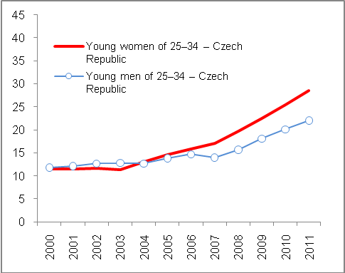 |  | 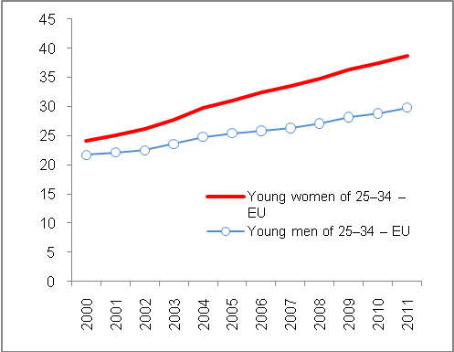
Source: Eurostat

- …but slower against comparable new EU countries, Poland in particular | Despite the fact that the share of young people with tertiary education had grown faster in 2000–2011 in the Czech Republic than on average in EU-27 and EU-15, its dynamics was weaker than in the most of countries that joined the EU together with the Czech Republic in 2004 (Lower growth than in the Czech Republic was posted only by Estonia, which already had a strong share, and Bulgaria, which had a higher share of young people with tertiary education than the Czech Republic in 2011).  Therefore, the Czech Republic was not able to keep pace with economically comparable countries even with regard to the growth dynamics of this share – despite the fact that the difference against the overall EU-27 average in p.p. has dropped from 11.2 p.p. to 9.1 p.p. against 2000 – and not even with regard to its final figure, as it has grown by one quarter in Poland to 39.2%, by 17.7 p.p. in Cyprus to 50.4%, by 14.5 p.p. in Slovenia to 33.8%. In 2011, Slovakia had approximately the same share as the Czech Republic (+14.6 p.p. to 25.7%); Hungary had a slightly higher share (28.4%) where the share of young people with tertiary education in the total population in the age group of 25–34 had risen similarly in 2000–2011 (+13.5 p.p.) as in case of the Czech Republic.
- Quality issues regarding tertiary education | Therefore, the CR has not been increasing its competitiveness in a situation when the share of young people with tertiary education has been rising. Unfortunately, its dynamics are slower than the dynamics of practically all the countries of the EU-27 that joined the EU together with the Czech Republic. Some concerns are also raised by the quality of such education provided to a great extent also by new private schools producing graduates and the impact of this quality on their ability to compete in the labour market. However, this is not a subject of this analysis.

- Since 2004, the share of young women with tertiary education has risen faster than the share of men with this type of education | Equally as in Europe, there was a higher share of women with tertiary education in the age group of 25–34 (28.5%) than in the same age group of men (22%) in 2011. The same is true for the EU-27, but these proportions are higher (38.7% and 29.8% respectively).  The same could be said already in 2000 when the share of women with tertiary education stood at 24.1% while it was only 21.7% for men in the EU-27 (22.9% in total in both categories). It was also true that the share was roughly 2 p.p. higher in the old EU countries.  On the contrary, in the Czech Republic the shares of young men and women with tertiary education in the share of people in the relevant age group were approx. the same in 2000–2004 (In 2000, men at 11.8%, women at 11.5%, in 2004 men at 12.7%, women at 13.1%). Since 2005, there has been a clear trend of an increasing share of women with tertiary education – however, given the increased dynamics in both of these categories, the share significantly deviated to the above-mentioned 28.5% in the case of the share of women in the given age category and 22% in the case of men. To some extent, tertiary education has begun to be the domain of young women in the Czech Republic. This proportion towards a greater number of young women with tertiary education is also apparent in the EU-27 (see Chart 58).

The data are compiled by Eurostat from balance of payments data of individual countries. IMF is the source of data for international trade.
The transitional character of the Czech Republic with regard to transport in Europe and the actual and potential benefits it brings; however, there is also a dark side in the form of the strong environmental burden resulting from the transit transport, which was apparent particularly after 2004.

