16 August 2024

Number of the self-employed decreased

Employment and unemployment in the Czech Republic as measured by the Labour Force Sample Survey – 2nd quarter of 2024

**The total employment increased by 103.4 thousand persons, year-on-year (y-o-y). The number of the unemployed, according to the methodology of the International Labour Organization (ILO), increased by 1.7 thousand persons. The number of the economically inactive aged 15+ years increased by 31.4 thousand.**

### Employment

In the Q2 2024, the seasonally adjusted **average number of employed persons** decreased by 42.7 thousand persons, compared to the Q1 2024.

The **number of working persons** aged 15+ years increased by 103.4 thousand, y-o-y, i.e. by 2.0% to 5 167.3 thousand. The increase is mainly owing to an increment in the number of working females. Their number was by 111.0 thousand higher, y-o-y. The number of working persons aged 45–59 years considerably increased, by 93.0 thousand; what was also inconsiderable was an increase of working persons aged 60+ years, whose number grew by 41.4 thousand, year-on-year. A slight year-on-year increase was also in the number of working persons aged 30–44 years. In the age category of 15–24 years, the number of working persons stagnated and among working persons aged 25–29 years, a year-on-year decrease by 39.1 thousand persons was recorded.

**Chart 1: The number of working persons in the national economy and their structure by age group (thousand)**

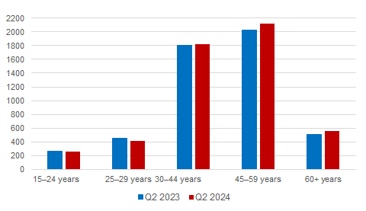

Source: CZSO, LFSS

The number of **employees** increased by 124.1 thousand persons. The **number of the self-employed** (without unpaid contributing family workers) decreased by 21.6 thousand persons. The overall decrease is owing to a decrease in the number of **the self-employed without employees** (own-account workers) by 14.4 thousand as well as a decrease in the number of **the self-employed with employees** (employers) the number of whom decreased by 7.2 thousand, y-o-y.

According to data for the Q2 2024, the development of employment in individual economic activities (CZ-NACE sections) in the Czech Republic was different*[1])*. In the **primary sector** of agriculture, forestry and fishing, the number of working persons increased, year-on-year, by 5.5 thousand to 143.7 thousand. In the **secondary sector** of industry and construction, a slight increase in the number of working persons was recorded; their number increased by 24.2 thousand to 1 826.9 thousand. In the **tertiary sector** of services, the total employment increased, y-o-y, by 73.7 thousand to 3 196.7 thousand. In this sector, the number of working persons especially increased in the section of ‘human health and social work activities’ by 26.0 thousand, further also in ‘public administration and defence; compulsory social security’ by 22.6 thousand persons and in ‘construction’ where the number of working persons increased by 22.4 thousand persons. A slight decrease in the number of working persons was recorded, for example, in the section of ‘professional, scientific and technical activities’, in which the number of working persons dropped by 8.5 thousand persons and in ‘arts, entertainment and recreation’, where there was a decrease by 7.3 thousand persons.

**Chart 2: The** **number of working persons in the national economy by economic activity (thousand)**

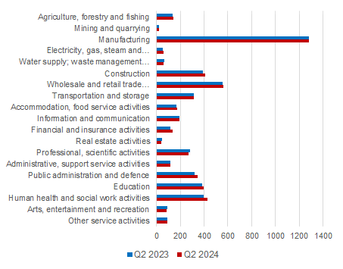

Source: CZSO, LFSS

Along with changes in the structure by economic activity (CZ-NACE section), changes in the structure of working persons by occupation also occurred. **According to the Classification of Occupations (CZ-ISCO)**, the number of working persons increased the most in the major group of professionals (by 65.0 thousand) and in the group of service and sales workers (by 40.2 thousand). On the other hand, the biggest decrease occurred in the major group of clerical support workers (by 62.6 thousand).

**Chart 3: The** **number of working persons in the national economy by Classification of Occupations (thousand)**

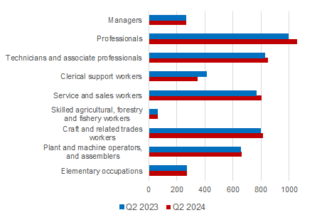

Source: CZSO, LFSS

The development trend in the number of working persons according to the educational attainment is also related to those changes in the employment structure. The number of working persons with **primary education** increased by 4.2 thousand to 239.0 thousand. The number of working persons with **secondary education without A-level examination** increased by 12.8 thousand to 1 619.6 thousand persons. The number of employed persons with **secondary education with A-level examination** increased the most, by 47.1 thousand, to 1 887.3 thousand working persons. The number of employed persons with **tertiary education** increased by 38.9 thousand to 1 420.3 thousand persons.

The **employment rate** (the percentage of working persons in the age group of 15–64 years old) remained nearly unchanged in the Q2 2024 compared to the corresponding period of the previous year. However, the development among males and females was opposing. The male employment rate decreased by 0.8 p. p. to 81.0%, the female one increased by 1.1 p. p. to 69.3%.

### Unemployment

The seasonally adjusted **average number of unemployed persons according to the ILO** **methodology***[2])* decreased in the Q2 2024 by 4.2 thousand persons, compared to that in the Q1 2024.

**Chart 4: The number of the unemployed in Regions of the Czech Republic (thousand)**

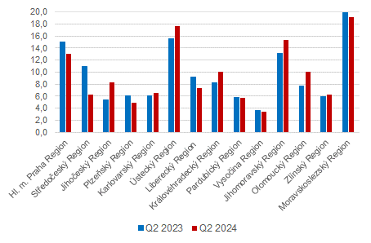

Source: CZSO, LFSS

The total **number of the unemployed** aged 15+ years slightly increased, year-on-year. The number of the unemployed increased by 1.7 thousand to 134.1 thousand persons. Specifically, it was an increase in the number of the unemployed males by 2.4 thousand to 66.9 thousand. The number of the unemployed females decreased by 0.7 thousand to 67.2 thousand.

The number of the unemployed increased the most in the *Jihočeský* Region (by 3.0 thousand) and also in the *Jihomoravský* Region and in the *Olomoucký* Region (both the same by 2.3 thousand).

The **number of persons unemployed for one year and longer** also slightly increased; their number increased in total by 2.4 thousand persons, y-o-y, and reached 39.9 thousand persons. The number of the long-term unemployed males increased by 1.5 thousand, y-o-y, the number of the long-term unemployed females in the Q2 2024 increased by 0.9 thousand compared to the corresponding period of 2023.

**Chart 5: The** **number of the long-term unemployed (for 1 year and longer) and their age structure (thousand)**

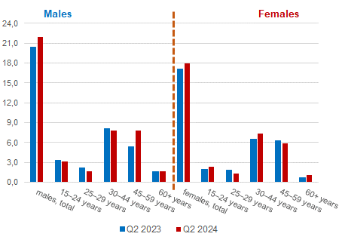

Source: CZSO, LFSS

The **general unemployment rate according to the ILO definition** in the age group of  
15–64 years old (the percentage of the unemployed in the labour force, i.e. in the sum of the employed and the unemployed) remained unchanged, year-on-year. In the Q2 2024, it also was 2.6%.

**Chart 6: Unemployment rate of the 15–64 years old in Regions of the Czech Republic (%)**

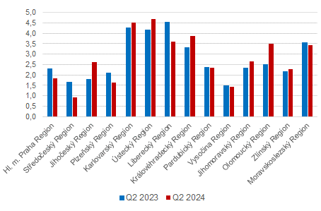

Source: CZSO, LFSS

In terms of a **regional comparison**, the general unemployment rate of the 15–64 years old was the highest in the *Ústecký* Region (4.7%) and in the *Karlovarský* Region (4.5%). It was the lowest in the *Středočeský* Region (0.9%) and in the *Vysočina* Region (1.4%). The biggest year-on-year decrease in the unemployment rate was in the *Liberecký* Region (by 0.9 percentage point (p. p.) to 3.6%); the highest y-o-y increase was in the *Olomoucký* Region (by 1.0 p. p. to 3.5%).

### Economic inactivity

**The number of economically inactive persons aged 15+ years** was by 31.4 thousand higher, year-on-year, and amounted to 3 500.4 thousand. The number of economically inactive males increased by 47.8 thousand; the number of economically inactive females was by 16.3 thousand lower than a year ago.

In the sample survey, data are also collected on **persons who do not work and do not seek a job in an active manner and therefore do not comply with the ILO conditions for the unemployed**, yet they state that they would like to work. In the Q2 2024, the number of such persons was 81.6 thousand persons, i.e. by 5.8 thousand persons less than in the corresponding period of 2023. The number of persons who are willing to work, however, they are not able to start in a potential job immediately, is relatively high. Only 13.3 thousand of the persons are able to start in a job within a fortnight, at the latest.

**Methodological change in the LFSS**

As of the 2nd quarter of 2023, [as announced in advance, the methodologyof the weighting scheme and grossing up changed](https://www.czso.cz/csu/czso/zmena-v-metodach-odhadu-pracovnich-sil-) (*details in* *Czech only*).

***Note:***

***Recalculation to the same population structure***

*The Labour Force Sample Survey (LFSS) is carried out in selected dwelling households. Collective accommodation establishments are not included in the survey. The data found were weighted to the population of the Czech Republic based on the results of the demographic statistics as at the end of the given year; estimates of the number of persons living outside private households were subtracted from the population totals of the demographic statistics.*

**Authors:**

*Marta Petráňová, phone number: (+420) 274 054 357, e‑mail:*[*marta.petranova@csu.gov.cz*](mailto:marta.petranova@csu.gov.cz)

*Gabriela Strašilová, phone number: (+420) 567 109 071, e-mail:* [*gabriela.strasilova@csu.gov.cz*](mailto:gabriela.strasilova@csu.gov.cz)

*Labour Force Statistics Unit*

1. *) Data for economic activities (CZ-NACE sections) may be influenced by the employed methodology of the Labour Force Sample Survey (LFSS). The survey only covers persons living in dwellings (flats), i.e. private households. Data on persons living in collective accommodation establishments are not measured; these establishments often give accommodation to foreign nationals.*
2. *)* *The ILO methodology defines* ***the unemployed*** *as persons who during the reference period were without a job, did not work an hour for pay or remuneration, and were in an active manner seeking a job they would be able to join within fortnight at the latest. This methodology is uniform for all EU Member States and provides internationally comparable data. It has to be taken into consideration that the definition of “the unemployed” by the ILO differs from the definition of “job applicants kept in the register of the labour offices” of the Ministry of Labour and Social Affairs.*