4 November 2013

Women Work Shifts as Frequent as Men
In 2012 there were 1 110 thousand persons working shifts, that is over 28.0% of all employees in the national economy, including members of producer cooperatives. Women work shifts as frequent as men. The share of employees working shifts in the Czech Republic is one of the highest in the all European Union.

Data on involvement of respondents in shift work according to the unified methodology of Eurostat have been measured within the Labour Force Sample Survey (LFSS) since 2002. At the beginning of the reference period in 2002-2005 the share of persons working on shifts was close below 30.0% of all employees and reached this level in 2006. Since 2007 it has oscillated at the level of 28.0-29.0% and in 2012 was 28.1%. Thus there were 1 110 thousand employees working shifts in absolute figure.

Substantial Differences in the Level of Shift Work among Economic Activities and Groups of Occupations
The highest number of employees worked shifts can be found in manufacturing (457 thousand), in wholesale and retail trade (148 thousand), and in human health and social work activities (124 thousand). Two thirds of all employees working shifts worked in these sections. Shift work is important in other sections of economic activities as well. In mining and quarrying over a half of all employees worked shifts; a high share of shift work is also in transportation and storage and in entities active in accommodation and food service activities.

On the contrary, shift work occurs as a minimum in professional, scientific and technical activities, financial and insurance activities, education, and in information and communication. A low level of shift work is in the large activity of construction as well.

Number and share of persons working shifts of employees aged 15-64 years by
CZ-NACE sections of economic activities in 2012
Indicator |  | Employees, incl. members of producer cooperatives
 |  | Total | Of which those working shifts in the main (one) job in recent 4 weeks
 |  | Total | Thousand | % of the number of employees
Aged 15-64 years, total |  | 3 950.8 | 1 109.9 | 28.1
CZ-NACE | Section
Section description:
Agriculture, forestry and fishing | A | 125.4 | 24.8 | 19.8
Mining and quarrying | B | 40.0 | 20.9 | 52.3
Manufacturing | C | 1 183.3 | 457.1 | 38.6
Electricity, gas, steam and air conditioning supply | D | 47.1 | 11.9 | 25.3
Water supply; sewerage, waste management and remediation activities | E | 48.5 | 7.7 | 15.8
Construction | F | 244.1 | 14.0 | 5.7
Wholesale and retail trade; repair of motor vehicles and motorcycles | G | 429.1 | 148.3 | 34.6
Transportation and storage | H | 276.3 | 99.1 | 35.9
Accommodation and food service activities | I | 136.4 | 60.1 | 44.1
Information and communication | J | 93.1 | 8.1 | 8.7
Financial and insurance activities | K | 96.5 | 4.6 | 4.7
Real estate activities | L | 25.3 | 2.6 | 10.3
Professional, scientific and technical activities | M | 117.6 | 5.3 | 4.5
Administrative and support service activities | N | 101.1 | 28.1 | 27.8
Public administration and defence; compulsory social security | O | 303.3 | 56.1 | 18.5
Education | P | 293.8 | 19.2 | 6.5
Human health and social work activities | Q | 293.9 | 123.8 | 42.1
Arts, entertainment and recreation | R | 54.9 | 11.2 | 20.5
Source: CZSO, Labour Force Sample Survey (LFSS)

There are great differences among groups of occupations according to the CZ-ISCO. Managers work shifts just seldom (6.4% in 2012). The share of shift workers is also low in the main group of professionals, clerical support workers as well as technicians and associate professionals also work shifts less frequently. On the contrary, over a half of employees in services and sales work shifts, plant and machine operators and assemblers, and skilled agriculture, forestry and fishery workers often work shifts as well. Data on the level of shift work in major groups of the classification of occupations correspond with data for respective sections of economic activities.
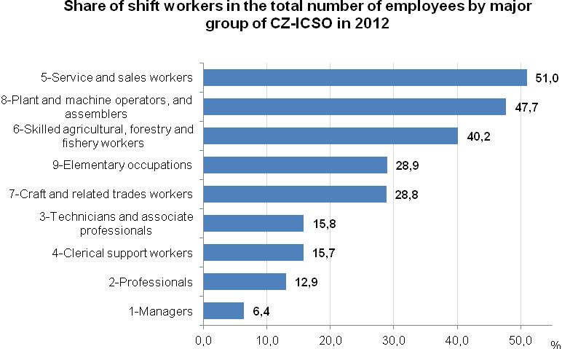
Source: CZSO, Labour Force Sample Survey

The total extent of shift work is in a significant manner affected mainly by conditions in manufacturing, in which over two fifths of all employees in the national economy are working shifts. This section of economic activities is characteristic for a high share of men and this could lead to a conclusion that the total level of shift work is higher in men than in women. The structure of economic activities in women, however, features high shares of trade entities and human health and social work activities. These two sections of economic activities show a level of shift work comparable to that of manufacturing and the result is the fact that the total share of women employees working shifts is identical with the share of such men. Differences in the level of shift work among major groups of the CZ-ISCO are similar in both the sexes.

A great portion of working population does not work shifts and thus numerous troubles, which shift workers have to cope with everyday, remain unknown to them. Inconveniences occur namely in the case of women, who must harmonise the change in their work rhythm with the provision of household activities, especially in the case of mothers taking care for younger children.

The highest share of shift workers was found in the youngest employees up to 25 years of age and is around the level of 40.0%. And women of this age work shifts significantly more often than men. The absolute number of employees in this age group is, however, much lower than those in older age groups because a great portion of the young is still involved in the education process and therefore is economically inactive.

In the group aged 25-29 years the share of employees working shifts reached 30.0%. In the next age group of 30-34 years the share of shift workers dropped to 26.6% last year. The ten-year age group 25-34 years is markedly dominated by the number and share of male shift workers over the female ones. This is clearly a result of the fact that a great portion of women goes to maternity and paternity leaves and after that, when joining a new job, they seek such occupations, which enable to take care of their youngest child.

Conditions are fundamentally changed at the age from 35 years when the share of women becomes prevail the share of men in employees working shifts. This also holds to the employees of the middle-age group till the age of women old-age retirement. The number as well as share of shift working men dominates those of women in the group of sexagenarians and older, yet the total number of shift workers in this age is of less importance.

Numbers and shares of men and women working shifts of the total number of employees aged 15-64 years by CZ-NACE section in 2012
Indicator |  | Employees, incl. members of producer cooperatives, working shifts in the main (one) job in recent 4 weeks
 |  | Men |  | Women
 |  | Thousand | % of the number of the section employees | Thousand | % of the number of the section employees
Aged 15-64 years, total |  | 605.5 | 28.1 | 504.4 | 28.1
CZ-NACE | Section
Section description:
Agriculture, forestry and fishing | A | 12.7 | 14.9 | 12.1 | 30.0
Mining and quarrying | B | 20.4 | 55.9 | . | .
Manufacturing | C | 296.5 | 38.2 | 160.6 | 39.4
Electricity, gas, steam and air conditioning supply | D | 11.4 | 29.4 | . | .
Water supply; sewerage, waste management and remediation activities | E | 6.5 | 16.7 | 1.1 | 12.1
Construction | F | 11.6 | 5.4 | 2.4 | 8.1
Wholesale and retail trade; repair of motor vehicles and motorcycles | G | 34.5 | 21.0 | 113.7 | 43.0
Transportation and storage | H | 75.0 | 36.9 | 24.1 | 32.9
Accommodation and food service activities | I | 24.6 | 50.4 | 35.5 | 40.6
Information and communication | J | 5.5 | 8.2 | 2.7 | 10.0
Financial and insurance activities | K | 1.1 | 3.0 | 3.5 | 5.8
Real estate activities | L | 1.8 | 15.6 | . | .
Professional, scientific and technical activities | M | 3.5 | 6.3 | 1.8 | 2.9
Administrative and support service activities | N | 20.8 | 35.3 | 7.3 | 17.3
Public administration and defence; compulsory social security | O | 48.9 | 30.1 | 7.2 | 5.1
Education | P | . | . | 18.3 | 8.0
Human health and social work activities | Q | 22.8 | 41.3 | 100.9 | 42.3
Arts, entertainment and recreation | R | 5.2 | 23.3 | 6.0 | 18.5
. Data is not sufficiently reliable
Source: CZSO, LFSS

The shift work extent is, first of all, determined by the nature of occupations of the respondents and by economic activity of their workplaces. These are immediately projected into regional differences in the share of shift workers in the total number of employees in respective regions. The level of shift work of employees in the Hlavní město Praha Region is substantially lower than those in all other regions, both in men and women. The share of shift workers in the Hlavní město Praha Region attained 18.3% in the last year, but in the Královéhradecký Region, Pardubický Region, Moravskoslezský Region, and in the Vysočina Region, for instance, one third of all employees work shifts. There is a high level of shift work namely in the Ústecký Region being twice as high as that in the Hlavní město Praha Region.

Share of Employees Working Shifts in the Czech Republic is One of the Highest in the All European Union

The shift work extent in Member States of the European Union is, similarly as many other aspects of employment, very varied. In 2012 the share of persons working shifts in the EU27 reached in total 17.7% of all employees. If data for the new Member State of Croatia are taken into account, the share of employees working shifts attained 17.8%. Croatia is a country where even one third of all employees work shifts. The difference in the level of shift work is demonstrated by the fact that data on shift work for Croatia is almost by seven times higher than that for Denmark, for example. Shift work occurs also scarcely in France, Belgium, and the Netherlands.

The Czech Republic occupies one of the leading positions in the European Union concerning the share of shift workers; if Croatia is included, then the share of shift workers in the Czech Republic is the fifth highest in the EU28. Slovenia, Slovakia, and Poland are also ranked above the Czech Republic. The share of shift workers in these countries is over 30.0% of all employees.

The share of women working shifts in the EU28 is a bit lower than that of men (16.4% of female employees compared to 19.0% of male employees). Differences among Member States are great in both the sexes.
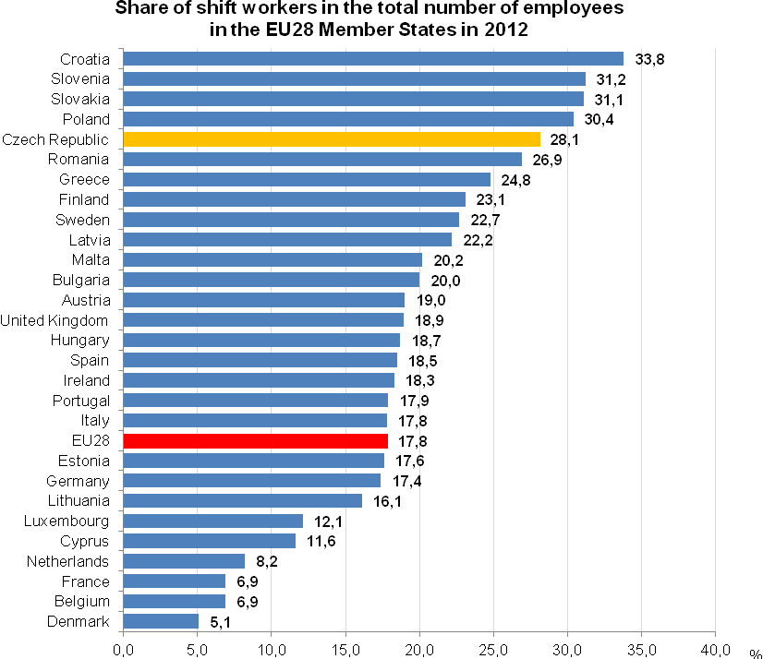
Source: Eurostat, Labour Force Survey

*****

Shift work is amply used in the Czech Republic. It, however, brings increased demands for harmonisation of this work regime with personal life of the respondents. This is well-marked in the case of mothers with children of school age, who must solve the dilemma of fulfilling of their employees’ duties and simultaneously performing their household activities and children bring-up. The more because for a number of them shift work is not limited merely to work days yet in many cases women work shifts on days off and weekends, on Saturdays and Sundays. It is necessary to take into account the level of wages and salaries of employees, especially women. Average wages in economic activities with a higher level of shift work are low compared to activities with the highest level of earnings, in which the share of shift workers is, conversely, very low.

Authors
Marta Petráňová, Bohuslav Mejstřík
Unit for Labour Forces, Migration and Equal Opportunities
Czech Statistical Office
Tel.: +420 274 054 357; +420 274 052 203
E-mail: marta.petranova@czso.cz; bohuslav.mejstrik@czso.cz

Methodological note: Shift work is a regular work regime. This type of work regime is characteristic feature is that various groups of workers or individual workers alternate at the same workplace and perform the same activities in recurring periods. The handing over and taking over of the work is important here. Changing of various workers at the same workplace in recurring periods is the inevitable condition for the work regime to be classified as shift work. Shift work concerns exclusively the respondent persons it does not relate to the character of operations of an enterprise or organization. Although other workplaces of an enterprise may work two or more shifts, professions and occupations, which work is not typically shift work (as technical specialists and clerical support workers) are not included. Shift work is measured for employees and members of producer cooperatives, not for the self-employed. Data on the extent of shift work in respective economic activities and groups of occupations are obtained by grossing up the data measured to the whole population.

