The Czech Economy Development in the First Half of 2012 September 2012

Labour market
- Total employment recorded a year on year increase for the sixth consecutive time |  | In Q2 2012, the situation on the labour market was slightly better than in Q1. New job vacancies emerged and there was an increase in total employment. The employment, as shown in the national accounts and adjusted by seasonal fluctuations, rose after two quarters of decline to the level reached in Q3 2011.  The total employment in the Czech economy, based on national accounts, rose in Q2 year on year by 13.6 thousands of persons (+0.3%), against Q1 2012, but the number of employees grew even more significantly – by 17.7 thousands of persons (+0.3%). In a year on year comparison, this was already the sixth consecutive quarter, in which an increase of total employment was recorded, which is influenced by the low comparative base in 2010.  The industries of trade, transport, accommodation and hospitality contributed in the year on year on growth of total employment by almost 39% (+15.3 thousands of persons). A higher number of employees in a year on year comparison were hired by industries of activities in the field of real properties (+8.9 thousand persons), professional, scientific and other activities (+7.2 thousands of persons) and the finance and insurance industries (+5.5 thousands of persons). Higher decreases of employed persons in a year on year comparison were recorded by public administration and defence, education and social care (-13.4 thousand of persons) and the manufacturing industry (-9.8 thousands persons).
- Total employment rose as a result of the increase of entrepreneurs |  | An increase of entrepreneurs is responsible for the improvement of total employment in a year on year comparison adjusted by seasonal fluctuations. Their number increased year on year by 35.4 thousands of persons, that is by 3.8%. From individual sectors, the highest increases of entrepreneurs were recorded in a year on year comparison in trade, transport, accommodation and hospitality (+12.3 thousands of persons) and in the construction industry (+8.2 thousands of persons). Only in information and communication activities (-1 thousand of persons) and the agriculture, forestry and fishing industries (-0.7 thousands of persons) did the numbers of entrepreneurs drop. The number of employees in a year on year comparison decreased in Q2 2012 by 21.8 thousand persons, i.e. by 0.5%. There has been a decrease in the number of employees in public administration and defence, the health sector, education and social care for the fifth consecutive quarter. In a year on year comparison, this decrease stood at 15.5 thousands of persons. The year on year drop in the number of employees in the manufacturing industry (-10.1 thousand of persons) and in the building industry (-8.6 thousands of persons) are also apparent.
- Moderate improvement of unemployment: more vacancies |  | The general rate of unemployment (in the age group of 15–64) reached in Q2 2012 a value of 6.8% and has not changed in a year on year comparison. However, against Q1 it dropped by 0.4 percentage points. In absolute terms, there were 350.9 thousands of unemployed persons in the Czech Republic in Q2, which in a year on year comparison was 0.5 thousands of persons less and in quarter on quarter comparison 18.3 thousands persons less. Therefore, a typical seasonality was reflected in the unemployment. The share of long-term unemployment from the total number of the unemployed already reached 44.3%. The rate of registered unemployment established at labour offices reached a value of 8.4% in Q2.  In Q2, the number of vacancies increased in a year on year comparison by 4.4 thousand to 42.8 thousand and the quarter on quarter increase was 2.6 thousand positions. Naturally, there are the discrepancy between the qualification of candidates and the required expertise for vacancies.
- Decrease of real wages |  | In the first half of the year, the average wage reached CZK 24,341. In a year on year comparison this represented an increase of CZK 657 (+2.8%). Due to the fact that consumer prices increased for the given period by 3.5%, there was a decrease in real wages by 0.7%. When looking only at the results for Q2, it must be noted that the nominal average wage increased year on year by 2.3%, which, in comparison with the increase of consumer prices by 3.4% in the monitored period, meant a decrease of real wages by 1.1%. In both the business and non-business spheres, the year on year development was equal in Q2 – in nominal terms, the wage increased by 2.3%, and in real terms, it dropped by 1.1%, which was influenced by administrative transfer of units between both spheres. As bonuses were paid in Q2 to a greater extent, the nominal average wage grew against Q1 by 2.4%.
Chart No. 13 | Total employment and number of employees (y/y in %) |  | Chart No. 14 | Nominal and real wages (y/y in %, recalculated values)
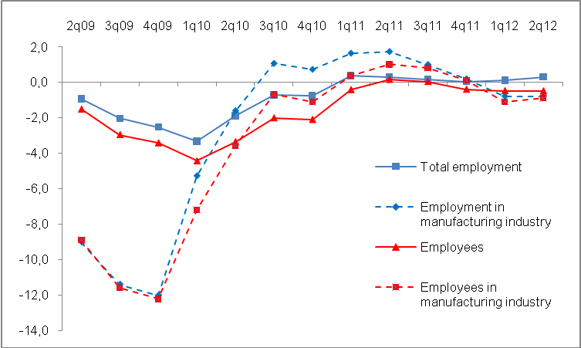 |  |  | 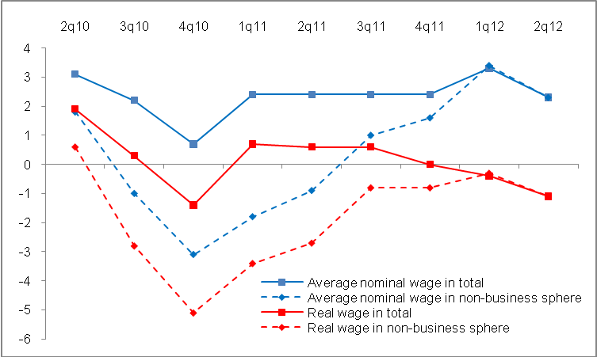
Source: CZSO

According to the definition of the International Labour Organisation (uniform for the EU member states), persons who did not hold in the reference period any job, have not worked a single hour for wage or remuneration and have sought actively a job that they would be able to take on in two weeks at the latest, are considered to be unemployed. The definition of unemployed persons under ILO, who are established by a selective survey of the workforce (LFSS) in CZSO, is different from the definition of a job candidate registered at labour offices of the Ministry of Labour and Social Affairs.

