11 August 2025

Development of international trade in goods price indices in the Q2 2025
In the Q2 2025, compared to the Q1 2025, export prices decreased by 1.7%. In the year-on-year (y-o-y) comparison, export prices decreased by 0.1% in the Q2 2025. Import prices decreased by 2.5% in the Q2 2025 compared to the Q1 2025. In the y-o-y comparison, import prices decreased by 0.5% in the Q2 2025. The terms of trade reached the value of 100.8% in the Q2 2025 compared to the Q1 2025. In the year-on-year comparison, the terms of trade reached the value of 100.4% in the Q2 2025.

Export prices
Quarter-on-quarter (q-o-q; in the Q2 2025 compared to the Q1 2025), the export prices decreased by 1.7%. The following decreased the most significantly: prices of electricity by 21.2% and prices of coke and refined petroleum products by 12.2%. Especially prices of the following were increasing: wood and products of wood and cork, except furniture by 4.8%, waste collection, treatment and disposal services by 3.6%, and prices of food products by 1.3%.
Year-on-year, in the Q2 2025, the export prices decreased by 0.1% (in the Q1 2025 they increased by 2.3%). Prices of the following considerably decreased: coke and refined petroleum products by 20.7%, waste collection, treatment and disposal services by 6.1%, and chemicals and chemical products by 5.2%. Mainly prices of products of agriculture, hunting and related services increased by 10.2% and wood and products of wood and cork, except furniture by 8.1%.

Import prices
Quarter-on-quarter (in the Q2 2025 compared to the Q1 2025), the import prices decreased by 2.5%. Prices of the following significantly decreased: prices of electricity by 24.6%, crude petroleum and natural gas by 16.3%, and prices of coke and refined petroleum products by 13.6%. Increasing were mainly prices of motor vehicles, trailers and semi-trailers by 2.0% and prices of food products by 1.6%.
Year-on-year, in the Q2 2025, the import prices decreased by 0.5% (in the Q1 2025 they increased by 2.2%). The most significant price decreases were in prices of coke and refined petroleum products by 20.2% and prices of crude petroleum and natural gas by 9.4%. Decreases were mainly in prices of beverages by 11.9%, food products by 9.1%, and prices of furniture by 6.2%.

The terms of trade
Quarter-on-quarter (in the Q2 2025 compared to the Q1 2025), the terms of trade reached the value of 100.8%. An important positive value of the terms of trade was reached by wood and products of wood and cork, except furniture (105.2%) and a negative value mainly by motor vehicles, trailers and semi-trailers (97.3%).
Year-on-year, in the Q2 2025, the terms of trade reached the value of 100.4% (in the Q1 2025 the value was 100.1%) and for the tenth quarter they remained in the positive values – see the Chart No 2. A significant positive value of the terms of trade was recorded by wood and products of wood and cork, except furniture (109.0%) and a negative value mainly by beverages (89.1%).

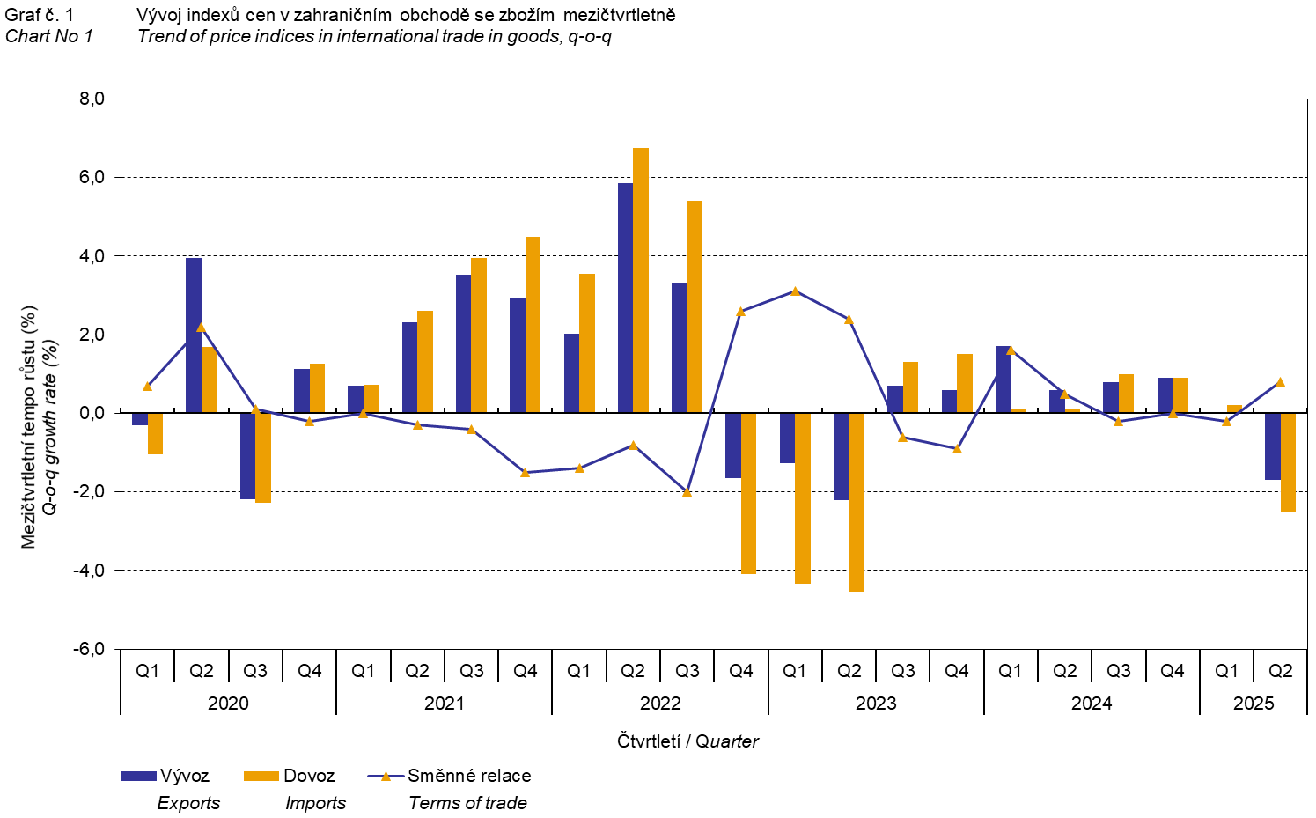

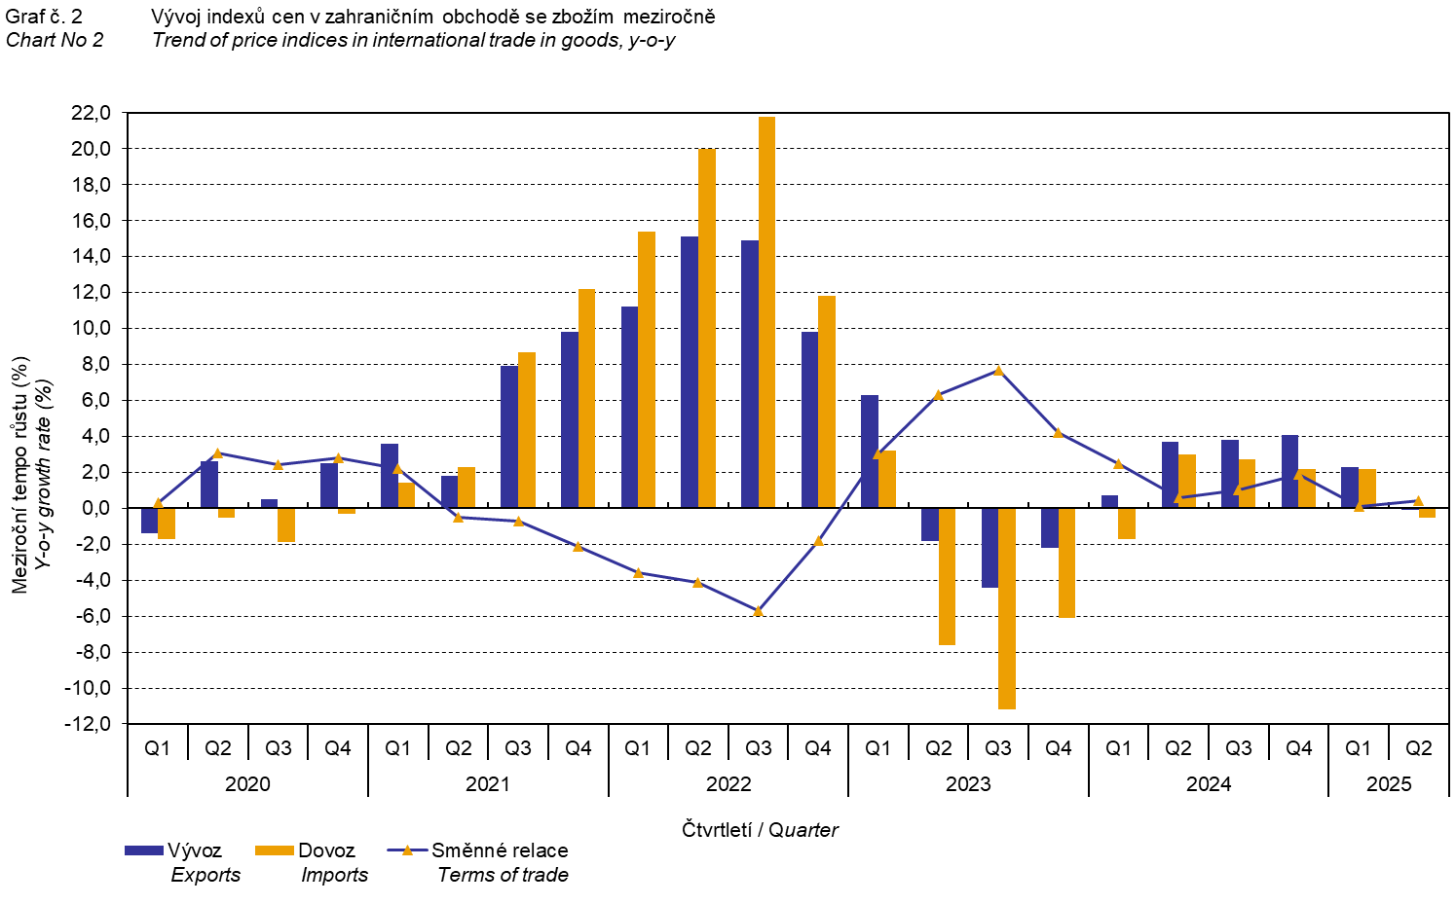

The international trade in goods (change of ownership) price development was also significantly influenced by the CZK exchange rate with the major foreign currencies. All monitored foreign currencies have been included in the quarter-on-quarter exchange rate index. Q-o-q indices of the CZK exchange rate to these foreign currencies were weighted by their respective weight, which pertains to those foreign currencies in the export price index and in the import price index (before the Q3 2023, only two most important currencies, i.e. EUR and USD, have been included; as of the Q3 2023, the calculation was refined by including all currencies and it was calculated backwards to the year 2021).

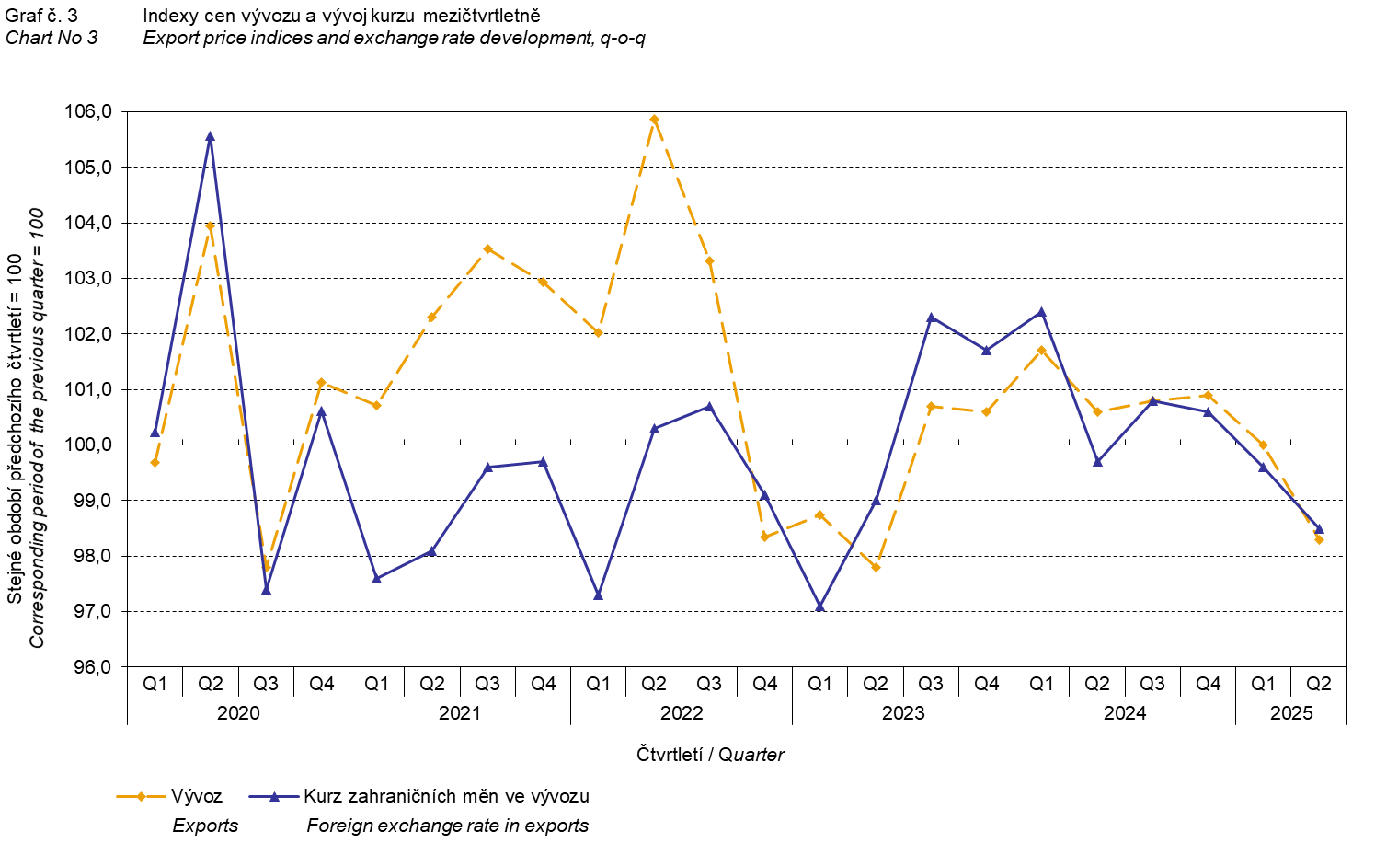

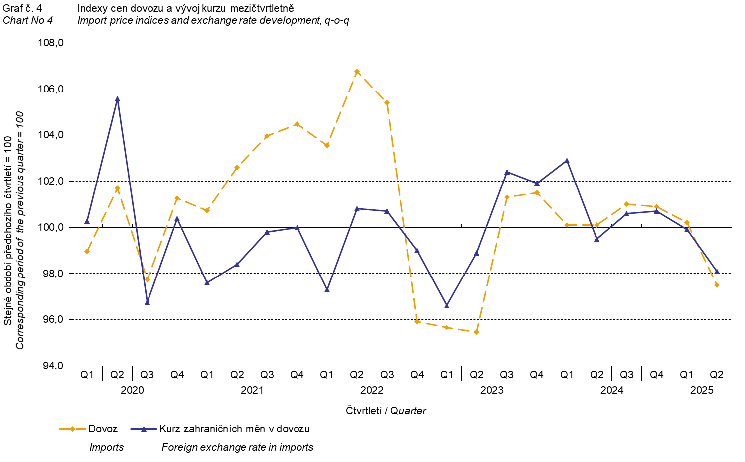

It is apparent from the aforementioned Charts Nos 3 and 4 that in case of both exports and imports the international trade in goods prices have a relation to exchange rate effects. Contracts with foreign entities are usually concluded for longer periods of time and the longer the contract period is, the stronger the relation to exchange rates is.

International trade in goods price indices, year-on-year, adjusted for exchange rate influence
The Czech Statistical Office (CZSO) also calculates year-on-year international trade in goods price indices adjusted for exchange rate effects. The calculation is carried out as follows: prices in foreign currencies reported in the current month are converted to Czech crowns by the exchange rate of the same month of the previous year. Afterwards, they are used for the weighted mean calculation together with prices reported in CZK. This exchange rate adjusted base price index of a month is related to the non-adjusted base price index of the corresponding month of the previous year and thus the year-on-year adjusted price index for a month is calculated. Year-on-year adjusted price indices for a quarter are calculated similarly, too.

Differences between the adjusted and non-adjusted price indices may be considerable; they are obvious in the Charts Nos 6 and 7, for example, in the first to the third quarter of 2024.

The method employed does not enable to make a 100% exchange rate adjustment because not all trade transactions made in foreign currencies are also reported in foreign currencies; the proportion does not exceed 30%. It follows therefrom that at the full exchange rate adjustment, differences between the published price indices and the exchange rate adjusted price indices would probably further increase.

The aforementioned exchange rate adjusted indices can also be used to make the exchange rate adjusted breakdown of increments of price indices. The Table 1 gives the published and exchange rate adjusted breakdown of increments of export and import price indices. The breakdown illustrates well how many percentage points each of the groups “exchange rate contributed” to the index.

It holds true in general that the exchange rate effect decreases the price indices in international trade in goods when the CZK is strengthening to foreign currencies in total. Conversely, the exchange rate effect pushes the price indices up when the CZK is weakening to foreign currencies in total.

The Chart No 5 shows the CZK exchange rate with the two most important foreign currencies, i.e. EUR and USD.

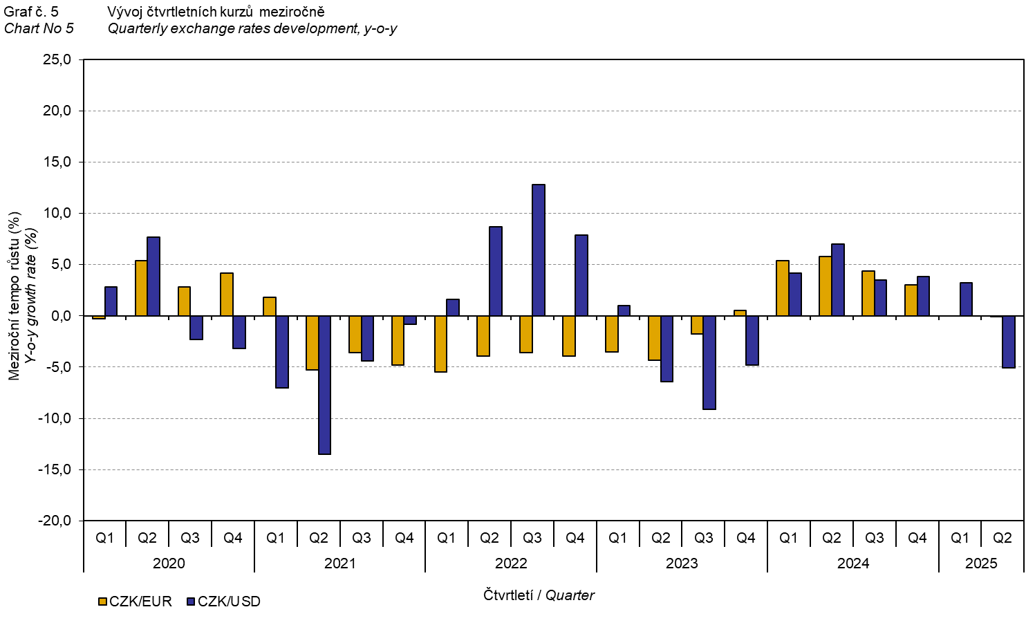
It is clear from the Charts Nos 6 and 7 below how significant the exchange rate influence of all monitored foreign currencies on the value of the export and import price indices was.

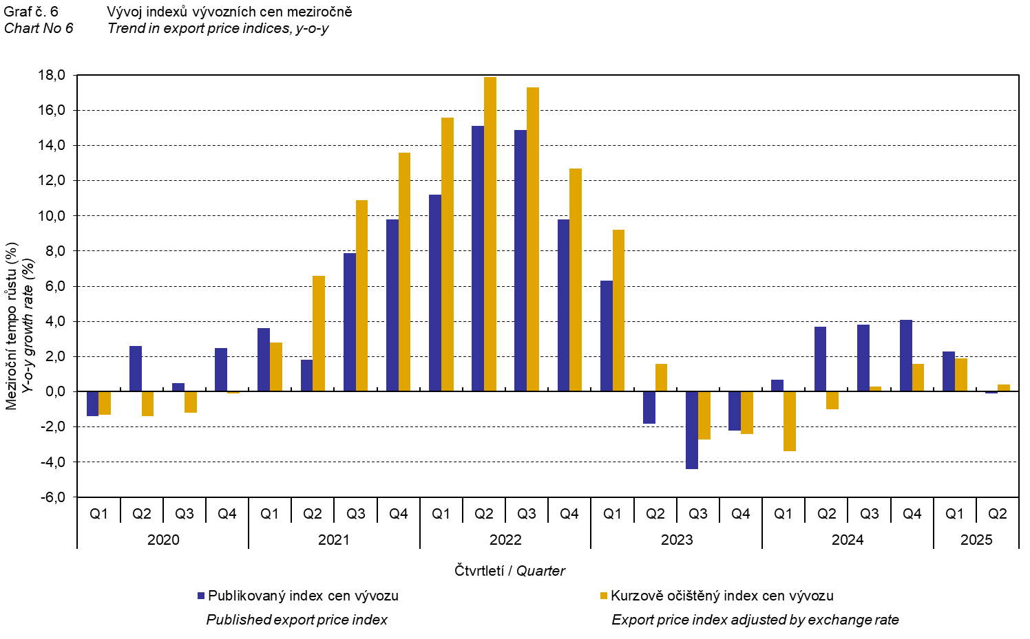

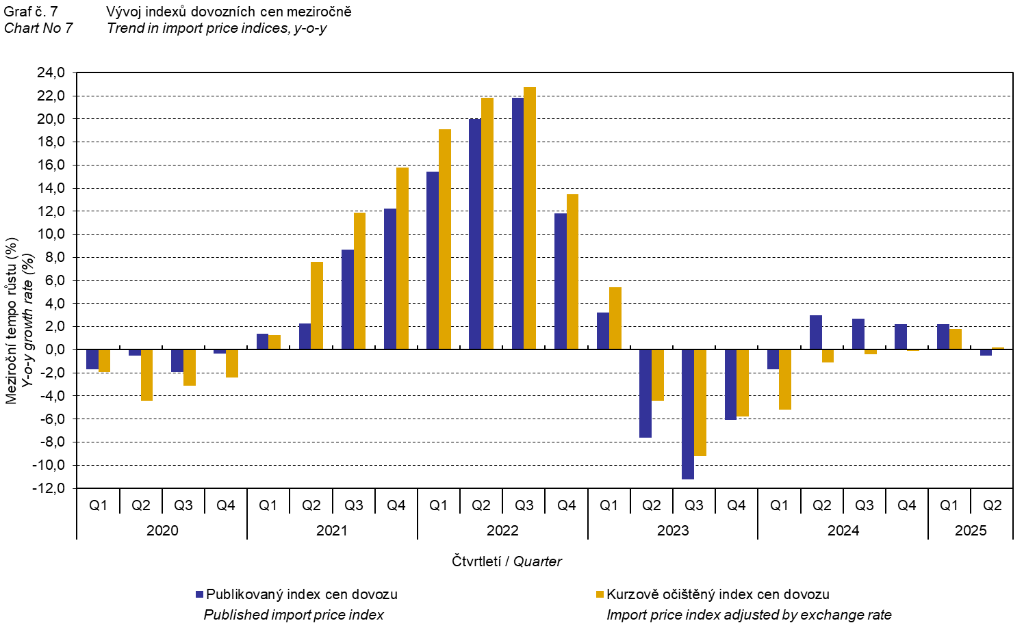

The Chart No 8 illustrates the exchange rate influence on the value of the year-on-year terms of trade.

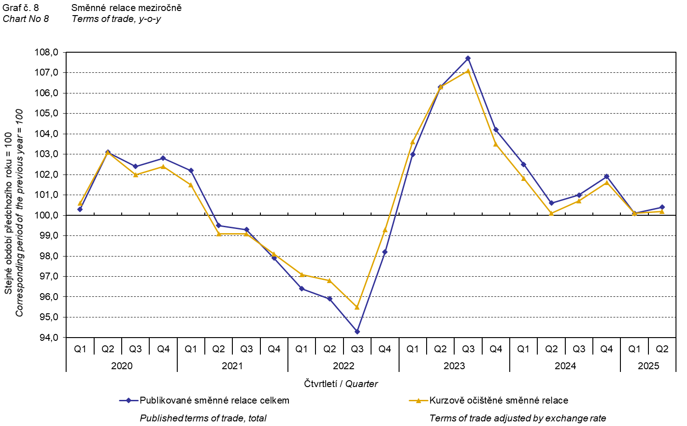
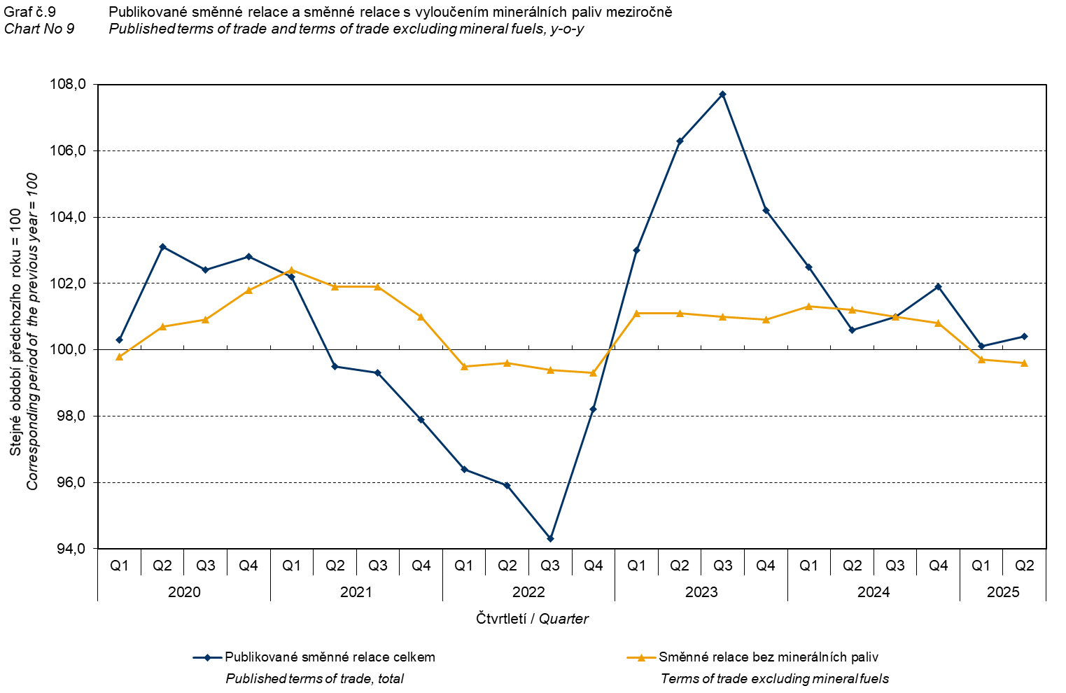

The Chart No 9 shows the development of the value of the terms of trade when mineral fuels have been excluded, i.e. two-digit divisions 05, 06, 19, and 35 of the CPA classification (which correspond to the SITC 3 section called ‘mineral fuels, lubricants and related materials’). In this chart, the effect of mineral fuels can be observed that has an influence on the total value of the year-on-year terms of trade. Since the Q1 2023, mineral fuels were increasing the value of the terms of trade. However, in the Q2 2024, there was a turnabout and mineral fuels decreased the value of the terms of trade. In the Q3 2024, the terms of trade with the mineral fuels excluded and the total year-on-year terms of trade reached the same value. Since the Q4 2024, mineral fuels have been increasing the value of the terms of trade again. This development is related to fluctuations of prices on world markets, mainly the crude petroleum ones. Import prices, which have a higher proportion of crude materials compared to export prices, respond in a more sensitive way to price turbulences and therefore the terms of trade are usually increasing when prices of crude materials are decreasing, and, vice versa, when prices of crude materials are increasing, the terms of trade are decreasing.

Final summary
In the Q2 2025, the exchange rate effect decreased, year-on-year, both the export price index and the import price index. Export prices decreased less than the import ones and therefore the terms of trade reached the positive value, year-on-year. After the elimination of the exchange rate effect, the terms of trade reached a lower value than the published terms of trade. The values free of the exchange rate effect correspond to the exchange rate adjusted indices – see the Charts Nos. 6, 7, and 8.

The closing table gives published non-adjusted international trade in goods price indices.

Note: For internal reasons, the Czech decimal comma is used instead of the English decimal point as a decimal separator in tables and charts of this analysis.

Elaborated by: Hana Lapáčková, Prices Statistics Department
phone number: (+420) 274 052 709, e-mail: hana.lapackova@csu.gov.cz

