Summary

- The Czech economy was gradually slowing down quarter-by-quarter in 2011 both in year-on-year and quarter-on-quarter comparisons. Quarter-on-quarter slowdown occurred sooner than in the EU economy. The loss of dynamics was affected only partially by the external demand and more significantly only in the 4th quarter. Major cause of the adverse development of the Czech economy lay in the inner environment, since full seven tenths of the Czech GDP in real as well as nominal terms is comprised of final consumption expenditure of households and general government, which were falling in real terms in each quarter. Investment was also decreasing for major part of the year. Foreign trade thus represented the only growth impulse in 2011.

- GDP grew in 2011 year-on-year by 1.7 % compared to 2.6 % in 2010. Slowing down of the growth rate was gradual throughout the year, similarly to the European Union economy. However, the year-on-year slowdown of GDP was in the CR in the second half of the year faster – while the union as a whole slowed down in the 3rd and 4th quarter to year-on-year rates of growth of 1.4 % and 0.9 %, Czech economy slowed down to 1.2 % and the GDP grew in the last three months of the year by 0.6 % only.

- Quarter-on-quarter the Czech economy in the last two quarters of 2011 fell, by the same rate of 0.1 %.

- According to the Eurostat data, the decrease of the final consumption expenditure of households as well as government was in the Czech Republic in individual quarters of 2011 one of the deepest in the European Union. Contrary to continuing growth of investment reported for EU 27, the CR experienced its fall.

- Gross value added formed in the industries of the Czech economy rose compared to 2010 by one half (+1.5 % as opposed to +3.2 %), with the largest dynamics in the manufacturing (+9.8 %). Its addition was smaller than addition of GDP. It is an evidence of progressing slowing down of activity in the economy. In 4th quarter the gross value added did not grow anymore.

- Firms in the industry increased their production in real terms by 6. 9 % with a significant slowing down of the rate of growth during the year. Manufacturing of motor vehicles formed half of this growth. Falling rate of growth of new orders revived by the end of the year due to foreign countries. Construction has remained in decline for a third year, receipts from retail sales excluding sales of motor vehicles stagnated, sales in the services sector have been decreasing since the end of 2008.

- The weight of motor vehicles on total export out of CR further increased, proportion of EU 27 countries shrank moderately.

- Labour market revived only slightly due to higher numbers of entrepreneurs and simultaneous drop in numbers of employees. Growth of the real wage was the slowest in the decade and it already decreased in the 4th quarter. Public sector features year-on-year decreases for six quarters already.

- Consumer prices went up by 1.9 % ranging significantly in growth rates for individual consumption items (prices of food went up by 4.6 %). Growth of industrial prices was the second largest in a decade, the fall of prices of construction works deepened. Adverse development of terms of trade caused lowering of the aggregate price level in the economy.

- Loans to businesses and households rose year-on-year by 5.5 % compared to 3 % in 2010. People are mostly repaying their liabilities. Balance of consumption loans decreased in year-on-year terms. The proportion of risky loans shrank for both businesses and households.

- Given the growth of tax receipts and stagnation of expenditure, the budget deficit improved.

Overall Economic Performance
- Rate of growth of Czech economy was year-on-year decreasing in every quarter of 2011 | Dynamics of GDP of the CR was characterised in 2011 by a downward tendency. Even though this development optically corresponded to the development in Europe, the structure of growth based on GDP components revealed, that the plunge of the Czech economy was notably affected by local conditions.  GDP in real terms, adjusted for seasonal effects and various number of working days grew in 2011 year-on-year by 1.7 %. Further, the rate of growth was decreasing in every quarter. While in the 1st and 2nd quarter (+2.7 %, resp. +2 %) grew the Czech economy faster than the economy of EU (+2.4 %, resp. 1.6 %), second half of the year featured a slow down of both Czech and European economies. In 3rd quarter, the Czech GDP grew year-on-year by 1.2 %, in 4th quarter slowed down to 0.6 %. The European economy grew in 3rd as well as 4th quarter faster (+1.4 % and 0.9 %).  GDP of Germany, significantly determining by its weight the direction of growth in Europe, grew compared to CR as well as EU 27 more energetically, even though it still experienced a slow down by more than one half (from strong +4.6 % and +2.9 % in the first half of the year to +2.7 % and 2 % in the remaining two quarters).
- CR GDP quarter-on-quarter decreased mildly in both 3rd and 4th quarter | Quarter-on-quarter the leaving of growth positions of the Czech economy in the first half of the year was more continual compared to the development in EU. GDP of the CR fell in the 3rd as well as 4th quarters compared to the previous period by 0.1 %. Despite such development suggesting, that the economy finds itself technically in recession, it is only a mild decline to be interpreted with caution. On the contrary, the GDP of the European union in the 3rd quarter still grew quarter-on-quarter by 0.3 %, in the 4th quarter it then more significantly decreased (-0.3 %), pulled down by the fall in the large economies (Italy -0.7 %, Great Britain -0.2 %, Germany -0.2 %). Especially in Germany, the GDP fell notably compared to its growth in the 3rd quarter by 0.6 %.
- „Domestic“ components of GDP slowed down its year-on-year growth, it stayed in positive numbers only due to the foreign trade | Only foreign trade contributed exclusively to the growth of GDP of the Czech Republic in 2011. Surplus in the trade with goods and services contributed to the year-on-year growth of GDP 2.6 p.p., other components slowed down the growth of the economy – household final consumption expenditure by 0.2 p.p., government sector expenditure by 0.3 p.p. Rate of growth of GDP also lost from the gross capital formation - investment -0.3 p.p., change in inventories -0.1 p.p.  Negative contribution of household consumption was rather increasing quarter by quarter (to -0.3 p.p. in 4th quarter), it fluctuated for both components of gross capital formation (in 4th quarter investment -0.4 p.p., change in inventories -0.5 p.p.). Net export increased the growth of GDP in 4th quarter by 2.3 p.p., which was however significantly less than in the 3rd quarter (+3.5 p.p.).
- Further decline in final consumption expenditure of households as well as government sector | The loss of year-on-year rate of growth of GDP and its decline in quarter-on-quarter view was affected by internal causes – final consumption expenditure as well as the gross capital formation weakened in real terms year-on-year, while they still grew in 2010 (+0.5 %, resp. +5.6 %). Final consumption was in 2011 lower compared to 2010 by 0.7 %. Households limited their expenditure by 0.5 %, governmental sector even more significantly (-1.4 %).  In the 4th quarter the systematic and continuing year-on-year decline in aggregate final consumption expenditure noticeable during the year stopped, since the government consumption slowed down its fall (to -1.7 % from -3 % in 3rd quarter). Nevertheless, fall of the household consumption continued (-0.7 % compared to -0.4 % in third quarter).  Quarter-on-quarter the household final consumption expenditure remained the same compared to the 3rd quarter, decline in the government consumption further deepened (to -1.1 % from -0.4 %). It has been lasting for already five quarters in a row.
- Lower investment, slower growth of import and export | Gross capital formation was in comparison to 2010 lower by 1.6 %, investment alone by 1.2 %. Year-on-year fall of investment occurred only in the second half of the year as a reaction to weaker economic activity given by the lowered demand. However, in 4th quarter it was less deep compared to previous quarter both in year-on-year (-1.2 % as opposed to -1.9 % in 3rd quarter) and quarter-on-quarter comparisons (-0.2 % compared to -0.5 % in 3rd quarter).  Even though the foreign trade was the only factor standing behind the year-on-year growth of GDP in 2011, in comparison to 2010 its rate of growth slowed down. Especially in case of import, whose significant slowdown confirmed the dive of the Czech economy (in 2010 the dynamics of both imports and exports was really the same). Export grew in 2001 year-on-year by 11 % in real terms, import by 7.5 % (in 2010 +16 %, resp. +15.7 %).  The development of rates of growth of export and GDP in individual quarters correlated, thus confirming the key meaning of export for the development of GDP. In numbers, export still increased year-on-year in 1st quarter by 18.5 % in real terms, in 4th quarter already only by 5 %. Quarter-on-quarter in the last quarter import as well as export fell (-6 %, resp. -2.6 %).
- Gross value added compared to 2010 increased, in 4th quarter year-on-year stagnated and it fell quarter-on-quarter | Sources of GDP in the form of gross value added created in industry increased in 2011 by 1.5 %, i.e. less than the expenditure side of GDP. Contribution did not reach even half of the rate of growth of gross value added in 2010 (+3.2 %). Throughout the first three quarters, its year-on-year rate of growth was falling, in 4th quarter it started stagnating, while quarter-on-quarter the gross value added in the Czech economy decreased. The difference between its addition and higher growth of GDP formed the favourable development of balance of taxes on products, which grew notably especially in 4th quarter. The reason was the coming changes in the tax rates followed by the strategy of creating inventories ahead.

- Decrease of government consumption in 4th quarter the same as in Greece; indebtedness one of the lowest in Europe | Restrictive features of development of most expenditure components of GDP are significant especially in comparison to EU 27. While their government sector consumption in 2010 till the half of 2011 year-on-year grew and stagnated only in the last two quarters, in the CR the drop started already in the 4th quarter of 2010. In 3rd quarter of 2011 (-3 %) it was the deepest in Europe following Ireland and Spain. Based on data for 4th quarter – complete data for all countries are not yet available - falls the decrease of government consumption in the CR despite partial moderation (-1.4 %) among three most significant after Spain and Slovenia.  Sharp quarter-on-quarter reduction in 4th quarter shows deep fall of the government consumption in the CR. At the same time the indebtedness belongs to one of the lowest in Europe. In 2010, the gross consolidated debt of the government sector in the CR came to 37.6 % of nominal GDP, which was after Estonia, Luxembourg, Bulgaria and Romania the least in EU 27.
- Households in the CR limit consumption as in countries with debt crisis; investment as opposed to Europe did not grow | The intensity of reduction of final consumption expenditure of households also markedly differs in the CR. Their decrease was reported in every quarter of 2011 year-on-year apart from the CR only households in Ireland, Netherlands, Portugal and also Slovakia. Simultaneous drop of consumption of households as well as general government was observed for the most part of 2011 in addition to CR only in countries with notable budget problems (Ireland, Spain, Hungary, Portugal), in Netherlands and currently also in Slovenia.  The development of investment in CR also differs from Europe (gross fixed capital formation). In EU 27 they grew for the whole year 2011 year-on-year – even though with decreasing dynamics -, but they were decreasing in the CR except for 2nd quarter. It is a reflection of weaker construction investment, but also certain cautiousness of firms in the long-term allocation of funds.
- Real gross domestic income lower than GDP due to the adverse development of prices in the foreign trade | Adverse development of terms of trade caused a loss for the CR in 2011 from the operations of foreign trade in the amount of 62.3 bn crowns. By this amount affected by the development of prices was the real gross domestic income of the CR lower than GDP (in average prices of the previous year). In 2010 was this loss of national work on foreign markets practically the same (63.9 bn crowns). However, at that time the real gross domestic income grew year-on-year by 1 %, while in 2011 it remained the same. Business losses were occurring in the last two years in every quarter; in 2011 they were gradually decreasing. However, it did not need to be caused exclusively by the price impact, but also the fact, that the flow of goods gradually weakened.

Graf 1 |  | Gross Domestic Product (constant prices, seasonally adjusted) (y-o-y in %) | Graf 2 | GDP (in c.p. y-o-y in %) and Confidence Indicators from Business Cycle Survey CZSO
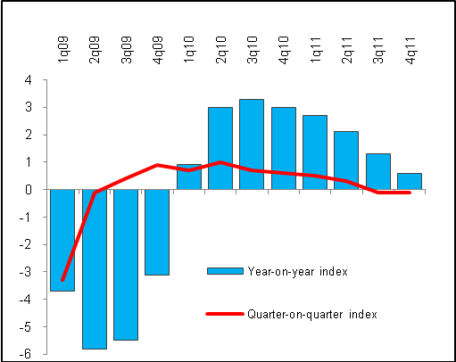 |  |  | 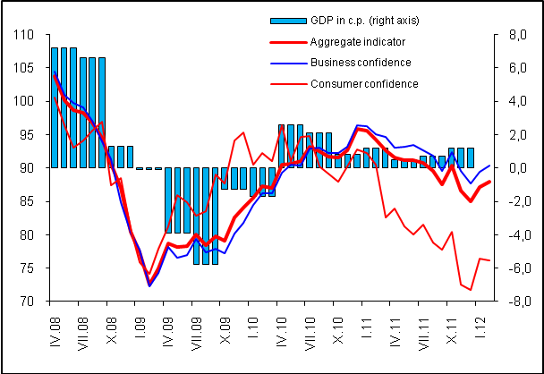
Graf 3 | Contributions of Expenditure Components to Growth of GDP (in p.p) |  | Graf 4 |  | Contributions of Industries to Growth of Gross Value Added (in p.p.)
Source: CZSO

Performance of the sectors

- Industrial output according to the gross value added in real terms considerably lost in rate of change and in nominal terms nearly stagnated |  |  | Dynamics of real industry performance of the Czech economy, measured by the seasonally adjusted volume created gross value added by them, in 2011 diminished. Year-on-year increment of 1.5 % was the lowest in the time series since 1995, when ignoring the drops in recession from the second half of nineties and the year 2009. In 2010 the gross value added increased by 3.2 %, in 2011 due to the adverse effect of the price development it practically stagnated in nominal terms (+0.4 %) and in 4th quarter its growth ceased year-on-year even in real terms.  More sources were compared to 2010 created only by agriculture (+6.5 %), industry (+5.1 %), financial intermediation and insurance industry (+5.6 %), real estate activities (+3.9 %) and seemingly paradoxically also public sector. Here the growth of value added of 2.8 % was however affected by weak comparative basis of 2010, when this branch as the only one decreased year-on-year. The highest growth was in 2011 achieved by the manufacturing industry, whose output according to the value of larger gross value added leapt nearly by one tenth (+9.8 %).  Deceleration of gross value added creation in the economy makes sense as a consequence of weak mostly domestic demand, which is not able to absorb the larger resources. It brings the risk of further loss of working positions.
- After crisis real growth of industrial production culminated in 1st quarter of 2011, subsequently weakening of demand slowed down the performance |  |  | Solid growth of Czech industry in 2011 (year-on-year +6.9 % in real terms) was accompanied by varied performance in individual quarters.  In 1st quarter the positive after-crisis development of industrial production reached its top with the second largest year-on-year growth (+12.3 %) in the time row since 2001 (after +13.4 % from 2nd quarter of 2004). Consequently the rate of growth was gradually slowing down to +3.1 % in the last quarter, when from the main branches of industry notably decreased year-on-year mining by 9.4 % (coal -12.4 %), the electricity, gas, steam and air conditioning supply (+0.3 %) after previous continuous decreases and the manufacturing industry grew (+4.2 %).
- Over half of the growth of industrial production in 2011 belonged to motor vehicle manufacturing… |  |  | Production of manufacturers increased by 8.3 % in 2011 driven by manufacture of motor vehicles, whose export together with spare parts further strengthen its weight on the total value of export from the Czech republic. If it was not for the contribution of motor vehicle industry – in case its production hypothetically stagnated -, the industrial production would increase in 2011 only by 3.2 %, not by 6.9 % and production of the manufacturing industry by 4 % and not by mentioned 8.3 %.
- … even with lower dynamics in the last quarter; the rest of industry as well as manufacturing industry slowed down even more markedly |  |  | Even in the 4th quarter the motor vehicle manufacturing industry (+15.5 % year-on-year) kept its significant distance from the dynamics of other manufacturers, even though it did not grow by one fifth as in the previous quarters. The most successful was the manufacture of other transport vehicles (+27.4 %) due to the effect of finalised large orders. On the contrary, after previous increases the textile, manufacture of paper and paper products and manufacture of basic metals decreased. In the whole second half of the year, the slump of printing and reproduction of recorded media, manufacture of coke and refined petroleum products, chemical as well as pharmaceutical industry continued. Manufacture of wood and of products of wood, manufacture of food products remained in continuous falls in each quarter and manufacture of computer, electronic and optical products experienced a sharp fall in the 4th quarter (-21.8).  Lower compared to 2010 were in 2011 also the manufacturers in manufacture of furniture (-0.5 %), manufacture of wood and products of wood (-5 %) and manufacture of food products (-4.6 %). Manufacture of coke and refined petroleum products weakened the most (-9.3 %), further manufacture of computer, electronic and optical products (-9.8 %). Strong throughout the year was the manufacture of transport vehicles (motor vehicles +21.2 %, other +22.1 %), repairs and installations of machines and equipment (+15.1 %) and manufacture of leather and related products (+13.3 %).
- The development of sales confirmed the two-tracked nature of industry |  |  | Industry received from sales on the Czech market in 2011 year-on-year less (-0.4 %) than in 2010, for the second time since 2002 (deeper was only the slump during the crisis in 2008). Sales from direct export (not the total export) year-on-year rose. While for the period of running out boom – according to the graph 6 from the half of year 2007 till half of 2008 – domestic sales grew faster than sales from direct export, from the half of 2009 the rate of growth of sales from direct export started to overtake the domestic sales. In the last quarter of 2011 the trend of gradual slump of domestic sales stopped and the fall started diminishing. Total sales in industry in 2001 grew year-on-year by 7.2 %.
- Dependency on foreign demand further strengthened |  |  | Last quarter brought a positive turnaround in the orders. Foreign demand grew year-on-year by more than in the 3rd quarter, the fall of domestic market orders slightly diminished.  From the long-term point of view was not the year 2011 in industry the most successful with respect to orders. Annually their value compared to 2010 increased by 5.4 %, but it was still less than the average rate of growth of the last decade (+6.9 %). However, it was not valid for foreign orders, which slowed down (+12.1 %), but still they exceeded the average rate of growth of the preceding ten years (+8.6 %) influenced by the sharp fall in 2008 and mostly in 2009. On the contrary very weak domestic demand caused the domestic orders in industry in 2011 to fall year-on-year for the first time since the beginning of its monitoring (-5-1 %). Their average dynamics in the last ten years (+4.5 %) was compared to the average rate of growth of orders from abroad one half. Future growth of industry will thus be in the nearest period affected more by the demand on foreign markets.
- Operating profit in industry grew faster than production and sales |  |  | Despite weakening output of industry evidenced by the development of production and sales, its financial position improved – profits at the operating level increasing by one tenth, in that in manufacturing by 7 %. It can be explained probably also by the lowering of costs in reaction to the economic slowdown and anxiety related to the development of future demand. This phenomenon, while the fall in output is accompanied by considerably lower negative change in profits and wages was in the Czech economy notable also during the 2009 crisis.
- Crisis created mostly by the lack of large constructions |  |  | Construction output dropped in real terms for the third year in a row. However in 2011 (-3.5 %) the fall from 2010 did not enlarge further (-7.1 %). It was valid also for building construction (-0.4 %, resp. -7.1 %), which has been falling fourth year in a row. On the contrary, large civil engineering constructions further enhanced (-8.7 %) their considerable year-on-year dive from year 2010 (-9.2 %). While it is just development in civil engineering construction standing behind the crisis in this industry.
- Significant losses of job vacancies |  |  | Varying dynamics in individual quarters was influenced by the comparison basis, weather as well as mild revival of building constructions in the last quarter, caused mostly by the reconstruction works. Efforts to gain orders by the way of price competitiveness led to current prices of construction works decreasing also in 4th quarter (-1.3 %). It also dropped in real terms (-0.8 %). At the same time it can be assumed that the very favourable December results related to large constructions could have been caused apart from the weather also by the finishing of remaining invoicing or invoicing ahead accompanying the increase of VAT beginning 2012.  Unfavourable is the loss of jobs in the industry – compared to levels ten years ago, there were 10 thousand people less working in construction in the 3rd quarter 2011, compared to the top of the boom in 2008 even by more than 23 thousand persons less.
- Profitability in construction declined, in industry rose |  |  | Financial results in construction were not favourable in 2011and even worse than the achieved performance – profit at the operating level was in comparison to 2010 by nearly 30 % lower (10.2 bn crowns), the addition to long-term fixed and intangible assets was roughly one half.  Profitability in the industry is falling – one hundred crowns of sales generated in construction only 1.42 crowns in profit (1.89 crowns in 2010), on the contrary noticeably more in the industry (4.58 crowns compared to 4.55 crowns in 2010). It confirms that when competing for orders the construction companies can also find themselves giving price offers below the level of costs for the given action.
- In the second half of the year excluding the impact of sales and repair of motor vehicles the retail sales fell and for the whole year only stagnated |  |  | Also in the 4th quarter the effect of sales of motor vehicles was working, affecting for the whole year to the large extent the dynamics of retail sales (in 2010 even more significantly). They grew in this quarter in real terms by 1.2 %, but in sale, repair and maintenance of motor vehicles increased four times faster (+4.9 %). Only slightly weaker mutual relationship held also for the whole year (+1.9 %, resp. +5.4 %). Statistically inseparable sale of motor vehicles in wholesale and to entrepreneurs increases the rate of growth of sales in the automotive segment and thus increases also the dynamics of the total retail sales. Excluding the effect of this segment the purchases in retail in the second half of the year decreased year-on-year and for the whole year only stagnated (+0.4 %).
- First annual fall of the sales of food products since the beginning of monitored time series |  |  | The sale of food products in retail further decreased in 4th quarter (-3 %) and fell also for the whole year 2011 (-1.2 %). It was the first year-on-year decrease in the time series since 2001 – the fall did not occur even in the crisis year 2009 -, which proves the seriousness of anxiety of households regarding their financial situation. Sales for non-food products in the 4th quarter revived in real terms (+2.3 %), but it can be assumed that it could be the consequence of marked pre-Christmas discounts, since in current prices these sales grew only by 0.7 %. Sales of fuel stations haves been experiencing continuous fall already twelve quarters in a row and they dropped in 2011 year-on-year by 3.5 %. The price pressure significantly pushes down the real consumption in this area.  Second quarter directed to real decreases also the sales of books, restaurant menus and medicine. But even the retail sale in non-specialised stores with food, beverages or tobacco predominating, probably experiencing the effects of mentioned lower sales of food products (even though in current prices their sales increased by 3.3 %, for large business chains then by 5.5 %). Internet sales grew roughly by the same pace as in 2010 (+11.8 %), nevertheless in the second half of the year notably slower. The fastest and faster in every quarter grew in 2011 the retail sales of information and communication equipment in specialised stores (+8.1 % in real terms). Retailers sold more in quantity, however for the cost of extreme price discounts (because in nominal terms these sales in 2011 even fell).
- Sales in services have so far not reached even the pre-crisis stagnation level |  |  | Services form after construction the most affected sphere of the Czech economy, which has so far not recovered from the year-on-year decreases launched by the crisis in 2009. Sales fell in 2011 compared to 2010 in real terms by 1.5 %. Year 2008 was the last year when the sales featured growth or rather year-on-year stagnation (+0.2 %).  Year-on-year growth maintained in 2011 mainly the services directly supporting the industrial production, which managed to balance the fall from the 3rd quarter (transportation and storage +1.2 % thanks to transportation activities, sales from warehousing and support activities for transportation on the contrary fell by 0.6 %). Further also the sales for accommodation and food service activities (0.6 % due to the strong growth in accommodation services), but mostly administrative and support service activities (+4.3 %). These were dominated with extremes additions by employment placement agencies, whose sales were compared to 2010 higher by one fifth. The growth in 2010 made sense following the crisis and continuing even more intensively in 2011 shows for once the delay of the labour market behind the economic development and for the second the behaviour of employers preferring in the uncertain times hiring employees from these agencies.  Most services were characterised by notable worsening of sales in the 3rd quarter, the results in the 4th quarter mildly improved.
Graf 5 | Industrial production (in real terms), sales (in c.p.) and value of new orders (all y-o-y in %) |  |  | Graf 6 | Sales in industry (in current prices, y-o-y in %)
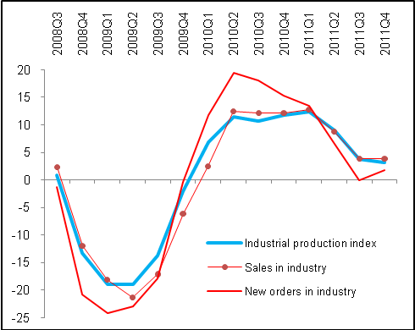 |  |  |  | 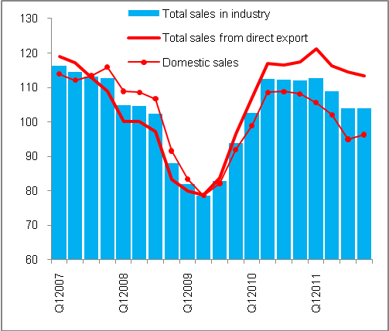
Graf č. 7 |  | Construction in 2011 (y-o-y in %, selected parameters) |  | Graf č. 8 | Sales in retail incl. automotive segment (in real terms, y-o-y in %)
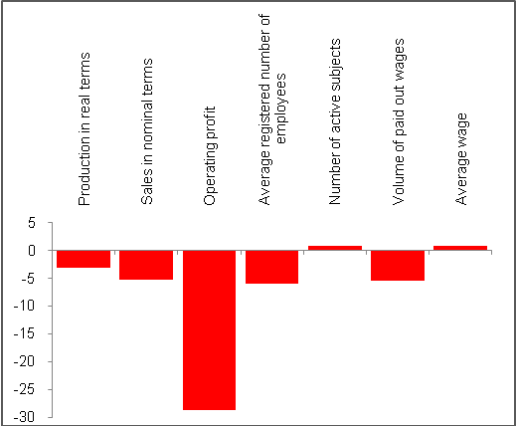 |  |  |  | 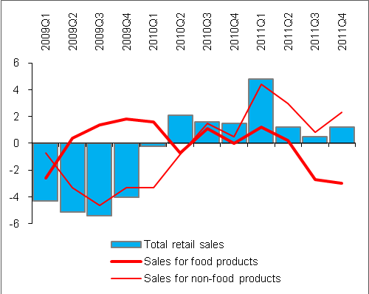
Source: CZSO

External Economic Relations
- External economic relations worsened despite improved current account deficit of the balance of payments |  | Balance of payments has worsened compared to 2010. CR received less foreign direct investment, inflow of portfolio investment was only a fraction of the volume in 2010 and markedly weaker was also the capital account surplus. Worsening eventuated despite the fact, that one of the measures of external balance developed favourably – current account deficit in 2011 improved thanks to the larger surplus in goods transactions and more favourable income balance. On the contrary, surpluses in export and import of services shrank compared to 2010 and the result of current transfers also worsened. In relation to nominal GDP the current account deficit experienced a positive change (2.9 % against 3.9 % in 2010).  Second measure of the sustainability of external relations, i.e. mutual compensation of deficits and surpluses inside the balance of payments however was not favourable in 2011. Financial account with its considerably smaller surplus compared to 2010 did not cover the current account deficit, even when adding the positive balance of the capital account.
- Trade balance higher by three quarters than in 2010, income balance improved |  | Current account deficit of the balance of payments in 2011 arrived at 109.1 bn crowns, by one quarter less than in 2010 (146.6 bn crowns), which represented significant improvement. Trade balance in the amount of 94 bn crowns was year-on-year by 40.2 bn crowns higher with the largest year-on-year addition since the Czech foreign trade in goods achieves surpluses. Export grew nominally by 12.6 %, import by 11 %. Trade in goods thus contributed to the improvement of the current account the most.  Income balance improved from the record deficit in 2010 (-285 bn crowns) to 271.9 bn crowns by the effect of higher inflow of money into the country, as well as year-on-year diminishing of outflow of money in the form of income from the Czech republic (neither repatriated profits nor the cost of labour of foreigners in the CR did reach the level of 2010).
- Surplus of services balance significantly weaker as well as the current transfers |  | Continuous growth of the surplus in the import and export of services, notable in the last six years switched in 2011 to fierce year-on-year lowering by 9 bn to 66.3 bn crowns. Receipts and expenditure for the Other services item had a neutral effect on the balance of services (they grew roughly by 10 bn year-on-year in both directions). Unfavourable was however the development of tourism – receipts remained year-on-year approximately the same (resp. fell by one billion to 135 bn crowns due to the impact of private travels), expenditure in the form of departures of residents from the Czech republic on the contrary grew by 3 bn crowns (for business travels from the larger part).  The balance of transportation services also worsened. Receipts decreased (-0.4 bn to 96.7 bn crowns) with simultaneous growth of expenditure (+5.6 bn to 84.3 bn crowns). The reason can also be a high price of fuels in CR and fuelling of transit transporters in the larger extent abroad.  Balance of current transfers deteriorated due to the slump in the 4th quarter caused by the lower receipts and higher payments to the EU budget (more in the chapter related to state budget).
- Strengthening of the weight of cars and spare parts on total export according to external statistics data |  | According to cross border statistics the weight of export of motor vehicles and their components on the total export from the CR in 2011 grew. While in 2010 the share of export of motor vehicles including components on its value arrived at 7.6 %, in 2011 it was already 8.6 %. The export eventuated in the value of nearly half a trillion crowns (461 bn crowns) and year-on-year the value of their export increased by 52.6 bn crowns which meant the second largest addition since 2000 (record occurred in 2010 with +63.5 bn crowns, for the preceding two years the value of their export decreased). Growth of value arose despite export prices of motor vehicles falling year-on-year for the most part of the year and negligible additions eventuated only in 4th quarter. It shows the significant export business ability of motor vehicle exporters.  There were in value terms imported by 39.9 bn crowns, in 2010 by 41.9 bn crowns of crude petroleum and natural gas more. Price influence empowered by the development of the exchange rate of crown had a significant effect, since in the volume expression the import of both petroleum and gas went down year-on-year.
- Lower share of EU 27 on total exports from ČR |  | Risk flowing from a very high focus on EU markets decreased in 2011. Their share on exports from CR fell to 83 % from 84 % in 2010, somewhat also the weight of Germany (to 32.1 % from 32.3 % in 2010). Despite the exports to Russia and China starting to grow markedly in the last quarter (by 40 %, resp. 30 %), their share in the export from CR is still very low – year-on-year growth of their shares has been so far only in the range of tenths of percentage (from 2.7 % to 3.2 % in case of Russia and from 0.9 % to 1 % in case of China).  Even thought the rate of growth of imports from China decreased in 2011 by one fifth (for example the boom of technologies for construction of sustainable sources of energy ended), the proportion of goods imported from China in total import to CR grew from 12.3 % in 2010 to 12.5 %. The proportion of imports from EU 27 also increased by 0.4 p.p. up to 63.8 %.
- Financial account notably weakened with the lower inflow of foreign direct investment… |  | In 2010 the financial account of the balance of payments of the CR was so strong, that its surplus in the amount of 174.3 bn crowns exceeded the aggregate deficit of the current and capital account by more than 60 bn crowns. Nevertheless, in 2011 it halved and even though the aggregate deficit of current and capital account was considerably smaller (94.4 bn crowns) than in 2010 (114.1 bn), it was not compensated by the weaker surplus of the financial account.  Inflow of the direct investment in the amount of 95.6 bn was year-on-year by one fifth lower and considerably weaker than the average in the last seven years (147 bn crowns), which can be caused by the cautiousness of the foreign capital anxious about the global slowdown. Domestic companies invested abroad 20.4 bn crowns mostly in the form of reinvested profits.
- … and notably lower net inflow of portfolio investment reaching 6 bn compared to 150 bn crowns in 2010 |  | While in 2010 the development of portfolio investment was significantly determined by the inflow of capital into the country, i.e. mostly by the purchases of bonds by foreign investors, this phenomenon was not repeated in 2011. While in 2010 the foreign portfolio investors bought debt securities (mostly Czech government bonds) in net worth 143 bn crowns, in 2011 worth only 19.8 bn. Their trades with shares were from the view of resulting net balance negligible. Domestic subjects bought foreign bonds worth in net expression 14.3 bn crowns and selling shares.  Aggregate inflow of portfolio investment to CR amounted to 5.9 bn crowns; in 2010 it was 150.4 bn crowns. Given the issue of government bonds in 2011 it seems that their buyers were mostly subjects in the CR.
- Czech currency appreciated |  | Czech currency was appreciating in the long term. It is notable out of the development of the exchange rate of crown towards main currencies, that the rate was a significant factor in the convergence of CR to the average level of the European currency union (with the exception of 2009 characterised by depreciation of average yearly rate against euro and 2009-2010 period with depreciation against the us dollar). For the 2004 to 2011 period the crown appreciated against euro by 22.9 % and against dollar even by 31.2 %. In 2011 the crown was traded on the currency exchange market at an average rate of CZK/EUR 24.586 and CZK/USD 17.688, which represented against the year 2010 appreciation by 2.8 %, resp. 7.4 %.
Price competitiveness of CR worsened |  | Cost competitiveness of Czech Republic in 2011 according to the change in real effective exchange rate of crown in comparison to 2010 worsened due to the development in the 1st half of the year, on the contrary it grew in the remaining part of the year. The year after crisis 2010 on the contrary witnessed mild improvement, in 2009 stagnation. Generally it can be noted that the worsening of cost competitiveness will logically occur by the impact of further increasement of the development of the Czech economy.
Graf 9 | Selected items of the balance of payments (balances, in mil crowns, 2010 and 2011) |  | Graf 10 | Export of motor vehicles, parts and total export from CR (y-o-y in %)
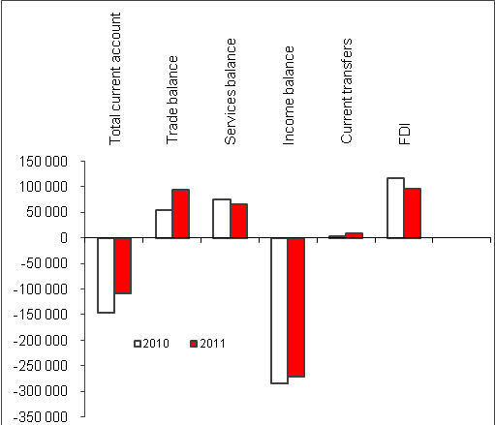 |  |  | 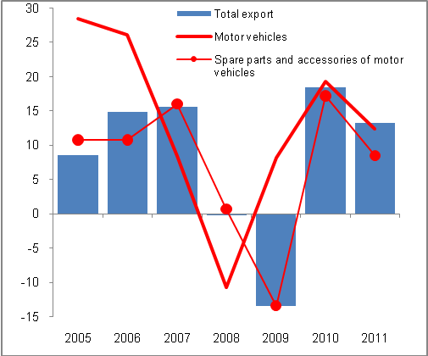
Source: ČNB

Prices
Aggregate price level decreased given varied development of producer prices, consumer prices and opposing effect of terms of trade | Movement of prices was characterised by the decrease in the aggregate price level in 2011. Adverse development of prices in foreign trade had such an impact that even though producer prices in industry and agriculture grew markedly and consumer prices increased, implicit deflator gauging the aggregate price level in the Czech economy dropped year-on-year by 0.7 %.  Prices in agriculture were determined by the effect of closing scissors of prices of vegetable and animal production, rate of growth of prices in industry then strong additions in the first half of the year. Price deflation of construction works deepened, prices of market services renewed their growth. Terms of trade were negative and only slightly better compared to 2010. Overall the price development was affected by stronger supply impulses in the first half of the year and the drop in demand in the rest of the year.
- Agricultural prices grew in 2011 by one fifth, prices of grain by 47 %; compared to prices of 2005 the prices of vegetable production were raised by one half, animal production was cheaper | Rate of growth of agricultural prices were from the second half of the year diminishing based on the dynamics of prices of vegetable production, which on the contrary for the prices of animal products practically stagnated in each quarter. Thus it created a phenomenon, last occurring by the end of 2008 – that the animal production was regarding the prices below the dynamics of the prices of vegetable production, however at that time in the deflation zone. In the 4th quarter, the prices of vegetable products grew year-on-year only mildly (+3.1 %) after notable drop in prices of vegetables (-37 %) and potatoes (-46 %). Prices of animal products were up by 8.3 % (prices of eggs and pigs were raised by one tenth).  Lowering of the rate of growth of prices of the agricultural producers was enabled in 2011 by a good harvest. Development of prices also allowed the growth of profits in agriculture – operating economic result for 2011 was remarkably higher compared to 2010. For the whole year the prices grew by 19.1 % (for vegetable production by 29.9 %, for animal production by 7.6 %). Prices of grain raised nearly by one half (+46.9 %) had in the price chain via manufacturers and traders a sharp impact on the prices of bread.  In comparison to 2005 the agricultural prices were higher by 21.2 %, in that the prices of vegetable production by 48.7 %. Prices of animal products on the contrary for the last six years went down by 2.2 %.
- Second largest growth of prices in industry since 1995 | Industrial prices moved up in 2011 by 5.6 %, which was second largest year-on-year growth for the last sixteen years (in 1995 +7.4 %). It was the consequence of the growth in the preceding grades of the price chain, which were influenced by one fifth’ increases of prices in manufacture of coke and refined petroleum products. Above average lay also manufacture of food products (+7.7 %), mining (+6.9 %), chemical products (+8.6 %) and metallurgy (+8.5 %). The last two named however experienced in the last quarter a slower rate of growth due to the reaction on changes in demand. Continuous fall of prices occurred in manufacture of computer, electronic and optical products, prices of transport vehicles were in 2011 year-on-year lower by 1.9 %.
- Quarter-on-quarter revival of prices in 4th quarter favourable | Strong quarter-on-quarter growth of prices in the first half of the year slowed down to stagnation in the 3rd quarter, in the 4th quarter then prices quarter-on-quarter revived somewhat (+0.4 %), which is positive when evaluating the demand for industrial goods. Quarter-on-quarter growth in the 4th quarter was affected mostly by the revival of the prices of transport vehicles (+2 %) after previous relatively long deflation, which increased also the quarter-on-quarter growth of prices in manufacturing, which then determined the overall dynamics of industrial producer prices. The revival of industrial prices in 4th quarter is important, since it can signal more favourable turn of the demand, which is noticeable also from the cessation of falling tendency of orders in industry.
- Prices of construction works further fell, prices of market services revived | Drop of prices of construction works from 2010 (-0.2 %) deepened to -0.5 % as a reflection of adverse situation in industry (reduction of prices was continuous in every quarter). On the contrary the prices of construction materials and products used in construction grew more notably (+2.8 %) than in 2010 (0.6 %). Prices of market services grew for the whole year by 0.9 %, again following a continuous growth in individual quarters: in 1st quarter only by 0.3 % - which was first addition after deflation in 2010 -, in the last quarter then by 1.3 %. Prices surprisingly revive even though the sales for these services were falling nearly the whole year.
- Inflation relatively low given marked raising of prices of food products, housing and supportive services and also the transportation | Prices were for consumers in 2011 by 1.9 % higher than in 2010. This relatively low increase however covers the fact, that considerably faster grew prices of goods and services which are necessities for consumers, which was in part compensated by the drop in prices of items, whose consumption is not regular. Overall growth of prices started at +1.7 % in the 1st quarter and ended at +2.4 % in the last quarter. Raised prices of necessities, which were faster than the aggregate inflation, were the most notable for food products (+4.6 %, in the 4th quarter by +5.3 %). These increased in the sharp rise of the prices of bread – from +6.4 % in 1st quarter to +16 % in 4th quarter – to year-on-year growth of +14 %, but the raising of prices occurred through the whole range of food products. Prices of housing and energies were higher by 2.8 % given the growth of prices of natural gas by 11.8 %. Prices in transportation (+2.8) were affected by the growth of prices of fuels (+9.9 %), where the increments stayed around 10 % for the whole year. Prices of holiday, household equipment fell down and lower were for the whole year as usual also the prices of clothing and footwear.
- Unfavourable terms of trade with growing import prices and stagnation of export prices | Unfavourable terms of trade (negative since April 2010) worsened the nominal result of the foreign trade – less intensively since the 2nd quarter. Quarter-on-quarter view improved the 2nd quarter (in June the import prices dropped and the terms of trade jumped to positive values). In 4th quarter the prices of import grew faster (+6-5 %, whole year +4-3 %) than export prices (+4.6 %, whole year +1.7 %). Exporters of motor vehicles exported in 2011 cheaper than in the previous year (-2.5 %), import prices were pushed up by the imported mineral oils, whose prices were raised by one quarter. Machinery and transport vehicles were imported cheaper. Exchange rate effect in the 4th quarter due to the depreciation of crown prices in the foreign trade pushed up.

Graf 11 | Prices of producers (y-o-y in %) | Graf 12 | Consumer price inflation by social groups (CPI, y-o-y in %)
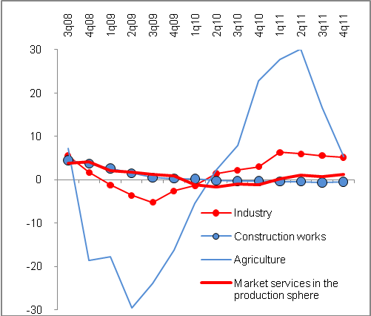 |  | 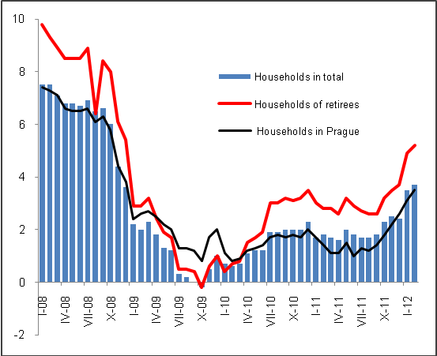
Source: CZSO

Labour Market
- Negligible revival of the labour market in 2011 |  | Labour market only slightly revived in 2011. Total employment – by the national accounts methodology - not only did not reach the pre-crisis levels, the yearly growth by 12.7 thousand persons (+0.3 %) was the lowest addition (within the growth years) in the time row beginning 1995. Economy employed 5067.3 thousand persons, less then in 2007.
- Aggregate employment in 4th quarter fell quarter-on-quarter |  | In 3rd quarter the employment rose against the 2nd quarter (+0.4 %) by a rate comparable to the highest after crisis year-on-year addition in the same period of 2010. Worsening came in the 4th quarter, with the decrease of quarter-on-quarter 0.3 % employees. The drop affected nearly all industries with the exception of agriculture and some branches of services (activities connected to real estate, varied group of professional, scientific and administration activities, but also the public sector and defence, where the employment was falling from the 2nd quarter of 2009 except for the break of 2010 and 2011).
- The trend of previous two years of growing numbers of entrepreneurs and lowering numbers of employees continued |  | Addition to total employment resulted from the higher numbers of entrepreneurs, since the numbers of workers with the status of employee again decreased in 2011 (-6.8 thousand). The losses of employee job positions were not as extreme as in 2009 and especially 2010 (-83 thousand, resp. -127 thousand), but they confirm the fact, that the Czech economy did not create adequate number of vacant positions in 2011.  Most numbers of employees dwindled according to data from national accounts in construction (-14.2 thousand), which is at the same time the only branch experiencing simultaneously the lowering of number of entrepreneurs (-3.1 thousand persons). Most people found new employee positions in trade, transportation, accommodation and hospitality industry (6.5 thousand). Total employment grew the most in manufacturing (+10.8 thousand persons), it fell apart from construction also in the agricultural sector (-4.4 thousand persons). Year-on-year grew also the numbers of employed in public sector and defence, education, health care and social care (+2.5 thousand persons), however after deep fall in (-35.8 thousand), so the overall employment (882 thousand persons) is here roughly at the 2007 level.
- Unemployment rate lower than in Europe, but featuring further dangers |  | Unemployment rate measured by the Labour Force Sample Survey according to the international methodology seasonally adjusted was throughout the year 2011 quarter by quarter decreasing from 7 % in 1st quarter to 6.6 % in the 4th quarter. Yearly average reached 6.8 %. In European comparison it is a favourable value – in the euro area the rate of unemployment exceeded 10 % beginning May 2011, in EU 27 from November. However structural issues of the labour market in the CR remain – the mismatch in the structure of supply of vacancies and demand (the largest demand exists for qualified tradesmen and repairmen for already two years).
- Real wage slowest in the decade |  | Wage development was not favourable. Average monthly nominal wage increased in 2011 year-on-year by 2.2 % to 24 319 crowns. Even though it was more than in 2010 (+1.9 %), still it was the second most modest wage raise in the last eleven years. This low addition together with the growing consumer prices means that the real wage in the CR increased only by 0.3 %, again the least since 2000. In the 4th quarter it even fell year-on-year (-0.2 %).  The difference between higher average wage in the private sector (24 326 crowns) and the public sector (24 287 crowns) in 2011 practically disappeared (in 2010 it arrived at 576 crowns). However, it can again grow as a consequence of the intended budget cuts, if the public sector is not forced to solve the situation by massive lay outs.  Second slowest growth of average wage in a decade for the employed in the business sector lowered given the growing raising of prices in 2011 year-on-year addition to their real wage (+0.8 %) to the lowest level in the given period – in the last quarter it fell by 0.3 %). Further, mere stagnation of average wage in the public sector (+0.1 %) on the contrary decreased the real wage of people employed in their institutions compared to 2010 by 1.8 %. It has been lower each quarter year-on-year already since 2nd quarter 2010. Given that in 2011 there were over 882 thousand of persons employed in the public sector, this wage development sends a negative signal regarding the abilities of households to spend. Subsequent fall of their consumption expenditure will be negatively reflected in the growth of the Czech economy.
Graf 13 | Total employment and numbers of emplyees (y-o-y in %, seas. adj. national accounts methodology) |  | Graf 14 | Nominal and real wage (y-o-y in %, recalculated values, monthly average)
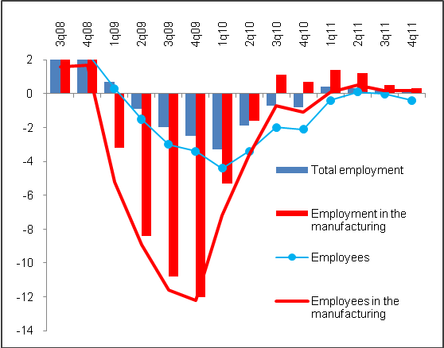 |  |  | 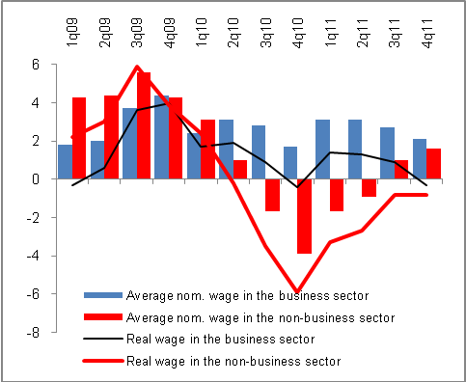
Source: ČZSO

Monetary Conditions
- Growth of nominal GDP was markedly lower than the dynamics of money supply and monetary conditions had an expansive effect |  | The growth of money supply in the Czech economy was in 2011 compared to 2010 from three quarters influenced by the addition of one-day deposits (+7.1 %), on the asset side then the growth of domestic loans (+9.9 %) driven by the expansion of loans to the government sector (+48 %). In total the money aggregate M2 showed year-on-year growth of 5.2 % and reached 2993.8 bn crowns. With respect to the fact that the GDP grew in nominal terms notably slower, the monetary conditions had in this regard an expansive effect, in that more intensively in the second part of the year.  The level of term deposits (i.e. deposits with maturity and notice period) increased in 2011 by 18.8 bn crowns (year-on-year +2 %). Revival occurred only in the last four months of the year. In the 1st quarter these deposits were each month markedly lower than in the same period of 2010 (on average by 14.2 %). Enhanced tendency of households to save, notable in the last quarter was apparently accompanied by the anxiety regarding the future financial health, which they also reported in the answers for Business Cycle Survey.  Since half of the year the growth of currency (money in circulation) in the economy also increased its pace (in December by +5.7 % year-on-year). Even this concentration of cash reflects the weak consumer confidence.
- Household deposits to all types of accounts rose by 82.7 bn crowns |  | In total, people increased their deposits in 2011 according to the bank statistics by the same rate as in 2010 – their one-day deposits, term deposits and deposits with maturity and at redeemable notice period in total by 82.7 bn crowns, i.e. similarly as in 2010 (80.7 bn crowns). However, in 2009 this increment was higher by one half (125.2 bn crowns).  However sharp reversal occurred for the savings of enterprises, whose deposits in this aggregate view grew in 2009 and 2010 year-on-year only negligibly (by 6 bn., resp. 9 bn crowns), but in 2011 much sharper (+54 bn). It was the consequence of weak investment activity.
- People behave rationally also regarding the debts: limit „the most expansive„ loans, take less and less of new for consumption… |  | Household loans grow, even though by a lower rate of growth. It is determined by the dynamics of mortgages, which remained from March till November stable at the +5.8 % level and in December it grew to +6.1 %, which could have been linked to the coming growth of the VAT rate on new houses. In total the people borrowed year-on-year more by 5.7 %, in 2010 by 7.5 % and in 2009 by 11.7 %. Currency risk is nearly negligible for deposits – compared to for example Hungary the loans in foreign currencies amounts in the CR only to 0.7 ‰ of total loans to population and 0.3 ‰ loans for consumption.  People are mostly repaying their actual liabilities. Consumer loans representing roughly one quarter of the volume of mortgages was year-on-year by 1.6 % lower. They started to fall beginning September and their decrease accelerated mostly due to the weakening consumer non-purpose loan, whose levels were in December lower by 3.5 %.
- … and are repaying their liabilities on credit cards and overdrafts |  | Eliminated is also the credit drawn by means of debit and overdraft balances on the current accounts, which did not grow year-on-year. They are very expensive featuring usually the same interest rates as the credit cards. Even they reveal the change in the behaviour of clients. While in 2010 the credit drawn by their means went up on average annually by 26.8 %, by the end of 2011 the increment amounted only to 2.6 %, again characterised by a falling tendency especially in the second part of the year. Households thus react – as in the case of limiting their consumption and enlarging the term deposits – to the weak supply of vacancies, lasting higher unemployment and only very mild growth of wages.
- The market of building savings societies is shrinking |  | Already since November 2010 the people started to limit taking bridging loans from building savings societies, whose rate of fall is accelerating (-17.3 % in December). Since the half of the year the balances of standard loans from building savings started to drop (-2 %). Apart from the fast reduction of loans the sector of building savings societies is „shrinking“ also thanks to the immense loss of the deposit dynamics. While in the period of 2003-2006 the deposits at building savings societies rose every year on average by 19.2 % and in the period of 2007-2010 by 4.6%, in 2011 their addition came to mere 1.1 %, that is 4.8 bn crowns.
- Households more in debt than the business sector |  | Despite mentioned development in the area of consumption loans from building saving societies was by the end of the year the households sector more indebted (1118 bn crowns) than the business sector (952 bn crowns). Levels of business loans has not reached the precrisis levels yet, on the contrary following their continuous growth from February till November their year-on-year addition in December mildly slowed down (+5.1 %). In total the credit to businesses and households in 2011 increased by 5.5 % against +3 % in 2010 and +0.8 % in 2009.
- Responsible repaying of debts with a lower share of risky loans |  | While in 2010 the proportion of risky loans out of total level of loans was growing, in 2011 their share decreased, in that more for enterprises (from 9 % to 8.2 % of total loans of non-financial businesses) than the household sector (from 5.2 % to 5 %). More disciplined proved in this sector the segment of entrepreneurs, since with respect to households the share of risky loans (that is failed loans) on their total loans was the same (5 %). Still the mentioned proportions were in 2011 worse in comparison to 2009 (comparably for sectors 7.9 %, 4.1 % and 3.8 %).
- Mild drop of the rates on credit, stagnation of rates on household deposits |  | Commercial banks left the interest rates on household deposits practically the same as in 2010 (-0.01 p.p. to 1.21 %), for deposits of companies they were slightly increased (+0.04 p.p. to 5.1 %). Regarding the loans the interest rates slightly fell in relation to both sectors – especially in case of new mortgages from 4.55 % to 3.94 %, but also consumption loans (from 14.05 % to 13.58 %). Due to this the drop in the margin of banks in both cases continued. The difference between the client interest rates and the price of money on the interbank market also diminished.
- Drop of net foreign assets |  | For the first time since 2007 the net foreign assets of the Czech Republic fell year-on-year (-1.6 %) due to their lowering on the part of business banks. Net domestic assets grew by 9 % thanks to the growth of domestic credit, mostly to the government sector, whose net credit including securities increased year-on-year by 109 bn crowns.
Graf 15 | Money supply, change in loans to businesses and households, deposits (y-o-y in %) |  | Graf č. 16 | Proportion of failed loans on total loans of sector (segment) (in %)
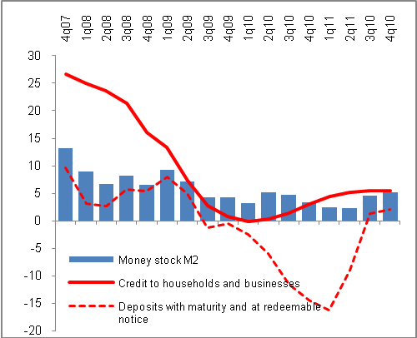 |  |  | 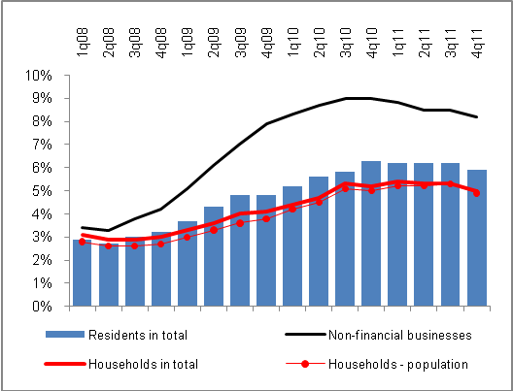

Source: CNB

State Budget
- State budget deficit improved given mild growth of receipts and stagnation of expenditure | State finances improved year-on-year, even though the result was below the approved budget. The effort to shrink the deficit lowered the budget deficit to 142.8 bn crowns. It was by 13.7 bn crowns better than in 2010. The outcome resulted from the higher receipts (year-on-year by 12.8 bn crowns) and stagnation of expenditure (-1.3 bn crowns). However, higher budget receipts in 2011 were only one half of receipt addition in 2010 and realised expenditure cuts were already milder. At the same time in the half of the year the total receipts were below the level of the same period of the previous year and the expenditure fall was then deeper than the fall of receipts.  Yearly state financial result was in 2011 the third worst in the history. Nevertheless, in relation to the weak growth of nominal GDP the budget deficit improved to 3.7 % from 4.1 % in 2010.
- Anticipations of tax receipts were more optimistic than the reality…. | Total budget receipts grew by 1.2 % (+12.4 bn crowns). Unfortunately, their anticipated level was not reached – approved budget calculated their year-on-year growth by more than 55 bn crowns, the adjusted budget from the end of September even by 70 bn crowns. In the end the budget receipts increased, also by the impact of recession in the second half of the year, only by 12.4 bn crowns.  Receipts from taxes were 20 bn crowns less than expected, in that on VAT by 3 bn crowns less. Collection of consumption tax was nearly in accordance with the budget anticipations. On the contrary enterprises paid on income tax less than anticipated, which was however lower than the expected income in 2010. Income taxes from physical persons were also by 11 bn crowns behind the budget anticipations.
- …but still the total tax receipts higher than in 2010 | In spite of notably more optimistic anticipations of the budget were the tax receipts overall higher than in 2010 with the exception of corporate tax. Aggregate tax receipts excluding social security insurance increased year-on-year by 3 %. The largest increase out of the so called big taxes experienced the consumption tax receipts (+6.4 %) also thanks to taxed solar energy (5.9 bn crowns against anticipated 4.2 bn crowns). VAT grew by 2.2 %, income taxes from physical persons by 3.6 %. Corporate tax fell by 4.6 % (-4 bn crowns), which the tax administrator ascribes to the writing-off the losses from the period of economic crisis.
- Other than tax receipts lower year-on-year by more than one tenth | Fall affected non-tax and capital receipts of state finances, to the large extent especially the received transfers. From EU and National fund the CR received by 7 bn crowns less than in 2010. Nearly all items of this group of receipts apart from received sanction and court charges experienced marked slump and the total year-on-year fall arrived at 10.2 %.
- Growth of current expenditure compensated by the fall of capital expenditure | Aggregate budget expenditure was year-on-year lower by 0.1 % given the growth of current expenditure by 1 % and the fall of capital expenditure by 8.3 %. State paid out by 22 bn crowns more year-on-year on retirement pensions (+6.3 %). All other current expenditure excluding payments to EU budget and state contribution to superannuation were lowered compared to 2010 - by one quarter the unemployment doses, by one third the expenditure on the active policy of employment, item of state social support in total by 5 bn crowns (-11.7 %). In total the current budget expenditure was higher by 9.9 bn crowns, on the contrary the capital expenditure lower by 11.2 bn crowns.  The state saved the most on the wages of its employees (-8.1 bn, in the half of the year -3.7 bn crowns year-on-year), on non-investment transfers to state funds (-7.2 bn, in the half of the year -4.7 bn year-on-year), on unemployment doses (-3 bn, in the half of the year -1.5 bn crowns). The state spent on remaining items of current expenditure affected by cuts by 6.7 bn crowns less compared to 2010.
- Further worsening of the retirement pension account | Retirement pension account deficit as the difference between received money in the form of social insurance meant for pensions on one side – which after slowdown in the second half of the year increased annually by 3.1 % -, and paid out pensions on the second side (+6.3 %), further worsened and exceeded 42 bn crowns. In the first half of the year it amounted to near 25 bn crowns.
- Superannuation slightly weakened, building savings with a one quarter fall | Forms of saving supported by state recorded in 2011 the loss of dynamics. Interest in superannuation based on the addition of new contracts decreased already for the third year in a row (-7.8 % in 2011), which did not show in the amount of paid state contribution (5.6 bn against 5.5 bn crowns in 2010). State contributed to members on average 105 crowns monthly. In the last three years people saved monthly less than in 2008.  The volume of state support of building savings has shrunk in the last six years by one third (from 16.1 bn in 2005 to 10.7 bn crowns in 2011). It can be contributed partly to the legislative retreat of the state from the size of this support and tightening of the conditions for its acquirement, but also to a lower interest in the building saving resulting from this procedure by clients. In 2011 the building saving impacted also the receipt side of the budget, where in the receipts from income taxes of physical persons did not show the anticipated 5.5 bn crowns, which the state plan to gain by placing a 50% tax on its contribution and which was cancelled by the Constitutional court.
- Gross state debt increased to 1499.4 bn crowns, costs for its servicing to 55.6 bn crowns | Costs to service the state debt of the CR grew in gross terms to 55.6 bn crowns (against 48.7 bn in 2010), in net terms then to 45.1 bn crowns. In that the volume of interest on internal debt amounted to 44.3 bn crowns, foreign issues of bonds then 10.1 bn crowns. Issue of bonds of CR are in the auctions demanded in higher volumes compared to the supply, which shows a relatively favourable assessment of riskiness of Czech republic on the part of investors (exception was the failed November auction).  Gross state debt reached one and a half trillion crowns. It grew to 1499.4 bn crowns from 1,344.1 bn in 2010 and 1178.2 bn in 2009. It is for the major part (83 %) located in medium- and long-term bonds. After including state financial assets the net debt portfolio of CR amounted by the end of 2011 to 1378 bn crowns.
- Higher payments to EU budget, after sanctions then lower received payments; for 2004-2011 period CR received 176 bn crowns net | Financial relation to EU had a significant impact on the state budget deficit in 2011. The CR had to after the revision of national accounting and reported higher level of GDP additionally pay out 5 bn crowns. On the contrary for obscurity in drawing EU suspended paying out money from its budget, which had been however from national sources prepaid.  Positive net balance of the CR thus in 2011 markedly worsened. It fell to 30.7 bn crowns from 47.9 bn in 2010 and 42.3 bn crowns in 2009. In 2011 the CR paid to EU budget 41.7 bn crowns and gained 72.5 bn crowns. The received amount was mostly created by the structural actions (structural funds 42.5 bn, cohesion fund 1 bn) and funds for agriculture (26.5 bn crowns with the largest share of direct payments, i.e. 16.1 bn and funds for development of countryside in the amount of 9.8 bn crowns).  In the period 2004-2011 the CR paid to the EU budget over one quarter trillion of crowns (261.3 bn crowns) and received 437.5 bn crowns. By its accession to union the Czech Republic has so far gained 176.1 bn crowns net.

Sources of data: CZSO, MF CR, CNB, Eurostat, CZSO calculations.
Latest information from the CZSO, CNB and MLSA sources given in this report are dated the 9th of March 2012.

Unless stated otherwise, data related to GDP and its components are considered in real terms and adjusted for seasonal and calendar effects.
Wider definition of a country falling to recession assumes that quarter-on-quarter decline lasting two following quarters relates not only to GDP, but to employment as well.
More on the structure of growth of the gross value added in chapter Industry Performance.
Data for Greek economy are stated by Eurostat only till 2nd quarter of 2011.
Accross the border concept.
Sales from direct export relate to the sales on foreign markets, arranged directly by the companies not by the exporting agency.
In the methodology of balance of payments (national approach), both export and import in FOB prices.
Using GDP deflator and weights of total foreign trade turnover.
According to the definition of International Labour Organisation (uniform for all EU member states), the unemployed are all persons who were during the reference period without work, did not work even one hour for wage or reward and were actively seeking work, and were available to work within two weeks at the latest. Definition of the unemployed by the ILO differs from the definition of „job applicants“ registered by the labour Office of MLSA.

