The Czech Economy Development in the First Half of 2012 September 2012

Prices
- Varied development of prices | The development of producer prices was a varied one. The prices of industrial producers were rising, while the prices of agricultural producers were falling. The deflation was apparent in the prices of construction works and market services as well. The price development thus corresponded to some cycles of individual industries and to price development on global markets. The increase of consumer price has recorded a moderate slowdown.
- Prices of agricultural producers recorded a further decrease | In Q2 2012, the prices of agricultural producers recorded a year on year decrease by 1.7%. Therefore, the trend from Q1 2012 continued. The prices of vegetable products were again in a year on year comparison lower, this time by 7% (in Q1 they were lower by 11%), and their weight was responsible for the drop in the total prices of agricultural producers. The prices of animal products have again posted a year on year increase for nine consecutive quarters (+5.8% against 10.6% in Q1). In particular, the lower price of potatoes that recorded a year on year drop by 42.3%, was responsible for the decrease in the price of vegetable products. The price of cereals and fruits have also decreased by 7.3% and 4.3% respectively. Not even higher prices of vegetables by 11.5% could stop the slump in prices of vegetable products. The growth of prices of animal products was affected by the increase of egg prices by 79.7%, and pigs by 15.8% and cattle by 9.3%.
- Slowdown of growth of prices of industrial producers | The growth of prices of industrial producers slowed. In Q2, prices recorded a year on year increase by a mere 1.8% (in Q1, the year on year increase was 3.6%). Despite the fact that the prices were well above average, the prices of coke and refined oil products slowed their increase (+8.1% against 16.7% in Q1). On the other hand, the prices of chemical substances and products recorded an increase well above the average (+6.4%, in Q1 by 3.7%). The same applies to food products, beverages and tobacco (+2.1%, in Q1 by 5.6%). The trend of year on year growth of the prices of the above-mentioned three groups of industrial products can be seen as long lasting. The year on year increase of the prices in the field of water supplies and waste water treatment services was also well above the average (+8.1%).  A significant year on year drop in prices was recorded in the mining and extraction industry (-5.1%), which may affect the decrease in prices of energy and construction materials. In the manufacturing industry, the prices of wood, paper and print producers (-0.6%), general metals and metalworking products (-0.2%) and electrical equipment (-0.5%) fell.
- Deflation of prices of construction works and market services | Based on estimates, in Q2 2012 the prices of construction works recorded a year on year drop by 0.6%, while the price of materials and products used in construction industry rose by 1.6%. When comparing prices of construction works between Q2 and Q1, a drop by 0.2% was noted, while the prices of materials and products used in the building industry grew by 1.1%.  In Q2 2012, the prices of market services dropped by 0.7%. Prices for advertising services and market research were again lower by 3.4% (In Q1 2012 the year on year increase stood at 5.3%, and cyclical changes in this segment can be seen again). In a year on year comparison, also some architectonic and engineering services and related technical consulting recorded lower prices by 2.7%, followed by services in the field of real properties by 0.8% and telecommunication services by 0.5%. Higher prices were also recorded by freight traffic by 0.9% and financial services, except for insurance and pension financing, by 1.5%.
- The growth rate of consumer prices recorded a moderate drop, which was mainly influenced by foodstuffs | The growth of consumer prices slowed down moderately in Q2. In a year on year comparison, consumer prices rose by 3.4%, which was less than in the previous quarter by 0.3 percentage points. The year on year increase of the average harmonised consumer price index (HICP) remained for the Czech Republic (+3.8%) in June 2012 for six consecutive months higher than the figure for the EU-27 (+2.5%). Individual items of the consumer basket saw a different development. In particular, prices in the section concerning food and non-alcoholic beverages, health and transport were responsible for a moderate slowdown of the price increase. On the other hand, the items concerning accommodation and catering, other merchandise and services recorded a moderate increase. In the section “food and non-alcoholic beverages” the increase of prices for bakery products and cereals, oils and fats, sugar and coffee slowed down, which was influenced by a sharp increase of prices in Q2 2011. For instance, the price of bread was in a year on year comparison higher by 6.9%, while it rose by 17.5% in Q1. The slowdown of prices in the transport industry may particularly be attributed to a low year on year increase of fuel prices.  The year on year growth of market prices recorded a moderate slowdown to 2.1% (in Q1 2.3%), while the growth of regulated prices slowed by 9.5% (in Q1 9.8%).
- Terms of trade in negative values for ten consecutive quarters | In Q2 2012, terms of trade posted a year on year moderate decrease to 98.3% (a drop by 0.1 percentage point against Q1), and for ten consecutive quarters they have remained at negative values. In Q2, export prices recorded a year on year increase by 3.9% (a drop by 0.1 percentage point against Q1). The export prices of chemical substances (year on year by 6.2%), and industrial consumer goods (by 4.9%) posted a significant increase. There was a significant drop in export prices of mineral fuels (by 5.4%). The most significant year on year increase was recorded by the import prices of mineral fuels (by 18.3%) and chemical substances (4.8%). The import prices have not decreased in any of the groups.

Chart No. 11 | Production prices in agriculture (y/y in %) | Chart No. 12 | Consumer prices (2005=100)
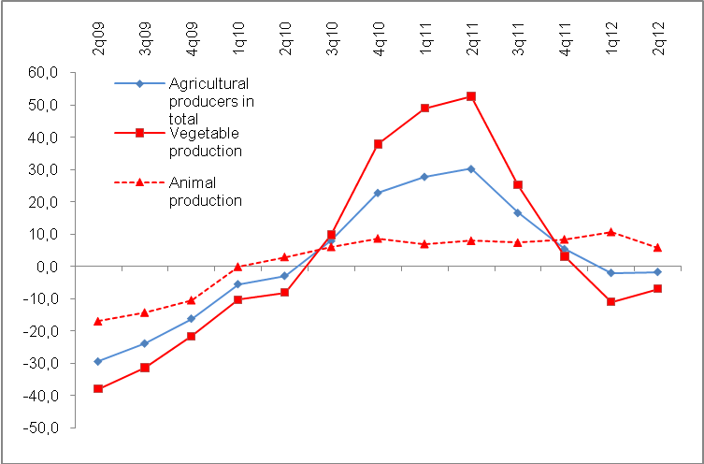 |  | 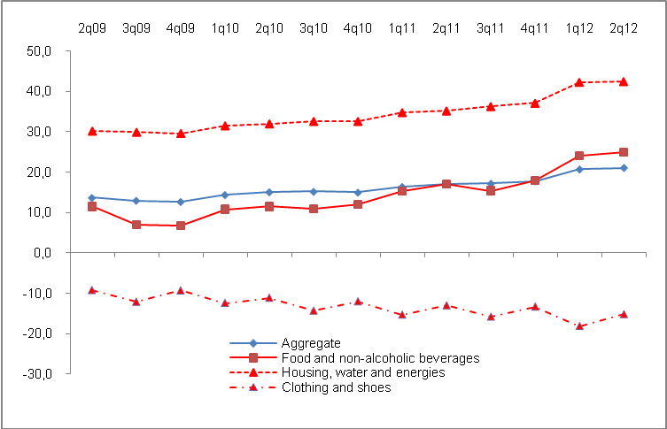
Source: CZSO

