- Macroeconomic development of the Czech Republic in the European context with regard to 2011

The Czech Republic economy became more dynamic following its entry into the European Union. A similar effect occurred in most of the countries that joined the project of a common European space with free movement of goods, services and capital and labour. Even though their economic cycles are not yet synchronized with the EU-27 cycle, some countries with a higher share of international exports in their economic performance draw benefits from that. The Czech Republic, predominantly with good growth in the European context in 2001–2011 and particularly in 2006–2011, saw declining performance in 2011, and in the ranking of the 27 countries of the EU it was positioned in the middle, which represented its second worst position after 2002.

  - Performance of the economy by the development of gross domestic product

- In 2011, the position of a fast growing economy in the European context was lost |  | While the Czech economy has featured predominantly in the first third of the ranking of the EU-27 since 2004, it was positioned in its bottom half in 2011 with the reason being that the post-crisis performance-related development was on the par with the EU average and the slump of the Czech economy in 2009 as such was slightly deeper than the decline of the EU-27. At the same time, the growth structure in 2011 was different from the growth structure of EU-27. While household and government final consumption expenditure participated substantially in the increase of GDP of the EU, the same role was played by foreign trade in the Czech Republic.
- GDP growth of the CR in 2011 was slightly higher than growth of the EU-27 and Eurozone |  | The gross domestic product (GDP) of the Czech Republic in real terms grew by 1.7% in 2011 against 2010, representing a slightly faster pace than the growth of the economy of the European Union (+1.5%). The so-called “old” EU countries that were members of the Union before 1 May 2004 when ten new countries joined the EU, recorded even slower growth (+1.4%). The growth rate of the group of countries using the euro was the same as the year on year dynamics of the EU-27 (+1.5%) in 2011.
- Strong Germany in 2011 |  | At the same time Germany, being the largest European economy, saw very strong growth (+3%), therefore the dynamics of the “rest” of the three large economies of the old member states (EU-15) were logically mostly lower. The economic growth of Italy (+0.4%) and the UK (+0.7%) was below the average of the EU-15, while the economy of France (+1.7%) stood above the average.
- Three countries with year on year falls |  | A year on year fall was recorded by some “peripheral” economies of the European Union (Slovenia -0.2%, Portugal -1.6% and Greece -6.9%). After the double-digit slumps in the crisis year of 2009, the Baltic states posted the fastest growth (Estonia +7.6%, Lithuania +5.9%, Latvia +5.5%) along with Poland (+4.3%) and also Sweden (+3.9%). In real terms, the GDP of the troubled Ireland that had been on a steady decline in the previous three years, recorded a moderate growth in 2011 (+0.7%).
- Regarding the growth rate, the Czech economy had been positioned in the first third of the ranking of the EU-27 since 2004, in 2011 it was in the middle of the ranking |  | The post-crisis surge of the Czech economy – in real terms GDP fell by 4.7% in 2009 – was demonstrated by GDP growth of the Czech Republic in 2010 (+2.7%) which was only slightly higher than the growth in the EU-27 (+2%). This was sufficient for a place among the top five fastest growing economies in 2010. However, it only remotely recalled the massive year on year surge in performance from 2005–2007 when the Czech economy in real terms converged strongly towards the EU level, in terms of increases – +6.8% (2005), +7% (2006) and +5.7% (2007).  However, these massive spurts of growth were sufficient for the position in the first third of the ranking of countries with greatest GDP dynamics only in 2005 and 2006 – in 2005 the Czech Republic took the fourth place behind the Baltic states, and in 2006 it was also surpassed by Romania and Slovakia. In the past ten years, the Czech Republic featured in the first third of the fastest EU countries also in 2004, 2008 and 2010. In 2011, the position in the middle of the ranking (14th place) is the second worst after 2002 (16th place).
Chart No. 12 | Real GDP (y/y in %, comparison of countries and groupings) |  | Chart No. 13 | Real GDP of CR in quarter on quarter (seasonally adjusted) and year on year comparison (in %)
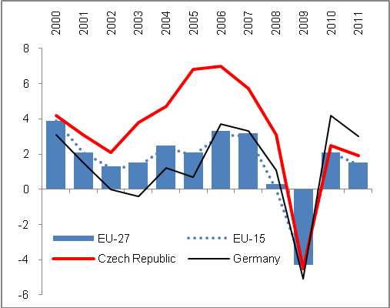 |  |  | 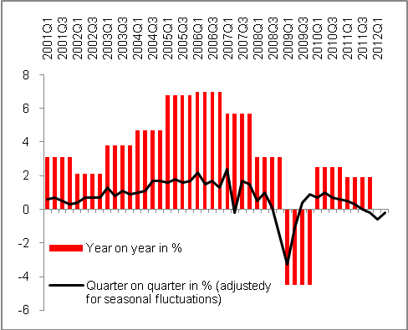
Source: CZSO, Eurostat

- From the long-term perspective, the economic performance of the CR has grown three times faster than that of the EU-27… |  | From the long-term perspective and in the European context, the Czech Republic is among states whose GDP volumes have significantly increased – in 2011 GDP was two fifths higher (+41.9%) than in 2000. It was the eighth greatest increase in economic performance among the EU-27 countries. Although the figure for the EU average is not yet available, it can be concluded based on the data for 2010 (+13.9%) that the GDP increase in the Czech Republic was three times higher than that of the EU-27 in 2011 as compared to 2000.
- … but it was far from achieving the dynamics of Slovakia as the fastest growing EU economy |  | Only economies of the Baltic states recorded more significant growth in 2011 against 2000 with DGP growth by more than half – Lithuania (+62.1%), Estonia (+52%) and Latvia (+51.3%) and also countries that were the last to join the EU, namely Romania (+53%) and Bulgaria (+51.9%). Stronger growth than the Czech Republic for this period has also been recorded by Poland (+52.9%). However, the greatest GDP increase in real terms in the context of the entire EU-27 was achieved by the Slovak economy, the performance of which rose by almost two thirds (+64.7%),  The economic performance of the group of the most developed European countries (EU-15) grew less (+12.3%) than that of the EU-27 as a result of the stronger growth of those countries that became EU member states later (the higher dynamics are logical when we consider the lower costs). However, not all “new” countries managed to post similar results. For example, in 2011 the GDP of Hungary has grown by less than one quarter since 2000 (+23.5%), which was less than the increase of such an advanced economy as Sweden (+28.1%). The weakest growth was recorded by Italy and Portugal where GDP has grown against the base from 2010 by not even 5% (+4.2% and +4.8% respectively) in 2011.
- GDP increase for 2006–2011, the fourth greatest among EU-27 |  | The comparison against the base in 2005, the period in which the Czech Republic had gone through the strongest and longest economic phase of prosperity, but also the crisis year 2009, shows an even more positive picture of the performance of the Czech economy. The GDP increase of the Czech Republic for 2005–2011 (+16.1%) was the fourth highest in the EU-27 and surpassed the dynamics of the EU (+6.1%) for this period by 2.6 times. It was mainly caused by the fact that the crisis slump of the Czech economy in 2009 (-4.7%) was slightly deeper than the EU-27 average (-4.3%). However, the average annual growth in 2004–2007 standing at +6.1% was significantly higher than in the EU (+2.8%).
- Most of the countries from the enlargement wave of 2004 are successful |  | Of the 12 countries that joined the EU in the last two waves of enlargement, seven converged by increases of their economies for 2006–2011 to the average level of the European Economic and Monetary Union – their growth rates were higher than the average growth of EU-27 for this period.
Chart No. 14 | Real GDP (y/y in %, CR and selected states, 2012 and 2013 estimate by Eurostat) |  | Chart No. 15 | Real GDP ( y/y in %, regression analysis, 2012 and 2013 estimate by Eurostat)
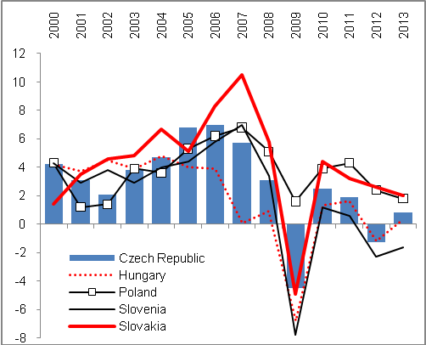 |  |  | 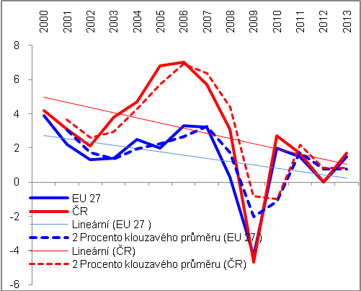Source: CZSO, Eurostat, own calculations

- The increase in volume of most expenditure components of GDP in 2000–2010 in the Czech Republic was approx. three times higher than EU dynamics with the exception of final government consumption expenditure | It is clear from the long-term development of individual components on the expenditure side of GDP, that is, for 2000–2010, that their volume has risen three times against the dynamics of these components of the old EU countries (EU-15) combined than in the Czech Republic. The domestic demand in the Czech Republic has grown in real terms in the given period by 29%, while it grew by 11.8% in the EU-15. Household final consumption expenditure has increased in real terms by almost two fifths (+39.6%), while in the EU-15 it grew only by 12.3%, with the export of goods and services in the Czech Republic by 115%, against +34% in the EU-15. The difference in the dynamics of investments is significant when the formation of gross fixed capital exceeded the base from 2010 by 31.7% in the Czech Republic, while only by 2.9% in the EU-15 (see Table 2).  On the contrary, costs for final consumption of the government sector rose in the decade of 2000–2010 in the most developed EU countries (EU-15) almost by one quarter (+23.2%), while only by one fifth in the Czech Republic (+20.5%). This was predominantly influenced by the development since 2005 when the increase of government final consumption expenditure in 2005–2011 was more than two times higher (+9%) as compared to the small increase in the Czech Republic. In particular, the more restrictive fiscal policy of EU-15 countries was responsible for this, as expenditures of these countries were mostly influenced by the condition of budgets of the problematic countries of the “South” and countries providing aid from their budgets towards the end of the above-mentioned period.
- A comparison for 2005–2011 showed a drop in investments in the EU-15 against their growth in CR; dynamics of household consumption influenced by the economic level reached | The period of 2005–2011 was characterized by approximately three times higher dynamics of export and import of goods and services in real terms apparent in the Czech Republic as opposed to the dynamics of the EU-15 (Chart 2). Domestic demand grew by 8.7% against +3.5% for the EU-15. Regarding household final consumption expenditure, the data concerning the increase of the EU-15 for 2011 was not available when this report was being compiled, but it can be seen for individual countries that the growth of consumption of households by 11.5% in the Czech Republic for 2005–2011 was significantly higher than e.g. that of Germany (+3.3%) or the drop in the UK (-0.5%), but much lower when compared to Poland (+26.5%). This comparison is strongly affected by the higher economic level of households of the old EU countries modifying the dynamics by the comparison base used.  In the crisis period, the formation of gross fixed capital fell in the EU-15 group much more significantly than in the Czech Republic, where growth of 9.2% was reported in 2005–2011 while investment dropped in the EU-15.
- The increase of gross added value in CR against the EU-15 more was significant in the period of crisis | The increase of gross added value in the Czech Republic for 2000–2011 was also three times higher than that of the EU-15 (+44.1% against +15.4%). For 2005–2011 the mutual dynamic ratio was even more profound (+17.6% against +5.7% in the EU-15).  This can be explained by the structure of economies, because the crisis occurring in the given period struck the service sector dominating in the developed countries more severely. On the other hand, the relatively strong share of the secondary sector in the Czech economy was responsible for the fact that, given relatively fast elimination of losses in production and export caused by weakened foreign demand, particularly the manufacturing industry and the added value created by this industry recorded an overall positive development for the entire period 2005–2011.

Table 2: Increase of GDP major components in medium and long-term perspective (in real terms, in %)

 | 2000–2010 |  | 2005–2011
 | CR | EU-15 | CR | EU-15
Household final consumption expenditure | 39.6 | 12.3 | 11.2 | -*
Government final consumption expenditure | 20.5 | 23.2 | 4.0 | 9.0
Gross fixed capital formation | 31.7 | 2.9 | 9.2 | -2.7
Export of goods and services | 115.0 | 34.0 | 53.0 | 19.5
Import of goods and services | 93.9 | 33.2 | 14.4 | 15.4
Domestic demand | 29.0 | 11.8 | 8.7 | 3.6
Gross added value ** | 44.1 | 15.4 | 17.6 | 5.7
GDP | 39.6 | 12.3 | 16.1 | 5.1
Source: Eurostat
*E.g. Germany +3.3%, UK -0.5%, and Poland +26.5%
** 2000–2011

Unless stated otherwise, figures adjusted for price influence and number of calendar days are given both here and further in the text.

