July 11, 2012

CONSUMER PRICE INDICES IN Q2 2012

Consumer prices increased only by 0.3% in Q2 2012 compared with Q1 2012. Prices rose by 3.4% in Q2 2012, year-on-year, which was 0.3 percentage points down on Q1.

The quarter-on-quarter (q-o-q) price level increase was affected especially by a price rise in two divisions of the consumer basket, namely in 'clothing and footwear' and 'restaurants and hotels'. The rise in 'clothing and footwear' came primarily from higher prices of new summer models in Q2 after winter sales in Q1. In 'restaurants and hotels', prices of meals provided by restaurants and accommodation services were higher (1.0% and 2.2%, respectively). The growth of food prices continued in Q2 with the exception of April.

The average month-on-month (m-o-m) growth rate in Q2 2012 was only 0.1%; in Q2 2011 it was 0.2%. This was demonstrated in a moderate deceleration of the year-on-year (y-o-y) price increase in Q2 2012.

Consumer price indices
the previous quarter = 100

 | 2011 |  |  | 2012
DIVISION | Q2 | Q3 | Q4 | Q1 | Q2
TOTAL | 100.6 | 100.1 | 100.5 | 102.5 | 100.3
Food and non-alcoholic beverages | 101.6 | 98.5 | 102.3 | 105.1 | 100.8
Alcoholic beverages and tobacco | 100.4 | 101.1 | 99.8 | 100.8 | 100.3
Clothing and footwear | 102.7 | 96.8 | 103.0 | 94.5 | 103.5
Housing, water, electricity, gas and other fuels | 100.3 | 100.8 | 100.6 | 103.8 | 100.1
Furnishings, household equipment and routine maintenance of the house | 99.7 | 99.5 | 99.7 | 100.0 | 99.7
Health | 101.1 | 100.9 | 101.4 | 106.2 | 100.3
Transport | 101.1 | 100.0 | 100.5 | 102.3 | 100.4
Communications | 99.9 | 99.7 | 99.6 | 99.6 | 99.7
Recreation and culture | 99.5 | 102.0 | 97.0 | 101.3 | 99.7
Education | 100.1 | 100.6 | 101.2 | 100.3 | 100.1
Restaurants and hotels | 100.4 | 100.6 | 100.5 | 102.0 | 101.1
Miscellaneous goods and services | 99.7 | 100.1 | 100.2 | 101.5 | 100.2

Consumer prices rose by 3.4%, y-o-y, in Q2 2012 compared with Q2 2011, i.e. by 0.3 percentage points less than in Q1 2012. A deceleration of the price growth occurred primarily in 'food and non-alcoholic beverages', 'health', 'transport', in lower rate in 'alcoholic beverages and tobacco' and 'housing, water, electricity, gas and other fuels'. On the other hand, two divisions - 'restaurants and hotels' and 'miscellaneous goods and services' showed a moderate increase in the y-o-y growth. The growth of market prices slowed down to 2.1% (from 2.3% in Q1) and that of regulated⁾ prices slowed down to 9.5% (from 9.8% in Q1).

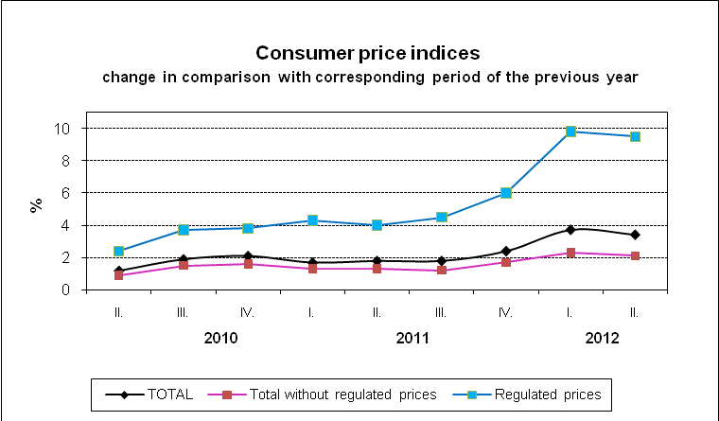

In 'food and non-alcoholic beverages', a slowdown of the price growth showed particularly bread and cereals, oils and fats, sugar and coffee, which was caused mainly by the rise in their prices in Q2 in the previous year. Prices of bread rose by 6.9% (17.5% in Q1), milk by 0.9% (6.6% in Q1), sugar by 4.6% (28.6% in Q1) and coffee by 20.2% (28.1% in Q1). Prices of rolls and baguettes remained at the level in Q2 2011 (19.1% in Q1) and prices of oils and fats were lower by 1.2% (a rise 6.7% in Q1). In contrast, a slowdown of the price decrease was recorded for vegetables and thereby the impact on the lowering price level was reduced. The turnover of fruit prices from the y-o-y drop in Q1 to the rise in Q2 had the same influence.
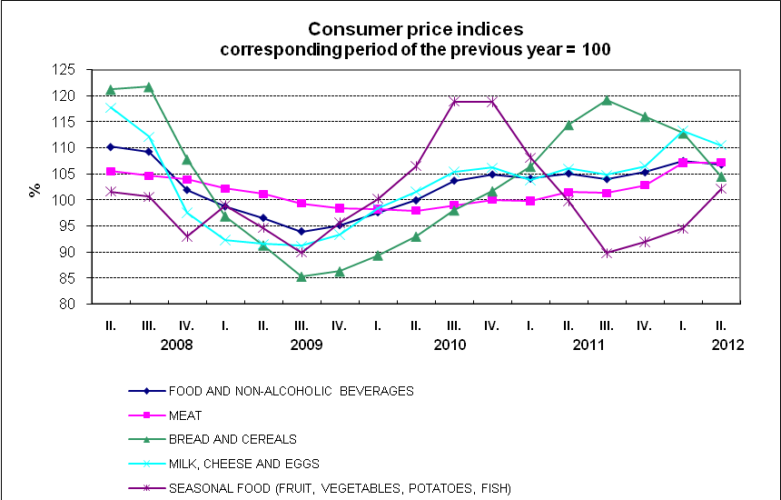

In 'health', the y-o-y growth of the majority of items slowed down moderately in Q2 after a marked price rise in Q1.

A slowdown in the price rise in 'transport' was particularly due to the lower y-o-y increase in fuel prices in Q2, which started to decline since May 2012 (a rise in fuel prices continued for 7 months). The development of consumer prices for fuel in relation to the prices of industrial producers and the import prices of oil products is shown in the following chart.

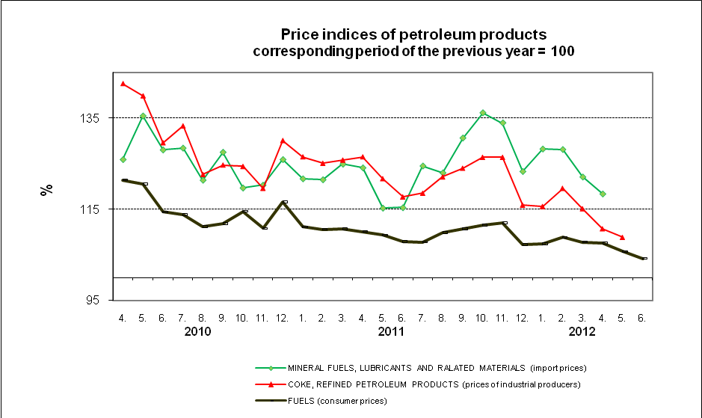

In 'housing, water, electricity, gas and other fuels', the price development of natural gas slowed down due to its higher price since June 2011. Natural gas prices were higher by 22.0% (25.1% in Q1). The net actual rentals went up by 5.6%, of which that for dwellings with regulated rentals rose by 13.6% and that for dwellings with market rentals by 2.0%. The price of electricity was higher by 4.2%, i.e. the same as in Q1. Prices of water supply rose by 12.0%, sewerage collection by 10.5%, heat and hot water by 8.4%.

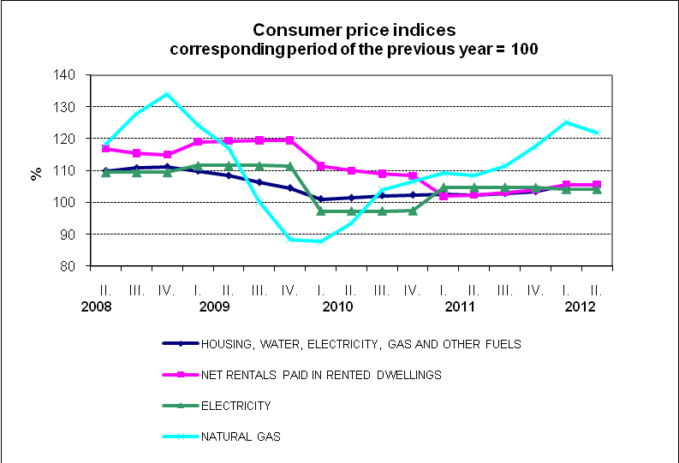

In 'restaurants and hotels', prices of catering services rose by 4.3%, of which prices in school canteens by 7.4%.

The y-o-y drop in prices, which slowed down in Q2, continued at clothing and audio-visual, photographic and information processing equipment; the decline in the prices of household appliances and mobile phones deepened.

Prices of goods in total rose by 3.7% (4.1% in Q1 2012) and prices of services by 3.1% (2.9% in Q1). From the chart, it is apparent that the prices of services grew since Q1 2011 more slowly than the prices of goods.

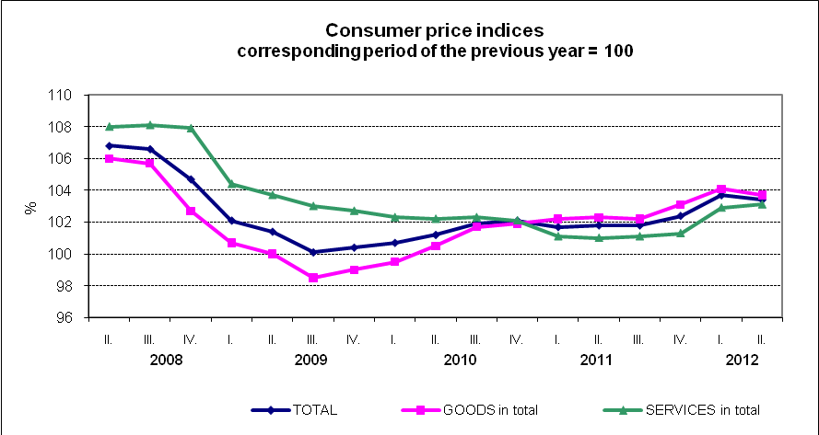

Harmonized index of consumer prices in the EU27
According to Eurostat preliminary data, the y-o-y increase in the average harmonized index of consumer prices (HICP) in the EU27 was in April 2.7% and in May 2.6%. In the Czech Republic (CR) the y-o-y change of the HICP was 4.0% and 3.5% in the same months. According to preliminary data, the HICP growth in the CR amounted to 3.8% in June. It can be seen in the chart below that the y-o-y HICP in the CR was lower than the average HICP in the EU27 member states over a long term, but at the end of 2011 both indices started to converge and after the January jump in consumer prices, the y-o-y HICP in the CR got about 1 percentage point above the average level in the EU.

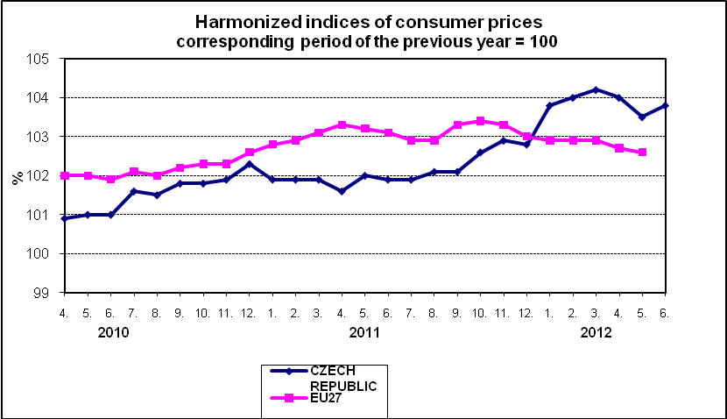

Consumer price indices in Q2 2012

Text not edited for language.

) Prices, which are fully or partly regulated

