- Structure of agricultural holdings by types of farming

The EU agricultural holdings classification system enables mapping the current structure of agricultural holdings in terms of types of farming. The basic information on the number of holdings in particular regions broken down by types of farming is given in Annex B1. The results of the 2023 Integrated Farm Statistics show that the Czech agricultural production is spread mainly in four types of farming: specialist field crops, specialist grazing livestock, specialist horticulture and permanent crops, and mixed production. Moreover, the distribution of types of farming depends on regional soil-climatic conditions, which is evidenced by the high proportion of holdings specializing in horticulture and permanent crops in the South Moravian, Zlín and Ústí nad Labem regions.
Based on the total area of utilized agricultural land (Annex B3), the most widespread specialization is field crops. Holdings with this specialization manage an area of 1,337 thousand hectares, of which almost a quarter (24%) is in the Central Bohemian Region. The second largest area is managed by farms with mixed production, in total 1,222 thousand ha, with the largest areas located in the Vysočina Region (16%). Specialist grazing livestock represents the third largest area in the CR (547 thousand ha) with 18% located in the South Bohemia Region.

The largest share of the holdings is formed by specialist field crops with a significant impact on the economy of Czech agriculture. More than one-third of Czech farms specialise in field crops production (37%). The share of the total acreage of utilized agricultural land is 38%. Concerning the legal form, the majority (83%) of field crops specialists are formed by natural person. In terms of the size structure, small-scale holdings prevail within the group of field crops holdings (53%). Only 6% of the holding are defined as a large-scale category. As for regional evaluation, most of the field crops specialists are situated in the Central Bohemian Region (2,361 holdings) with the largest proportion of this type of farming (56%), leaving aside the capital city of Prague as a non-agricultural separate region. An important position is also held by the Vysočina Region (1,522 holdings), Ústí nad Labem Region (881 holdings), and Olomouc Region (830 holdings). The regions suitable for field crops planting are naturally determined by altitude and soil-climatic conditions.
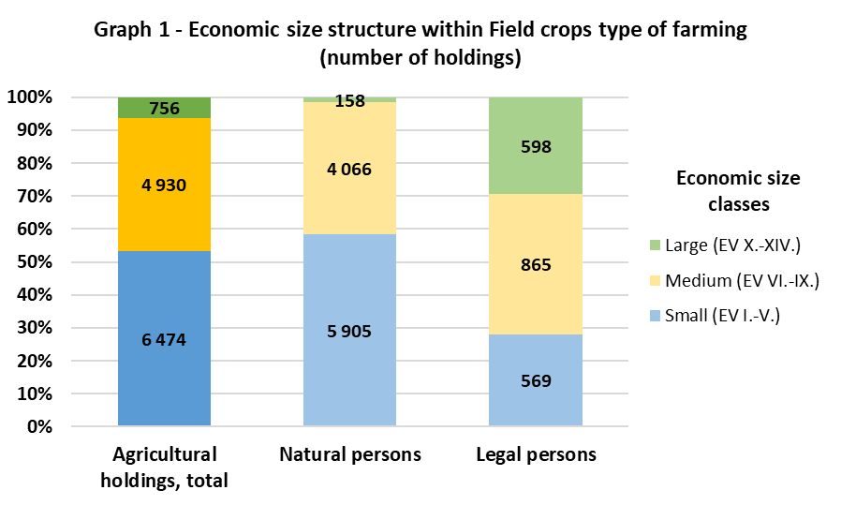

The general type of field production consists of holdings specializing in cereals, oilseeds and protein crops and general field cropping (specialized in combined cropping of field crops, root crops and field vegetables). Almost two-thirds (61%) of these holdings belong to the group of farms specializing in cereals and oilseeds cropping. These farms manage 76% of the agricultural land under field production and 29% of the total agricultural land in the country. The remaining 39% of field crops specialists were classified as general field cropping. The proportion of small-scale holdings (40%), medium-scale holdings (53%), and large-scale holdings (7%) is typical for the group of cereals and oilseeds specialists. The average acreage reaches 138 hectares per holding in this type of farming. Within agricultural holdings specialized in general field cropping, the proportion of small size farms is more significant (73%); which results in a lower value of the average acreage (66 ha/holding).

An important role among the analysed types of farming plays specialist grazing livestock. The development of this production was influenced by the support of breeding suckler cows within the framework of CAP and is typical for the Areas with Natural Constraints (former Less Favoured Areas). The grazing livestock specialists form a quarter of the total agricultural holdings in the Czech Republic (25%). More than two thirds (69%) of these farms represent small-scale holdings, which is due to the high proportion of natural persons in this specialisation (87%). Agricultural holdings specialized in grazing livestock utilise 16% of agricultural land resources. The share of these holdings on total animal production expressed in livestock units is 16%, as well. Among the regions, the largest proportion of grazing livestock specialists is concentrated in Karlovy Vary Region (68%), followed by Liberec Region (58%) and South Bohemian Region (39%). In absolute numbers, most of these farms operate in South Bohemia Region (1,402 holdings).

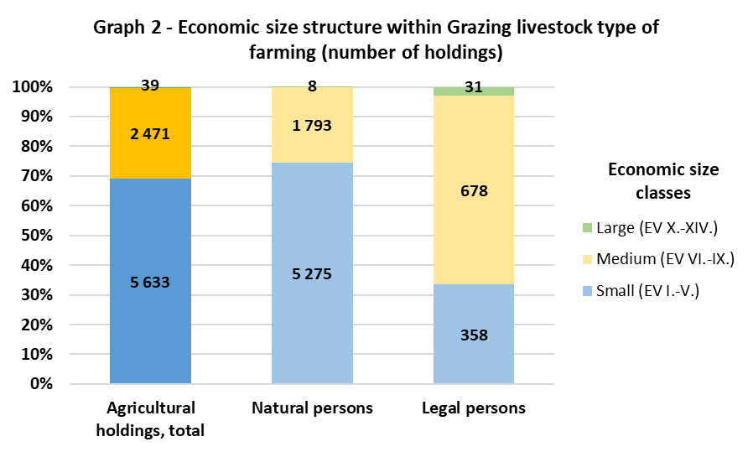

The group categorised under grazing livestock consists of specialist cattle – rearing and fattening (70%), cattle – rearing and fattening combined (3%), and sheep, goats and other grazing livestock (27%). Within the frame of grazing livestock type of farming, a significant role is played by specialist cattle-rearing and fattening (5,695 holdings), which manage 87% of agricultural land and 87% of livestock units within the abovementioned general type of farming. Average acreage in this type of farming reaches 83 ha/holding and the average number of livestock units equals 40 units per holding. The second most frequent type of farming in terms of the number of holdings is sheep, goats and other grazing livestock type (2,218 holdings). However, 89% of these farms are by small holdings; therefore, its economic significance within the agricultural sector is negligible.

Despite the marginal share of the total utilized agricultural area (2%), holdings specialized in horticulture and permanent crops (19%) belong to the third most numerous types of farming and generate a relatively significant part of Czech agricultural production. Within this specialization, natural persons predominate (90%), with a high proportion of small-scale farms (74 %). On average, the acreage managed by these holdings is 10 ha/holding. The regional distribution is predominantly determined by climatic conditions. The production is concentrated in traditional winegrowing and fruit-growing areas. The South Moravian Region has a clear dominance, with 4,565 horticulture and permanent crops holdings, which represents more than two-thirds (71%) of these holdings in the Czech Republic.
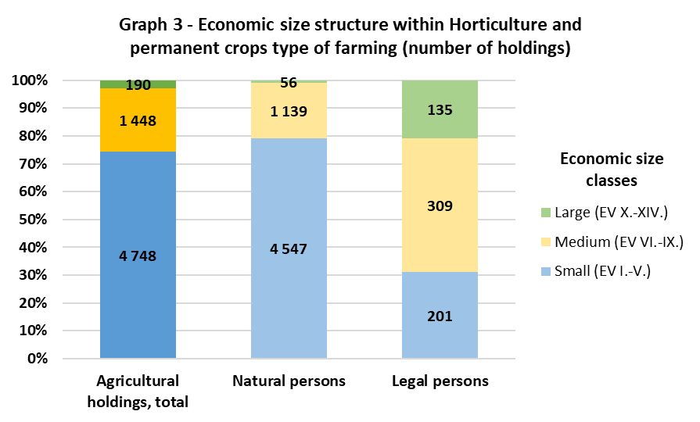

The 2023 Integrated Farm Survey included 460 subjects specialized in horticulture. This group consists of specialists in horticulture indoors (greenhouses, foil covers - 38%), horticulture outdoors (32%), and other horticulture (30%). The category of other horticulture involves holdings specialized in nurseries (growing seedlings of trees, shrubs and other plants for planting) and mushroom production (production of various types of mushrooms, often in specialised facilities), etc.
The specialist permanent crops represent a significant group in terms of the number of holdings (5,926 holdings). This group is divided into specialist vineyards (69%) and specialist fruit holdings (31%). Within the fruit-growing holdings, less than half (47%) are permanent crop producers and more than half (53%) are diversified permanent crop producers. Most specialist vineyards belong to small size economic classes (81%). Specialist vineyards reach average acreage of 4 ha/holding. In the case of fruit-growing holdings, small-sized farms account for 70% within this specialization. Fruit farms utilize 11 ha/holding on average. The various permanent crops holdings are composed of 74% small holdings and utilize 30 ha/holding on average.

The group of agricultural holdings specialized in mixed production is composed of mixed crop-livestock farms. On a smaller scale, holdings oriented on a mixed cropping and mixed livestock production are also involved. With a total number of 5,078 holdings, the mixed production type of farming represents the fourth most frequent agricultural specialization in the Czech Republic. Mixed production has a decisive influence on the level of agricultural production in the Czech Republic, generated mainly by large holdings. Large legal persons account for 12% of this production specialization. Natural persons, with a predominance of small holdings, account for 82% of all holdings in this specialization. Mixed production farms cover 35% of the total utilized agricultural area and 37% of the total number of livestock units. Most mixed production farms are situated in the Pardubice Region, where they account for a quarter (25%) of the total number of agricultural holdings in this region. The Vysočina Region (24%) is almost identical, followed by the Zlín Region (22%). The highest number of holdings is situated in the Vysočina (719 holdings), Central Bohemia (691 holdings) and South Bohemia (652 holdings) regions.
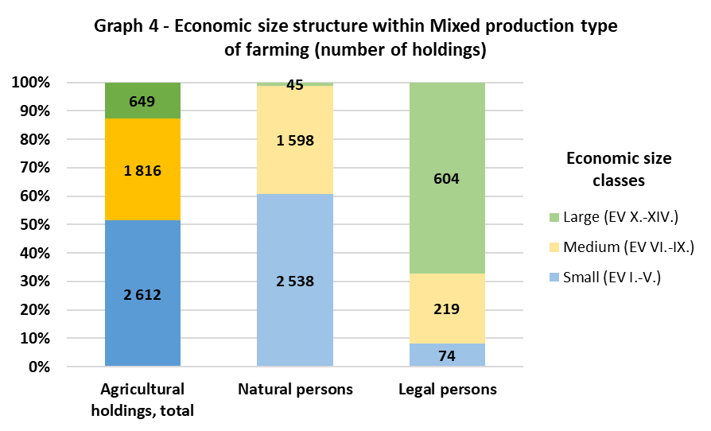

The combination of field crops and grazing livestock production is the prevailing type of farming (53%) within the group of mixed production specialists, followed by various crops and livestock combined (25%), mixed cropping (12%), mixed livestock, mainly grazing livestock (8%), and mixed livestock, mainly granivores (2%). Holdings focusing on a combination of field crops and grazing livestock production make a decisive contribution to the production of the specialization. Within the frame of mixed production type of farming, these holdings cover the highest share of both utilized agricultural area (78%) and the number of livestock units (69%). This group of farms reaches 355 ha/holding and 153 LSU/holding on average.

An intensive form of production is typical for specialist dairying. There are 877 holdings classified as such in the Czech Republic. The highest share of this specialization is found in the regions of Pardubice (6%), Vysočina and Hradec Králové (5% each). Nevertheless, the greatest number of milk farms is located in Vysočina Region (160 holdings), in the South Bohemia Region (128 holdings), and in the Hradec Králové Region (102 holdings).

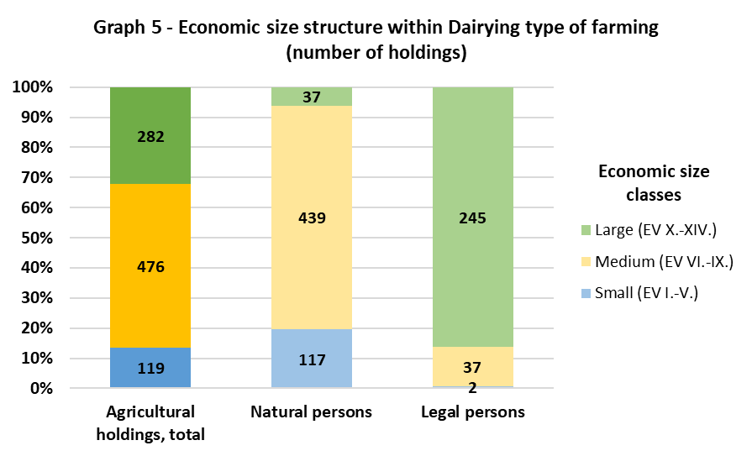
More than one-half of the dairy farms are of medium-sized holdings (54%). Almost one-third of holdings belong to the large-scale category (32%) and only 14% of holdings belong to the small size category. The share of large holdings is significant, accounting for more than a quarter (28%). This group of holdings significantly contributes to the agricultural output. Specialist dairying farms utilise 378 ha/holding on average, which covers 9% of the total agricultural land in the country. Dairy farms account for 14% of the total livestock units of the CR. One holding of this specialization, therefore, rears on average 260 livestock units.

The lowest number of holdings in the Czech Republic is classified as rearing of granivores. This specialization involves 391 holdings. A high proportion of legal persons (42%) and large-scale holdings is typical for this group. Most holdings are small farms (41%), nearly a third are large holdings (31%) and slightly fewer are classified as medium-sized holdings (29%). Agricultural holdings belonging to specialist granivores can be characterized by an intensive way of rearing. These holdings concentrate 28% of the total number of livestock units in the Czech Republic. On average, there are 1,182 livestock units per holding. The average area is only 44 ha/holding due to the nature of this livestock production. Most of the granivores holdings are located in the Olomouc, South Moravia and Central Bohemia regions.

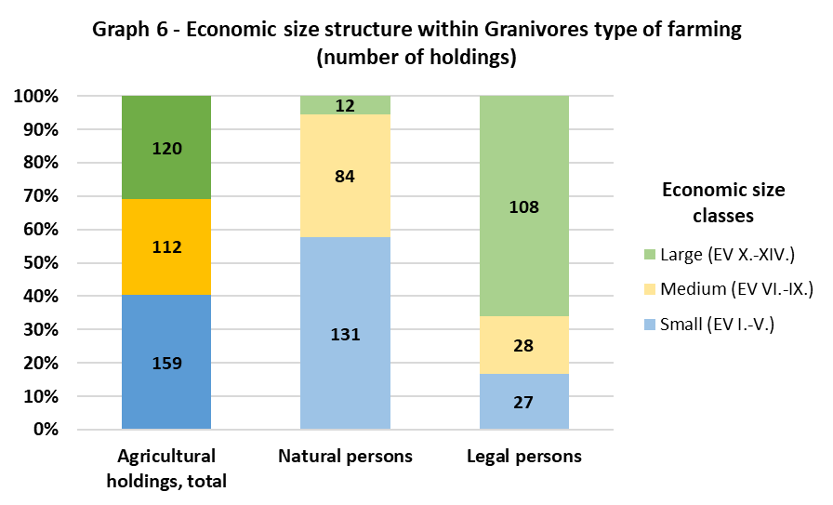

The principal type of farming specializing in granivores includes specialist pig farming (53%), specialist poultry farming (39%) and various combined granivores, i.e., a combination of specialist pig and poultry farming (8%).

