Labour Market

Aggregate employment highest since 2008, in the second half of the year the rate of growth however did not accelerate any more |  | Labour market according to the employed persons expanded in 2013 the most in the last five years. Year-on-year addition by 0.9 % was not however even one half compared to the average of the boom period (for years 2005-2008 it added up to 2 %). In the second half of the year based on seasonally adjusted data in the national accounts conception the growth of the aggregate employment did not accelerate any more – the number of persons being employed was on the contrary gradually falling to 5 117.7 thousand persons in the last quarter during the year, which was less than the whole year average (5 124.2 thousand persons). Labour market was thus in this view the third strongest in 2013 in the last nearly two decades.
In 2013 significant addition to employed persons also in the public services, having lost nearly 41 thousand job positions in the previous four years |  | Compared to year 2012 less persons worked only in agriculture and construction. In the manufacturing industry and the group of services activities (trade, transportation, accommodation and restaurants), where a quarter of persons employed in the CR economy works in both cases, the aggregate employment increased by 1 %, resp. by 0.5 %. On the contrary the economic activities with a relatively low weight on total employment in the economy recorded roughly the triple rate of growth of employed persons (e.g. ICT year-on-year +2.7 %). Also the growth of employment in the public services (+2.5 %) was significant, with the employment always year-on-year falling in the previous four years (in total there were 40.7 thousand jobs lost in this time period).
Strong dynamics in fixed-term employments… |  | Following a year-on-year stagnation in the number of employees in 2012, its marked improvement arrived in 2013 (+1.6 %). The dynamics was however – similarly to the aggregate employment – stronger in the first two quarters (+2 %, resp. +2.3 %). The addition to the number of employees was lower than yearly average only in the agriculture and industry.  Wariness of businesses in hiring new employees into the „core numbers“ is however still apparent. According to the data of the Labour Force Sample Survey (LFSS) namely the numbers of fixed-term employees increased during the whole year – in Q3 the proportion of those working in these employments already amounted to more than one tenth (10.2 %) from the total number of employees, in Q4 10 %. While in 2011 the stated ratio was 8.5 % of the overall number of employees, in 2012 it climbed to 8.8 % and in year 2013 the share of fixed-term jobs was already nearing also one tenth (9.6 %) of all employees in the CR economy.
… and in part-time jobs |  | The part-time jobs also follow a similar development. This form of employment was chosen or needed to be chosen by 5.5 % of employed persons in 2011, in 2012 already 5.8 % and in 2013 the share of persons working part-time arrived at 6.6 % out of total number of employed persons in the CR. The share has been growing continually every quarter since year 2012. Opposed to this, the fixed term jobs feature certain „seasonality“ – every 1st quarter of each year, the proportion of these employees against the preceding quarter mildly falls, it climbs up during the year and in the last quarter again mildly decreases. It can be assumed, that these types of jobs can be significantly utilised in branches of seasonal jobs (agriculture, construction).
Hourly labour productivity grows due to the fall of hours worked in the economy ... |  | The dynamics of the number of hours worked also corresponds to the logics of increasing share of jobs to other than „standard“ employment contracts – number of people, who boosted the labour market grew faster to the number of aggregate hours worked (in 2013 year-on-year -0.8 %, in Q4 -0.9 % and quarter-on-quarter even -1.6 %). However, it was not valid for the industry sector and most branches of the services sector.  Stagnating number of hours worked has been apparent in the economy for already three years in a row. If we relate the product created (the size of gross value added in the economy) to the number of hours needed to its creation, we gain the growth of hourly labour productivity, while the labour productivity per one worker on the contrary kept falling as a consequence of the rising number of employed persons in both recession years (-0.1 % year-on-year in 2012, -0.6 % in 2013).
… which is not however valid for activities with part-time jobs or fixed-term jobs represented to a lesser extent |  | Hourly labour productivity rose in the CR economy in 2012 year-on-year by 0.4 %, in 2013 already by 1.1 %. This trend was not however reflected in the manufacturing industry and in total for activities of trade, transportation, restaurants and accommodation services – where together more than half of persons employed in the CR works; further then in the services activities, where the drop of hourly labour productivity either deepened (e.g. in ICT -8.8 % against -2 % in 2012) or newly arose (real estate activities with -2.3 % compared to +2.3 % in 2012).
Unemployment rate did not fall substantially during the year 2013 |  | Based on the monthly data, which beginning the year 2013 the CZSO commenced to record seasonally adjusted, the general unemployment rate (related to the population aged 15-64 years) given the trend curve slightly lowered, however the actual fall was apparent only in the period February-June (from 7.3 % to 6.7 %). In the second half of the year the labour market from the view of unemployment already only stagnated between 6.9 %-7 % unemployed persons. Female unemployment rate was however even in this period continuously falling (from August 8.5 % to December 8.1 %), which can indicate, that it is just the female labour force which is absorbed on the labour market in the form of fixed-term jobs or part-time jobs more intensively.  Market has also absorbed in the so far not seen extent the part of labour force, which previously acted in the group of economically inactive (rate of economic activity as the share of employed to unemployed of this group age reached in the so far highest level since year 1993 in Q4, i.e. 73.3 %). The number of long-term unemployed persons also decreased (year-on-year by 12 thousand to 150.1 thousand persons in Q4). Still, they represent more than two fifths (42.2 %) out of total number of unemployed in the CR economy.
Historically the deepest fall of the average monthly nominal as well as real wage in Q4 2013 … |  | The sinking of real wage in the non-business sector lasts already more than four years in a row, two years in the business sector. The real wage in total for the economy fell year-on-year by 1.3 % in 2013, in Q4 itself its lowering was by 2.9 % historically the deepest slump since the commencement of observation. Especially the stagnation of the nominal average monthly wage stood behind the fall of the real wage in the Czech economy (+0.1 % to 25 125 crowns recalculated to average number of registered employees to full time employed). Consumer prices did not grow according to the inflation rate, shrinking the development of the nominal wage to a large extent (+1.4 %) in 2013. Yearly stagnation was influenced by the year-on-year lower nominal wage in the first three months of the year , but especially in Q4, when it fell by 1.8 %. Again it presented the worst wage result in the CR history, with the effect of the comparative basis of extraordinary compensations standing behind it.  Historically for the first time also the average nominal monthly wage of the employees of businesses fell in 2013.
…with respect to a marked impact of year-on-year lower extraordinary bonuses especially in high-income branches |  | Large extraordinary bonuses in the last quarter of 2012 pushed up at that time year-on-year very significantly the rate of growth of wages in the business sector (nominal +4 %, real +1.2 %), also placing the total result for the CR into positive numbers.  It was this high comparative basis playing a major role in the marked drop of wages in the same period of year 2013, where the extraordinary bonuses were year-on-year lower. This movement in the extraordinary bonuses eventuated especially in branches with high average wages, which were since year 2013 burdened with the so called solidarity tax (7 % for wages exceeding in any month 103 thousand crowns). In the last quarter of 2013 thus in the financial and insurance activities the average nominal wage sank by 18 %, in the energy industry then by 12.6 % - this decreased the nominal wage in the business sector by 646 crowns and in the figure for the whole economy by 464 crowns (in the non-business sector this effect in reality did not occur). Thus for the whole year the average monthly wage remained practically the same in the CR economy (+16 crowns) with a negligible decrease in the business sector (-28 crowns) and increase by 213 crowns in the non-business sphere. However, there works over four fifths of employees in the businesses (in recalculated balances).
Differentiation according to industry – with respect to number of employees, wages did not decrease to most of them |  | It is important, that in the manufacturing industry, which is key especially for the employment of the key employees, the nominal wages did not fall (+1.3 % for the whole year 2013, +0.9 % in Q4). Considerably worse development in Q4 is suggested also by the fact, that while for the whole year 2013 over 63 % of the total number of employees worked in the industries characterised by growth resp. stagnation of the nominal wage (recalculated to the number of full-time employees), in Q4 it was already only 53 %. Still, this high proportions of persons in industries, where the wages did not fall can indicate, that the impact on the effective demand of households does not have to be fatal. What is however clear is the inflation effect „nibbling away“ from the increments of these wages and deepening the total decrease of the real wage in the CR economy, which was deeper in the business rather than the non-business sector.

Chart 15 | Aggregate employment and numbers of employees (y/y in %, seasonally adjusted) | Chart 16 | Nominal and real wage (y/y in %, recalculated numbers, monthly average)
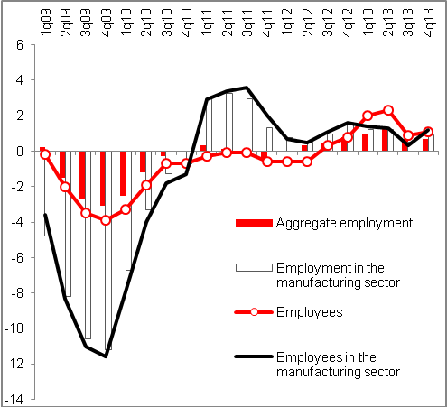 |  | 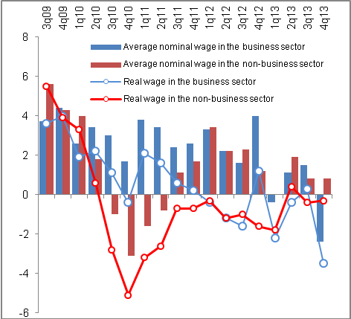

Chart 17 | Annual development of wages (y/y in %, average registr. number of employees from seas. adjusted data) | Chart18 | Gross average monthly wage in CZK (2013); wage dynamics in 4q2013 (y/y in %)
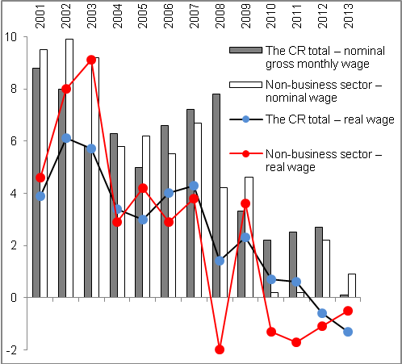 |  | 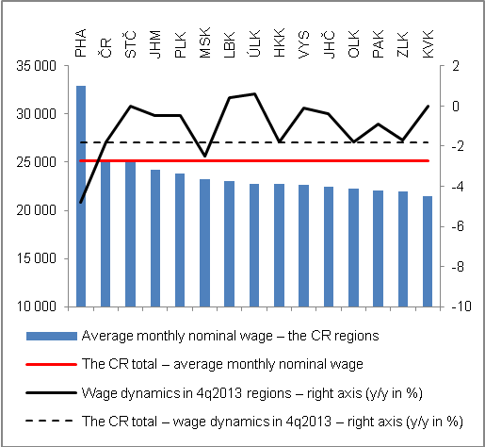
Source: CZSO
Note to chart 18:
Regions: Pha=Capital city Prague, STČ=Central Bohemia, JH=South Bohemia, PLK=Pilsen region, KVK=Karlovarský region, ÚLK=Ústecký region, LBK=Liberecký region, HKK=Královéhradecký region, PAK=Pardubický region, VYS=Vysočina region, JHM=South Moravia, OLK=Olomoucký region, ZLK=Zlínský region, MSK=Moravia-Silesian region

According to the definition of the International Labour Office (ILO).
Persons who do not work, do not seek work in an active manner and thus do not comply with the ILO conditions for the unemployed, yet they state they would like to be working. Statistics captures the numbers of these persons aged 15-64 years for the calculation of the ratio „employed/unemployed“ of this age group, i.e. the rate of economic activity.

